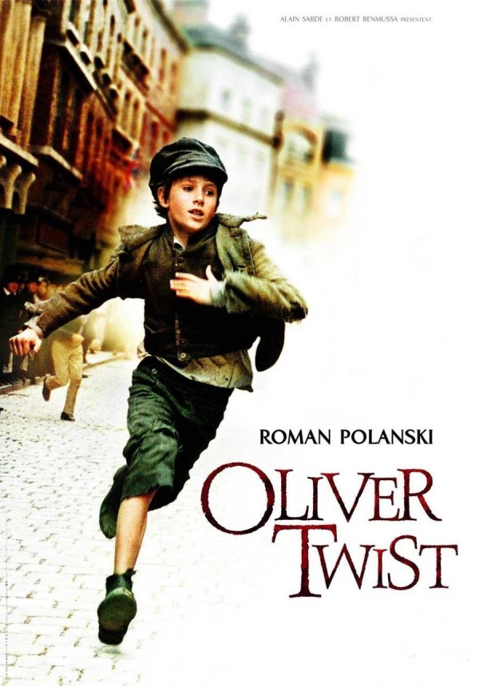 Oliver Twist … with a twist
Jack kicked a stone aimlessly from foot to foot as he trotted down the street with Oliver and Charley. He was wearing a long pale blue jacket and raggedy bottle green trousers the cote was far too long for him and came down to his grubby ankles. His towers were rolled up and black with soot and grub off of the jaggedly cobbles around. His tummy rumbled loudly, giving away the fact he was starving. He was an orphan so could not afford food.
As they stepped into a partially poor part of London, a smell of pungent rubbish hit them like a sudden heat wave. As they strolled down the cobbled street shoppers hurried past them and shop owners shouted there trade at the top of tear voices. A man hurried passed them shouting BREAD, fresh bread only one shilling. Watch it cried Charlie as a partially pudgy man hurried pasted them nocking his hat off.
As Charlie jammed hat back on his rather raggedy coat fell heavily on Olive’s rather dirty blonde hair. Charlie hastily pulled his coat off Oliver revealing the inside of his coat which was crammed full of handkerchiefs, pocket watchers and wallets that he had stolen over the past week or so.
After that, Jack led them off to a book shop wear a wealthy lord stood brooding over a vast collection of books. They could hear him murmuring something about a library but couldn’t pick out the finer detail. Jack sidled up to the man.
As quick as a flash, Jack slid his long spindly hand into the man’s pocket and withdrew it hastily clasping in his hand a long velvet handkerchief with golden seems and patterns across it. Quickly, he pocketed and ran but Oliver stayed put. As the man put his hands into his pocket, he noticed something was missing. Slowly, he turned around and saw Oliver standing there with a guilty expression on his face.

Suddenly, Oliver took to the wind and ran as fast he had never ran before. He could only see flashes of where he was going. As he passed the grocer he slowed to a jog and finally stopped. Panting slightly, Oliver looked around. He could see Jack and Charlie coming into view at the end of the road. Suddenly there was a shrill whistle and the Bobbies came out of an alleyway shouting stop thief. Oliver started to run but this time the Bobbies out ran him and blocked his way.

As quick as a lightning, the Bobbies where upon him like a pack of dogs. Within a couple of minutes, one of them had punched him hard in the head and he was knocked unconscious.

Meanwhile, Jack and Charlie went back to Fagin’s house. As they entered the room, a huge babble of talk broke out and Fagin quieted them.
‘Where’s the young laddie?’ asked Fagin.
‘He was so noble and kind, that he took the blame on me when I got caught so no harm done really.’
As Jack drifted off to sleep that night, he had wistful thoughts of living and being Fagin’s favourite, and Oliver (an unwanted orphan like himself) being locked in jail. How nice it was to live with Fagin, or was it...

