CATHEDRAL SCHOOL NEWS
Edition No. 32
21th May 2012.

Dear Parents,

This issue will outline some of the exciting developments and achievements in the arts at Cathedral School.

Artsmark Gold Award
Artsmark is a national award that celebrates high quality arts education in England. It is the Arts Council England’s flagship programme to audit, reward and develop high quality arts education in schools and further education colleges. This award has been developed in partnership with the Department for Culture, Media and Sport, the Department of Education and OfSTED.


On the May 14th, Cathedral School received the Artsmark Gold award from the British Arts Council for our outstanding provision of the arts at school. In fact our application was praised, according to Lucy Oragano, the Artsmark assessor we,

“Demonstrated an excellent commitment to providing high quality arts provision that is embedded across your curriculum and we would like to congratulate you on the hard work and commitment that went into achieving this respected award.”

This is a fantastic achievement for Cathedral School and shows the school communities devotion to providing the very best arts education.

Art in School

Art is a real focus in the school. We are proud of our artist in residence Dilek O’Keefe who works with each class over the year to refine a particular skill.

The children are encouraged to work creatively, using a variety of media and techniques in art and design. An awareness of colour, shape, balance, focus and proportion are developed alongside the use of symbols to convey ideas and feelings.

In their art lessons the children draw, paint and use a wide variety of art materials to explore collage, sculpture, clay and textiles. In Key Stage 2 pupils have their own special sketch books which build up a portfolio of work and are a lasting memory of their art at school.

We encourage all children to take part in a wide range of art initiatives as well as organising special weeks at school to help support creativity across the curriculum for example, Sustainable Enterprise Week, Olympic Day and Book Week.

We also provide extracurricular clubs to support budding artists; at the moment we are running a Photography Club, Story and Art Club and Art Adventurers Club to support gifted artists.

Art is incredibly important at Cathedral School and this is reflected in the wide variety of children’s work which has been framed, demonstrating the value we put on pupil’s work. Art is a valuable way to support other subjects, enriching the curriculum and stimulating children’s learning. Our annual Arts Week provides a whole school focus on the promotion of Arts within the school.
Art Exhibition
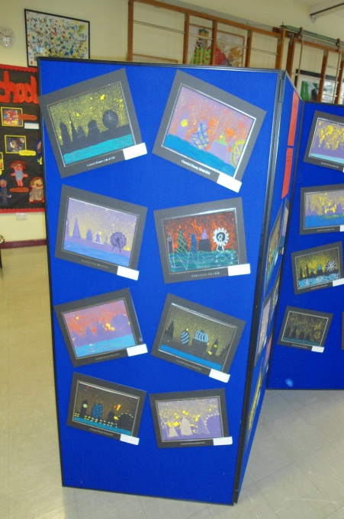
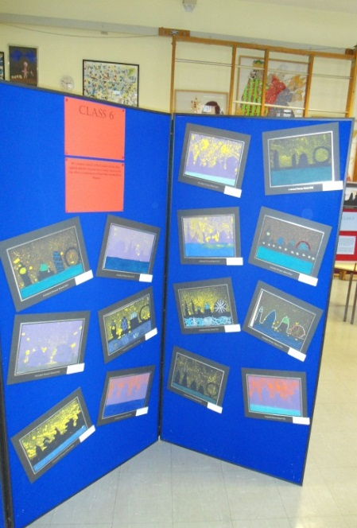
This year for the first time we hosted a school wide art exhibition and sale. Thank you to all the families who visited and bought their children’s work making it a huge success and allowing the school to buy some much needed art resources for each classroom.
Yes! There will be more of these art exhibitions for families to come to and celebrate children’s achievements across the arts at Cathedral School.

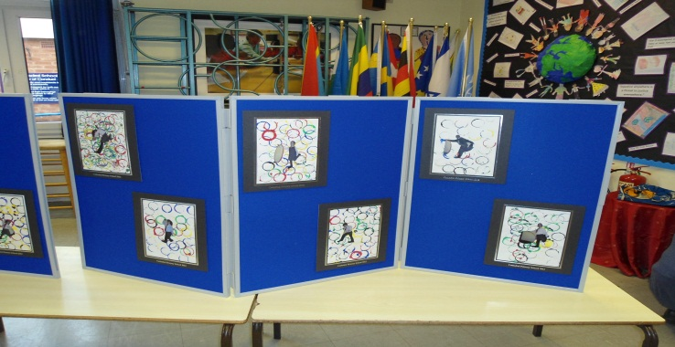

Dilek O’Keeffe
Cathedral School is extremely fortunate to have its very own artist in residence Dilek O’Keeffe, who over the year will work with each class developing a particular skill.

Dilek completed her Fine Art Degree course at City & Guilds of London Art School in 2002, She was selected for the ‘Best of New British Graduates’ by the Beatrice Royal Gallery and showed at the Battersea Art Fair. The following year one of her works was selected for the Royal Academy Summer Show, which received international attention as well as interviews – from Rolling Stone Magazine to the BBC.
Future of Art
The future of art at Cathedral School is looking very bright and will continue to go from strength to strength. With arrival of the iPads we are now able to easily record, edit and blog new forms of digital art. The new digital cameras allow us to take pictures and manipulate them to create pieces of art. This equipment is used across the curriculum, at Photography Club and in Art Adventurers. We will continue to use the local area as inspiration, recently Year 1 took part in an art workshop at Tate Modern and Year 5 visited the National Gallery. It is an exciting time here at Cathedral School for the arts and I can assure you that the arts in all its forms will continue to be a priority.
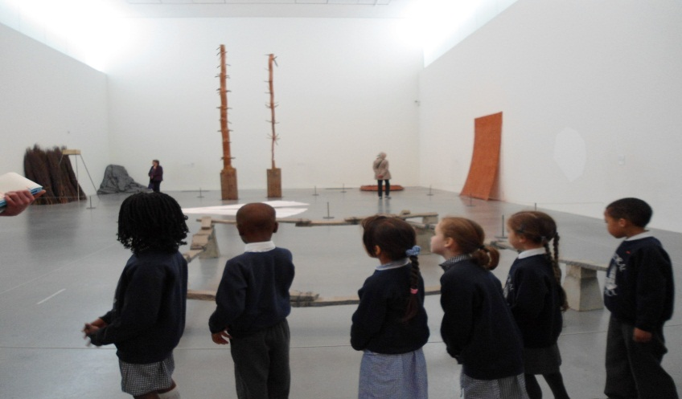

For Your Information
Cake Sale
Parent Forum will be holding a cake sale in the school hall, 24th May at 3.15 to raise funds for the school fete.
#

Handwriting Pens
When children have achieved a good standard of cursive writing in pencil they will be rewarded with a “pen licence”. This usually happens in Year 2. They should then use a handwriting pen for all lessons except numeracy where pencil should always be used. Berol handwriting pens and V-pens can be purchased from the school office or the Business Ventures page on the website (http://www.thebvshop.com) alternatively other brands of handwriting and fountain pens can be used and must contain blue or black ink. Biros are not to be used because they do not promote good handwriting development.

Friday 25th May 2012
As part of International Week children are invited to wear national dress or a traditional costume from their family heritage. Alternatively, we suggest children dress in the colours of the country being studied in class that week. No trainers, jeans, sports logos or slogans please. Donations of £2.00 per child, all monies going to UNICEF.


Nursery
Ashling and Sasha have both made great progress in maths this term. They are both able to find one more of or one less of any given number to ten with confidence.

Reception
Naima and Emil. Both children have tried really hard with their maths this week. They are able to count on from a given number and can use this skill when adding.

Year 1
Layla and Parker did extremely well on their mental and written maths tests. They are both able to add two digit numbers up to 100 quickly and are now telling quarter to and quarter past on a clock.

Year 2
Myah and Fuad are marvellous maths magicians. Both children have been working hard in class and at home to improve their calculation skills and number facts.

Year 3
Lola and Vanessa. All of class 3 have worked very hard in their assessments. Both Vanessa and Lola have been able to demonstrate what they have learnt this year in numeracy, working to the best of their ability.

Year 4
Benjamin and Denis work incredibly well together in numeracy lessons. I have been particularly impressed by the systematic way they have been solving a variety of word problems recently.

Year 5
Renee and Kayode have made fantastic progress in maths this year. They are able to read a question carefully and independently decide what they need to do to solve the problem.

Year 6
Ella and Louis have made excellent progress this year and grasped a wide range of concepts.

Class Attendance
Nursery – 82% Reception – 78% Year 1 – 89% Year 2 – 100%☺
Year 3 - 98% ☺ Year 4 – 98%☺ Year 5 – 96% Year 6 – 95%

