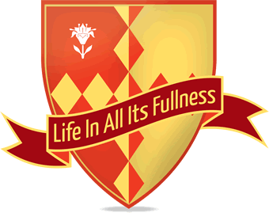
Cathedral Primary School
Term Dates 2017/18

Autumn Term 2017
First Day of School | Monday 4th September 2017
Half Term Holiday | Monday 23rd October to Friday 27th October 2017
Last Day of School | Wednesday 20th December 2017
INSET Days (Staff Only) | Friday 1st September 2017

Spring Term 2018
First Day of School | Monday 8th January 2018
Half Term Holiday | Monday 12th February to Friday 16th February 2018
Last Day of School | Friday 23rd March 2018
INSET Days (Staff Only) | Thursday 4th and Friday 5th January 2018

Summer Term 2018
First Day of School | Wednesday 11th April 2018
Bank Holiday | Monday 7th May 2018
Half Term Holiday | Monday 28th May to Friday 1st June 2018
Last Day of School | Friday 20th July 2018
INSET Days (Staff Only) | Monday 9th and Tuesday 10th April 2018

