Book Bingo Year 4 and 5 Book List
A
B
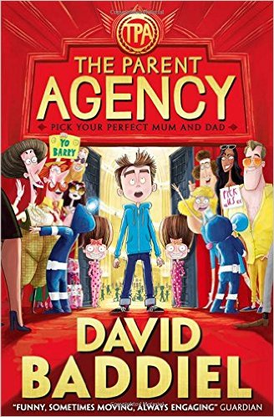 | 9+ | Barry Bennett has a long list of things he dislikes about his parents: being boring; being too tired, not letting him play video games and getting a limo to take him to see the latest James Bond film on his birthday (and naming him Barry) being just some of their deeply heinous crimes. But what if the tables were turned and children could choose their parents? What would Barry do?  With a thoughtful look at just what might happen in an alternative world, David Baddiel explores what most children will probably have considered at some point in their lives - trying out different parents - with hilarious results.
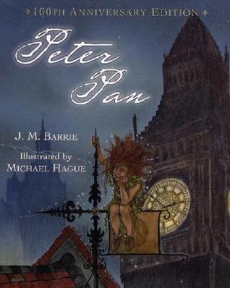 | 9+ | Peter Pan, the book based on J.M. Barrie's famous play, is filled with unforgettable characters: Peter Pan, the boy who would not grow up; the fairy, Tinker Bell; the evil pirate, Captain Hook; and the three children--Wendy, John, and Michael--who fly off with Peter Pan to Neverland, where they meet Indians and pirates and a crocodile that ticks. Renowned children's-book artist Michael Hague has brought the amazing adventures of Peter Pan to life. His beautiful illustrations capture the wild, seductive power of this classic book. This newly designed edition will be enjoyed by fans young and old alike.
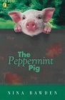 | 9+ | Johnnie was only the runt of the litter, a little peppermint pig. He'd cost Mother a shilling, but somehow his great naughtiness and cleverness kept Poll and Theo cheerful, even though it was one of the most difficult years of their lives.
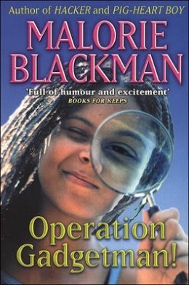 | 8+ | Beans's Dad is a bit of an eccentric. When he's not embarrassing her in front of her friends with his strange behaviour, he's in his workshop inventing ridiculous things like exploding shortbread (and irritating the neighbours while he's about it). But one day, Beans comes home from school to find that he has been kidnapped! She and her friends set out to find him using only their wits and the extraordinary 'Gadgetman Spy Kits' he has given them, and in the process uncover a sinister criminal conspiracy…  Beans is a likeable lead, and despite the unlikely series of events that the story relates, her relationships with her friends and family are warmly and believably portrayed. A lively (if not madcap) adventure that will find fans amongst younger readers.
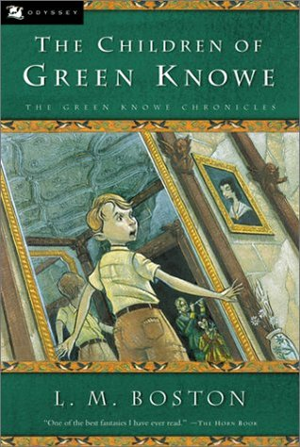 | 8+ | "Tolly" Toseland 7 is rowed up to great-gran Linnet Oldknow by servant Boggis - there has always been a Boggis at Green Knowe. The real "castle" is over 900 years old. Gran tells old family stories, and songs. Over the generations there have been many who can see, hear, and feel the ghosts, evoked by white-on-black illustrations. Toby 14, Alexander, and Linnet 6 linger after the Plague, as does the cursed topiary Green Noah.
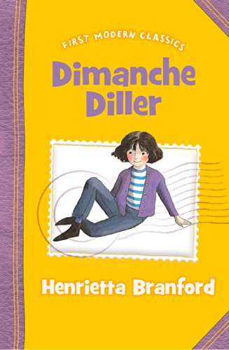 | 8+ | When Dimanche is orphaned at the tender age of one, Chief Inspector Barry Bullpit advertises for any known relative to come forward. Unluckily for Dimanche, her real aunt does not see the message, but an evil money-grabbing imposter does. Dimanche, heir to an enormous fortune, is sent to live with the dreaded Valburga Vilemile, who tries to rid herself of Dimanche at every opportunity. But her lack of success is partly due to Dimanche's wits and courage, and partly to Polly Pugh, Dimanche's young and pretty nanny, who foils all Valpurga's attempts and helps Dimanche find long-term happiness with her real aunt.  All the ingredients for a brilliant, attention-grabbing shorter novel are here; evil plots, kidnapping, wicked villains and gorgous heroines. Every chapter makes you want to shout 'Look behind you' or 'Oh no she doesn't' at almost every page turn.
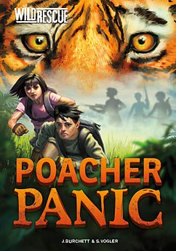 | 8+ | Twins Ben and Zoe travel the world on secret missions for their uncle's elite environmental organization, WILD. In these exciting, informative books, the two teens travel all over the world to save animals in danger and protect the environment. No matter how dangerous the mission, no matter what's at stake, Ben and Zoe will do whatever it takes to rescue at-risk animals.
C
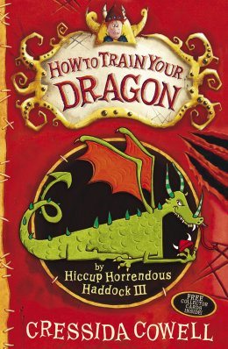 | 9+ | Hiccup Horrendous Haddock III was an incredible sword-fighter, dragon-whisperer and the greatest Viking hero who ever lived. But he wasn't always like that - in fact, in the beginning, Hiccup wasn't fierce, brave or heroic at all. But the arrival of the Seadragonus Giganticus Maximus offers the chance for Hiccup to shine. The ferocious bravado of the other Vikings proves useless, and Hiccup is called upon to save them by using his brains rather than his brawn.Can he defeat the dragon and save the Viking tribe from certain death?  This award-winning story of Vikings and dragons, with its striking black-and-white-illustrations, is enormous fun. Young readers will love Cressida Cowell's sharp wit and humour, and will be keen to follow Hiccup's adventures through the rest of the books in this hugely popular series.
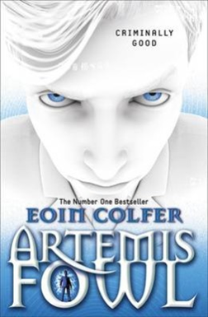 | 9+ | Twelve-year-old criminal mastermind, Artemis Fowl, hatches an ingenious plot to steal all the gold in fairy land. Although a little dubious about the plan - indeed not even quite believing in the existence of fairies - his trusty bodyguard and companion, Butler, is on hand to help. However, they have not reckoned on Captain Holly Short, who as first female officer in the Lower Elements Police Reconnaissance unit, or LEPrecon, has much to prove. When she is kidnapped by Artemis, she is determined to stand her ground and protect the fairy secrets.  This hilarious and exciting adventure story is a deserving favourite with young readers. The unscrupulous Artemis Fowl is such a likable character that you will almost will him to succeed in his dastardly schemes - whilst also rooting for the bold Captain Holly. Colfer's explanations of the structure and technology of his spin on fairy land are absolutely believable, creating an amusing and highly imaginative vision of fairies, dwarves and trolls that is just right for 21st century readers.
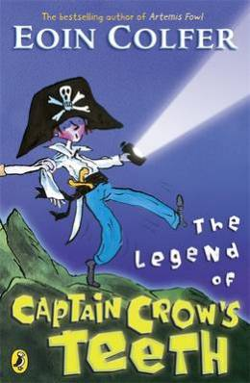 | 6+ | Five brothers are spending the summer holidays in a cramped caravan in Ireland with their parents. They are mischievous little monkeys who are a trial to their parents.  Marty, the eldest, reads his brothers spooky stories, and his favourite is about Captain Crow, a cut-throat pirate who is out to get his revenge on any available nine year old boy. This summer, Will who is nine years old, is to be the butt of Marty's most elaborate prank so far.  With characters last seen in Colfer's The Legend of Spud Murphy, this is another light-hearted adventure for younger readers, in which the issue of sibling rivalry is deftly and humorously handled.
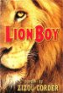 | 8+ | What do you do when you come home one day and discover that your parents have been kidnapped? Well, if you're a brave young guy named Charlie Ashanti, you go off in search of them. And since you happen to know how to speak Cat, your feline friends—the stray cats of the city and the caged lions on a magnificent, astounding floating circus—rally around you, bringing help, advice, and occasional special deliveries. Little do you know that in this search of yours, the fate of the world is at stake.  From an exciting new mother/daughter writing team comes this captivating adventure full of heroes, villains, and astounding events. Set in a near future that blends the familiar and the new in unexpected, intriguing ways, Lionboy is an exhilarating, suspenseful whirlwind of a novel—a book destined to become a classic.
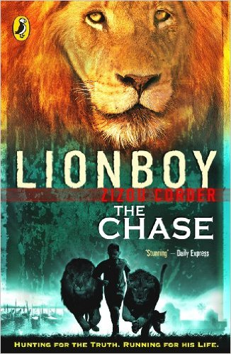 | 8+ | Charlie and his lion friends have made it safely to Venice, but it turns out that their journey has only just begun. King Boris's palace was meant to be a haven, but it's starting to feel more like a prison. When word arrives from the cat grapevine that his parents are not being held in Italy after all, Charlie knows he must take fast action. Luckily a new ally has come on the scene - and just in the knick of time: Rafi is in hot pursuit.
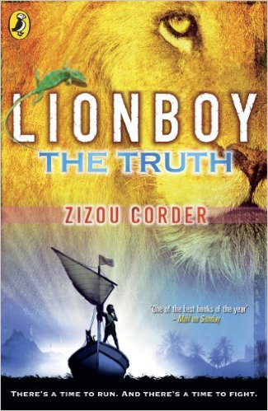 | 8+ | The second volume in the Lionboy series ended with Charlie Ashanti, the Catspeaker, finally reunited with his parents. The evil lion trainer Maccomo has gotten his comeuppance, and only troublemaking Rafi Sadler left to worry about. Everything is great, right?  Not for long, as Charlie is soon kidnapped, and he and his parents become involved in a high-speed Atlantic Ocean pursuit. Charlie's beloved lions get in on the act, and Charlie finally has his chance to confront the powerfully evil Corporacy --- but not before he must make some tough choices.  There are plenty of surprises along the way, including more discoveries about Charlie's family, some of them not entirely welcome. Charlie also learns more about his past, and even has an emotional --- and surprising --- reunion with the leopard responsible for his ability to speak the language of cats.
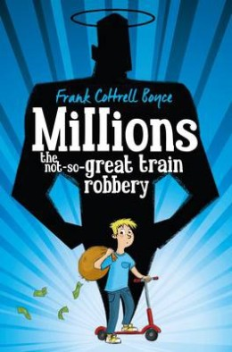 | 9+ | Since the death of his mother, Damian has become obsessed by saints. In order to escape the trappings of the material world, he builds a hermitage out of cardboard boxes near the railway line.  One night, a bag containing £229,370 falls from the sky and flattens the hermitage. Damian is convinced it is a gift from God, and contemplates with his older brother Anthony the best way to spend it. But with only 17 days left before the national currency switches to Euros and the money becomes worthless, this proves to be much more difficult than they had anticipated...  Funny, thought-provoking and thoroughly entertaining, this outstanding novel was a deserving winner of the 2004 CILIP Carnegie Medal
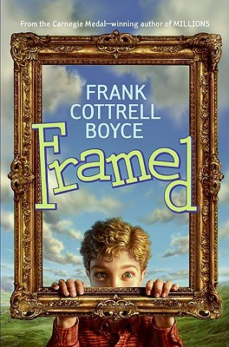 | 9+ | A few things to know about Dylan  He is the only boy in his entire town—so forget about playing soccer.  His best friends are two pet chickens.  His family owns the world's only gas station/coffee house—their pies are to die for, but profits are in the hole.  Criminal instincts run in his family—his sister is a mastermind-in-training, and the tax men are after his father for questioning.  And one more small thing about nine-year-old Dylan—the crime of the century has just fallen into his lap.
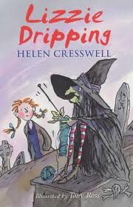 | 8+ | No-one in the village believes that Lizzie's seen a witch! But Lizzie doesn't care because she knows that in all Little Hemlock there's no one half as interesting as this witch - and besides it makes life far more exciting to have such an unusual friend.
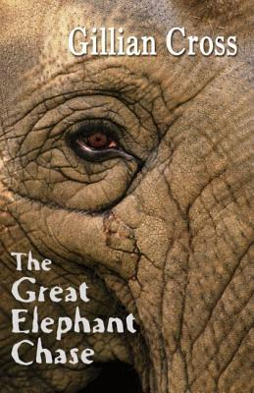 | 9+ | When the elephant came to town, Tad and Cissie went to the show like everyone else. Little did they know it would change their lives for ever. Because of the elephant, they get involved in a chase across America, by train, by flatboat, and steam boat. This book is the winner of the Whitbread Children's Novel Award and the Smarties Prize.
D
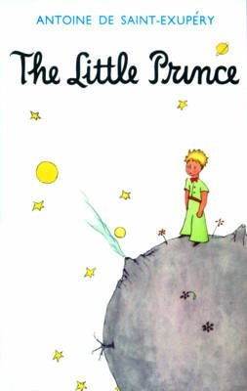 | 8+ | An air pilot makes a forced landing deep in the Sahara Desert. There, he makes a mysterious Little Prince, who tells him a series of wise and enchanting stories.  This simple, beautiful fable has captured the imaginations of both adults and children ever since it was first published in the 1940s. Now considered a contemporary classic, it is a book to share and to treasure.
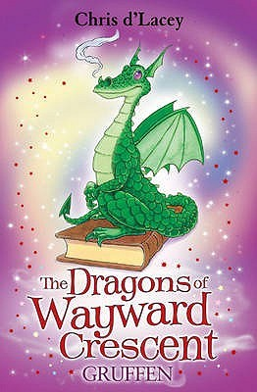 | 7+ | When Lucy suspects there's a 'monster' in her bedroom, her mum knows exactly what to do. Liz makes a guard dragon, Gruffen, to look after her....
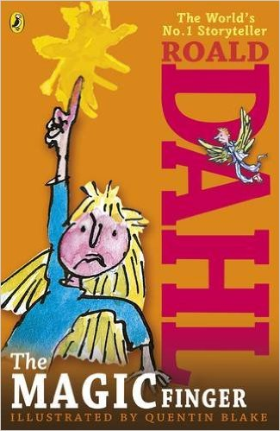 | 6+ | When the girl in this story gets cross, strange things start happening. Above all, she can't bear it when people are cruel to animals. So when her neighbours the Greggs go shooting, her magic finger teaches them a lesson they'll never forget...
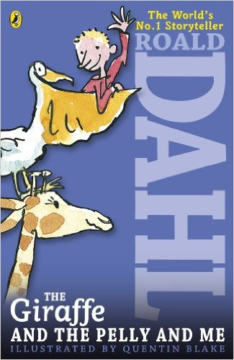 | 7+ | The Ladderless Window-Cleaning Company has just moved in to the old wooden house not far from where Billy lives. He'd rather have a wonderful sweet-shop, but when he meets the members of the Company - the Giraffe, the Pelican and the Monkey - he can't believe his eyes.
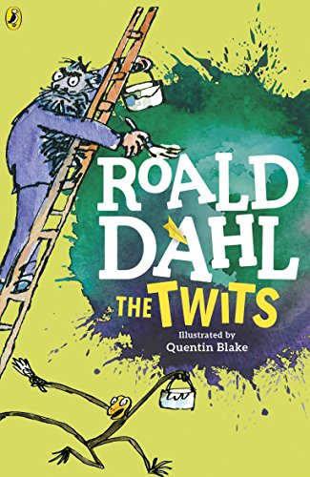 | 6+ | Mr Twit is a foul and smelly man with bits of cornflake and sardine in his beard.  Mrs Twit is a horrible old hag with a glass eye.  Together they make the nastiest couple you could ever hope not to meet.  Down in their garden, the Twits keep Muggle-Wump the monkey and his family locked in a cage. But not for much longer, because the monkeys are planning to trick the terrible Twits, once and for all . . .
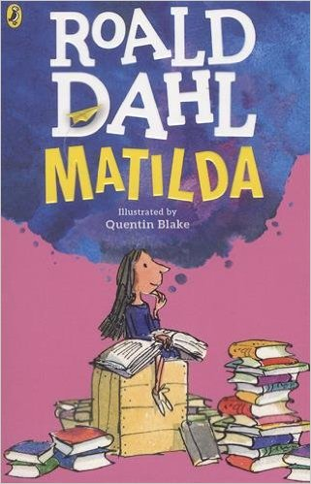 | 8+ | Matilda is not yet five years old, and already she is a very unusual child. Teaching herself to read, she works her way through all the books in the children's library and then gets started on the adult section, to the amazement of the librarian. Her narrow minded parents don't notice that they have a genius in their midst - but is soon becomes clear that underestimating Matilda is a big mistake.  When she starts school at Crunchem Hall, Matilda meets the frightening and bullying headmistress, Agatha Trunchbull, and witnesses her terrible temper. Soon, she puts her very special talents to work to get the better of Miss Trunchbull and the other unpleasant grown-ups around her - as well as to help warm-hearted class teacher Miss Honey.  This modern fairy-tale with a brilliantly inspiring young heroine is one of Roald Dahl's best loved stories. Full of magic and mischief, children will love witnessing Matilda pit her strength, courage and cool intelligence against the nasty and spiteful adults in her life, and ultimately coming out on top.
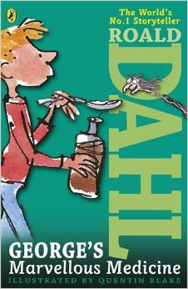 | 6+ | George's nasty old grandma needs teaching a lesson. George decides the best remedy for her grumpiness is a special home-made medicine. But Grandma gets more than she bargained for!  In George's Marvellous Medicine, published in 1981, George Kranky's Grandma may not anticipate the results of the medicine fed to her by her grandson, but like George, Roald Dahl also had fun mixing marvellous concoctions. He called them witches potions and delivered them to his children just before bedtime. They included ingredients like tinned peaches blended with milk and either pink, blue or green food colouring. His were put together carefully, though - none of the nasty side effects George's Grandma experienced..
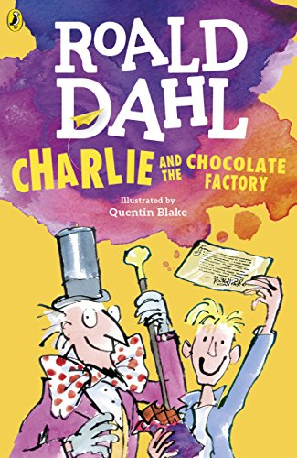 | 7+ | The famous story of Charlie Bucket and his Golden Ticket, and Willy Wonka and his amazing chocolate factory. Mr Willy Wonka, the most wondrous inventor in the world, opens his gates of his amazing chocolate factory to five lucky children.Gobstoppers, wriggle sweets and a river of melted chocolate delight await - Charlie needs just one Golden Ticket and these delicious treats could all be his!
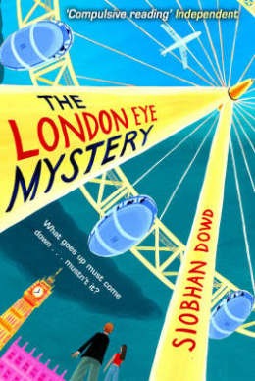 | 9+ | Ted likes the weather, he also likes statistics and routine but his life is thrown into disarray when his Aunt Gloria and cousin Salim arrive, like a hurricane, to stay in London en-route to a new life in New York.  Ted and his older sister Kat arrange to take Salim on the London Eye but although they watch him go up in a pod, he never comes down again. Salim is missing. Ted's analytical mind becomes an asset as he and Kat piece together the information surrounding their cousin's disappearance and begin to unravel the mystery.  Ted is an endearing character and the focus of the story is on the solving of a mystery rather than his Asperger's syndrome. This is a beautifully written and engaging book.
E
F
 | 8+ | First published in 1941, Walter Farley’s best-selling novel for young readers is the triumphant tale of a boy and a wild horse. From Alec Ramsay and the Black’s first meeting on an ill-fated ship to their adventures on a desert island and their eventual rescue, this beloved story will hold the rapt attention of readers new and old.
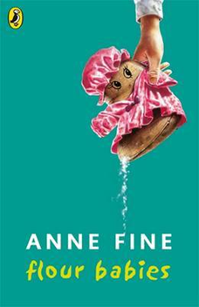 | 9+ | As part of a Child Development project, each boy in Class 4C is given a 'flour baby', a sack of flour which must be looked after for three weeks, ensuring it does not get lost or dirty. Simon becomes unusually attached to his flour baby - and soon begins to appreciate some of the sacrifices his mother has made for him as a single parent.  This funny story from former Children's Laureate Anne Fine is an established favourite of classrooms and homes everywhere. Thought-provoking and unusual, it cleverly balances episodes of laugh-out-loud humour with some very touching moments.
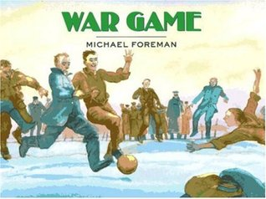 | 9+ | In 1914, four British boys dream of competing for the national soccer team, but join the English infantry instead. On Christmas day, after months of fighting, war becomes a game when German and British soldiers break all the rules to play soccer and exchange presents..
G
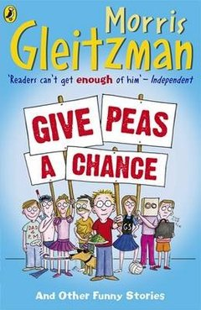 | 9+ | Fifteen funny stories, at times comic, wry, whimsical, moving, off-the-wall and downright hilarious, make up this brilliant book.  Meet Macques, whose parents want to make him unique by spelling his name strangely; and Mark, who takes his cricket-mad Grandad's ashes to a Test Match but the wind is blowing the wrong way; not to mention Nat and friends, who shave their heads to cheer up their hospitalised friend as the bandages come off her fire-damaged face.  Each punchy story induces laughter, yet also tackles a serious issue - from global warming and terrorism to parental honesty and the holiday plans of a nose germ. As well as making readers chuckle, these stories also make them think.
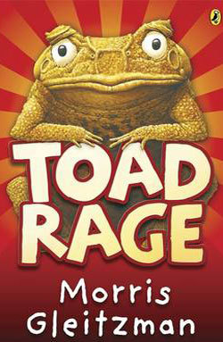 | 8+ | Limpy, the cane toad, deeply disturbed that motorists appear to swerve their cars specifically to run toads over, is determined to put a stop to this needless loss of life. He sets out on a perilous journey to try to persuade humans that cane toads are loveable, friendly creatures. He decides to endear himself to the public by becoming a mascot for the Australian Games, so travels south to begin negotiations with the Games organisers. However, the way is fraught with danger, and he often has to limp hurriedly away from the clutches of angry security guards and salivating dogs!  This hilarious and original story is superbly written.
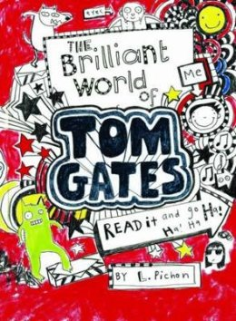 | 9+ | The hilarious homework diary of Tom Gates charts his progress through the trials and tribulations of school and home life, including a disastrous camping trip, his vexed relationship with nosey teacher Mr Fullerman and that perennial domestic trial - parents’ evening. Luckilly Tom’s appetite for humour means he can take such trials in his stride and mine them for comic potential. They also inspire some brilliant cartoons for the reader enjoy.  Tom scribbles the world from his point of view, each page is an explosion of hand-written rants, funny stories and dynamic cartoons. 'All I want to do is get tickets to see the best band ever, DUDE3, when they come to town. It’s not easy when I’m up against Delia, my weirdo big sister, and all my plans seem to get me into MAJOR TROUBLE…' This book oozes personality and with so much going on it promises to maintain the attention of young readers for hours at a time.
H
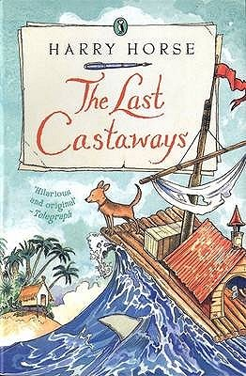 | 9+ | On holiday in Saltbottle, Grandfather and Roo discover the Unsinkable, the boat which took them to the North Pole in the first book, lying in a sadly dilapidated state and up for sale. At the auction, the short-sighted auctioneer accidentally sellsthe boat to Roo - sold to the old lady in the brown fur coat! Now they have to find the money and the Captain suggests a fishing trip to the Great Cod Banks in the Forgotten Sea. Off they go, but the trip ends in disaster when the boat sinks and Grandfather and Roo are cast away on a desert island. They find their own Man Friday (called Tuesday) but he turns out to be a film director staying in a luxury hotel. Meanwhile, the Captain has found the treasure and rescued the Unsinkable.
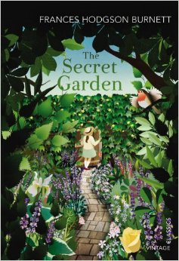 | 9+ | When the spoilt and bad-tempered Mary is orphaned at the age of ten, she is sent from India to live with her hunchback uncle on the Yorkshire Moors. At first, she is utterly miserable, but gradually the frienship of her maid and the discovery of a secret garden in the grounds of the house begin to change her.  Then she finds another secret in the house - Colin, her sickly cousin, who is as self-centred and disagreeable as herself. This classic novel is a satisfying and absorbing read, and demonstrates the resilience of children even when they are surrounded by uncaring and flawed adults.
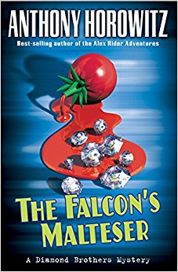 | 9+ | When the vertically-challenged Johnny Naples entrusts Tim Diamond with a package worth over three million pounds, he’s making a big mistake. Tim Diamond is the worst detective in the world. Next day, Johnny’s dead, Tim feels the heat, and his smart younger brother, Nick, gets the package—and every crook in town on his back!
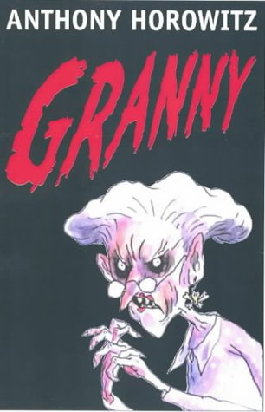 | 9+ | Twelve-year-old Joe Warden isn’t happy. Sure, he’s rich, but his parents don’t care about him. His grandmother should make everything better, except that Joe’s granny is a nightmare. She’s not just physically repulsive, she’s horribly mean. Everyone thinks she’s just a dotty old woman, but Joe knows the truth. He’s seen behind her mask and glimpsed the wicked glimmer in her eyes—she is pure evil. And now she’s out to get Joe, unless he can stop her and her band of nasty grannies first.
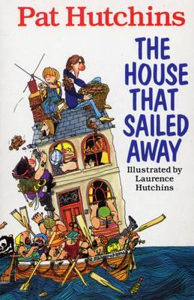 | 8+ | Poor old Grandma! It had rained every day since she came to stay with Mother, Father, Morgan, the baby and Tailcat. But just as everyone was getting really fed up of being stuck indoors, the most amazing thing happened! Suddenly the house started to shudder and rock - and then just floated off down the street and off to sea. Before long, the family find themselves on the wackiest adventure ever! Hungry cannibals, blood-thirsty pirates, a kidnapping and buried treasure are just some of the hair-raisers in store. Will the family ever see dry land again or will evil One-Eyed Jake cut them into a million tiny pieces?
I
J
K
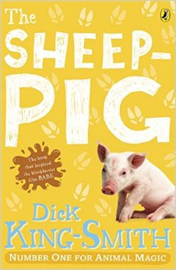 | 7+ | When Farmer Hogget wins a piglet at the fair, he is amazed that Fly, his sheep-dog, welcomes him as one of her own pups. Fly names the piglet Babe and teaches him all he needs to know about the farm and its animals.  As he watches his 'mum' round up the sheep, he decides he would love to try too. However, his legs are too short and he is far too plump to run around after a flock of sheep. He then tries a different tactic; politely asking the sheep to form an orderly line! The sheep are so surprised to be treated with respect that they happily oblige and Farmer Hogget soon notices that Babe has a certain knack with them...  One of Dick King-Smith's best-loved tales, this wonderful book is full of gentle humour. The short chapters make it ideal for early confident readers, and it will be especially adored by young animal lovers.
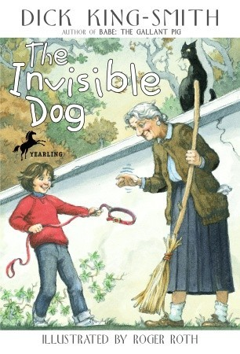 | 7+ | Illustrated in black-and-white. When her parents can't afford a new pet, seven-year-old Janie invents one. Her new pretend dog is Henry, an invisible Great Dane who eats invisible food bought with invisible money. Then some mysterious events--and perhaps a touch of magic--bring the invisible Henry to life.
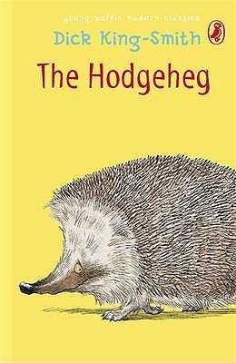 | 7+ | Max's family dreams of reaching the Park. But no one has ever found a safe way of crossing the very busy road. Young Max, who is brighter than the average hedgehog, is determined to solve the problem.
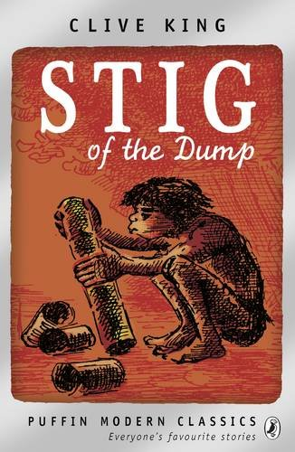 | 8+ | Barney is a solitary little boy who often wanders off by himself in the countryside. Exploring an old chalk pit, he finds himself in a cave where he meets a strange boy who wears a rabbit skin and speaks in grunts. His grandparents don't believe Barney when he tells them about his new cave boy friend - but nevertheless, the two enjoy plenty of fun together.  This lovely story about the unlikely friendship between Barney and stone-age Stig has stood the test of time. Although it is now over 50 years old, contemporary children will love reading about the pair's lively adventures. Clive Kings' story is perfectly accompanied by Edward Ardizzone's classic illustrations.
L
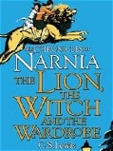 | 8+ | When the Pevensie children - Peter, Susan, Edmund and Lucy - step through a wardrobe door in the strange country house where they are staying, they find themselves in the land of Narnia. Frozen in eternal winter, Narnia is a land of snow and pine forests, and its creatures are enslaved by the terrible White Witch.  Tempted by the promise of endless Turkish Delight, Edmund becomes the White Witch's servant - and its up to his brother and sisters to release him from his enchantment and to rid Narnia of the witch. But just when it seems that all hope is lost, the Great Lion Aslan returns to help the children to save Narnia.  This classic story is certain to capture young imaginations, cleverly blending elements of fairy-tale and fantasy to create a wonderfully engaging adventure. Adult readers will be quick to spot the Christian symbolism woven through C S Lewis's story, which some critics have found problematic - but children will enjoy the magic of this spellbinding adventure in its own right.
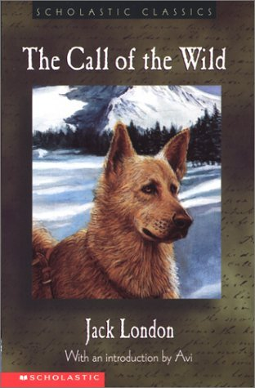 | 9+ | Follow a dog named Buck through violence and hardship, loyalty and loss, finally finding himself and his home in the Yukon wilderness. Truly a must-have for London fans, book lovers, and adventurers.
M
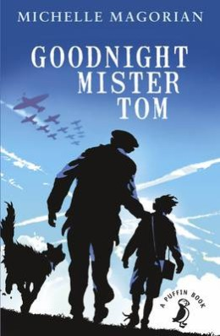 | 9+ | Willie Beech is evacuated to a tiny English village in the country just before the outbreak of World War II. A lonely and deprived child, he finds himself living with the reclusive, gruff old widower, Thomas Oakley. Although the two find it hard to adjust to their life together at first, they gradually develop a strong, mutual bond. Willie begins to enjoy life and make new friends in the village.  However, everything is thrown into confusion when Willie is suddenly recalled to London by his neglectful and abusive mother. After several weeks with no letter from Willie, Tom Oakley becomes concerned for his welfare and sets out to London in search of him.  Michelle Magorian's classic wartime story is a superbly written and deeply moving tale, which shows that even the most unlikely people can become exceptional parents.
 | 9+ | Set during World War I, Private Peaceful charts eight hours in the life of Tommo, a young soldier at the Front, as he looks back over the formative events of his life: his father’s early death, his relationship with his loving mother and brothers, Big Joe and Charlie, and their beloved schoolfriend Molly – all set among an evocative and beautifully realised rural landscape.  Passionate, beguiling and moving, this award-winning story is also an unflinching examination of the horrors of war and the injustice surrounding the execution of soldiers by firing squad, on the – often false – grounds of desertion or cowardice. Former Children's Laureate Michael Morpurgo uses all his superb storytelling skills to weave this powerful, poignant tale of the horrors of World War I, which will touch readers of all ages.
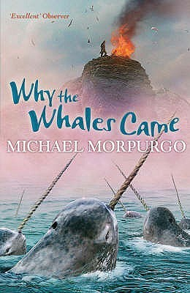 | 9+ | The Birdman puts spells on people. We mustn’t talk to him. We’re not supposed to.  Gracie and Daniel have been warned to stay away from the mad Birdman - but the message in the sand tells them that the Birdman isn't what he seems.  Then they get lost in the fog and stranded on Samson Island. Should they believe the Birdman's story that the island is cursed?
 | 9+ | Life on the Scilly Isles in 1907 is bleak and full of hardship. Laura's twin brother, Billy, disappears and then a storm devastates everything. It seems there is little hope... that is until the sailing ship the Zanzibar is wrecked on the island’s rocks and everything changes...
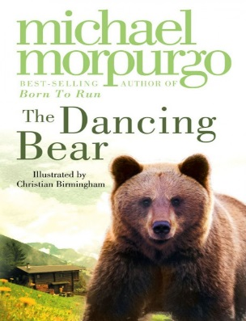 | 7+ | High in the mountains, in a tiny village, an abandoned bear cub is adopted by a lonely orphan child. Soon they are the best of friends, beloved by the whole village – safe, until the arrival of a glamorous film crew who need a dancing bear…
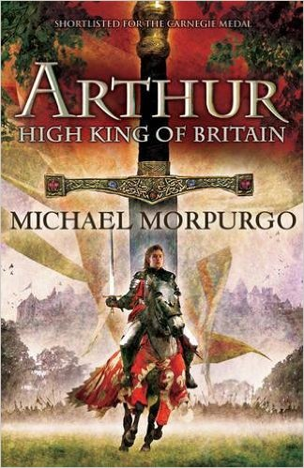 | 9+ | Marooned on a sandbank, the boy faces certain death. With the sea closing in and the current about to drag him to a watery grave, his final wish is to see heaven. But, waking in a strange bed, the boy meets an old man sitting by the fire with his dog. It is Arthur, the great warrior king of legend, who tells the boy of Camelot, magic, evil and betrayal.
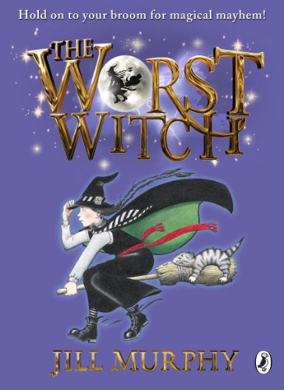 | 7+ | Hold on to your broomstick for magical mayhem! Jill Murphy's much-loved classic The Worst Witch is the original story of life at a magical boarding school, perfect for readers aged 5 - 9 years.  Mildred Hubble is a trainee at Miss Cackle's Academy for Witches, but she's making an awful mess of it. She keeps getting her spells wrong and crashing her broomstick. And when she turns Ethel, the teacher's pet into her worst enemy, chaos ensues...
N
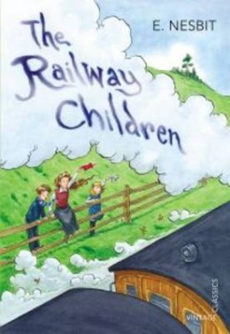 | 9+ | This story centres on the lives of three children whose comfortable, middle-class existence ends when their father has to go away unexpectedly.  Roberta, Peter and Phyllis leave their London home and move with their mother to a small cottage in the country where life is very different. With their mother now busy writing to earn money, the railway becomes a source of fascination and solace to the children.  They make friends with Perks the Porter and the station master, and discover new and exciting things about the trains. However, mystery remains - where is their father? Then the terrible truth is discovered.  This charming story deals sensitively with the subject of an absent parent, and the challenges of living in changing circumstances.
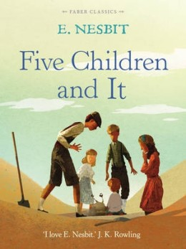 | 9+ | When five siblings - Cyril, Anthea, Robert, Jane and their baby brother, the Lamb - discover a sand-fairy in their gravel pit, they are jolly surprised and a little delighted. Even better, the Psammead is able to grant them wishes, although the magic wears off at the day's end. Unfortunately, all of the wishes the children make go hilariously wrong and they soon learn that their foolish desires are more likely to get them into trouble than get them what they want!
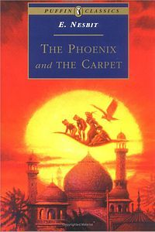 | 9+ | The Phoenix and the Carpet is a fantasy novel for children, written by E. Nesbit and first published in 1904. It is the second in a trilogy of novels that begins with Five Children and It (1902), and follows the adventures of the same five children: Cyril, Anthea, Robert, Jane and the Lamb. Their mother buys the children a new carpet to replace one from the nursery that they have destroyed in an accidental fire. The children find an egg in the carpet, which hatches into a talking Phoenix. The Phoenix explains that the carpet is a magic one that will grant them three wishes a day. The five children go on many adventures, which eventually wears out their magic carpet.
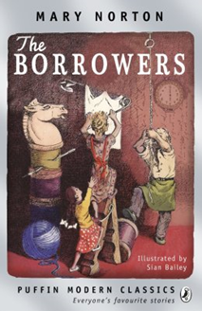 | 9+ | The Borrowers are tiny people who live in the secret places of old houses - behind the mantlepiece, inside the harpsichord, under the kitchen clock. They borrow everything from humans, existing on the scraps they collect from the homes they live in.  Arriety Clock's father, Pod, is an expert borrower, able to scale curtains using a hatpin, and bring back a doll's teacup without breaking it. Girls aren't usually supposed to go borrowing, but Pod makes an exception for Arrietty, who can't wait to explore the house and gardens that lie beyond her cramped home. But when she is at last allowed to accompany Pod on one of his borrowing expeditions, something terrible happens - she is 'seen' by a human boy.  This beautifully-written story will enchant young readers, who will love the idea of the Borrower's hidden 'wainscot world'. Exciting, mysterious and with a hint of sadness, it has a deserving reputation as a classic of twentieth century children's literature.
O
P
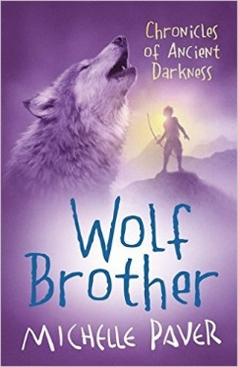 | 9+ | Thousands of years ago, the land is a dark forest, peopled by hunter-gatherers who know every tree and herb. Then a dark, malevolent force conjures a demon contained in the body of a ferocious bear that will slay everything it sees - a demon determined to destroy the world.  Twelve-year-old Torak sees his father murdered by the bear. With his dying breath, Torak's father tells his son that he is the only one who can stop it - he must lead the bear to the mountain of the World Spirit, and beg the spirit's help to overcome it. But Torak does not want to be a hero - frightened and alone, he must set out on a terrifying quest which will see him tricked and betrayed and every turn. Thankfully he has the company of a young wolf cub, whom he seems to understand better than any human.
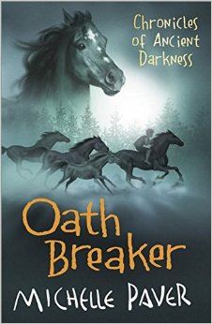 | 9+ | When he was outcast, Torak was the hunted one.  The following spring, he becomes the hunter when he swears to avenge the killing of one of his closest friends. To fulfil his oath he must brave the hidden valleys of the Deep Forest, where the clans have reverted to the savagery of an earlier time. Here, Torak finally learns why he is the Spirit Walker – and discovers the true cost of revenge…
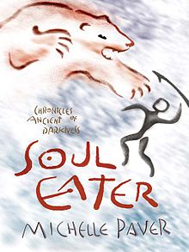 | 9+ | Thousands of years ago an orphan boy and his wolf cub companion challenge a demon bear that threatens to destroy their world forever. With the help of the World Spirit, Torak destroys the bear, but his beloved Wolf is lost in the ensuing avalanche.  And Torak's quest is far from over. A strange, creeping sickness, silent and deadly, is threatening the Ravens, whose leader Finn Kedinn has told Torak something of his history. Word arrives that the Seal Clan have the cure and Torak must face a lonely journey across treacherous terrain alive with menace and danger to find it. He must search for the rare herb which is part of the cure and find it by Midsummer. On the Seal's Island he stumbles into a world utterly unlike his own. And here Torak is welcomed by the kindly Seal Mage, Teneris, and kinsman, Bale. But all is not as it seems, Torak must keep his wits about him to judge who might be friend or foe, to face the dark art of the Soul Eaters, who haunt him even in his dreams, and to master his fears.
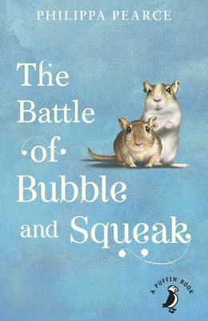 | 8+ | Sid, Peggy and Amy adore the two gerbils, Bubble and Squeak, but their mother detests them. A major family battle results, and it's clear life is never going to be quite the same again. But after a near fatal encounter between Bubble and Ginger the cat, Mrs Sparrow begins to see that life with a pair of gerbils might not be so bad after all.
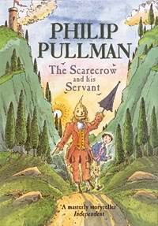 | 8+ | Struck by a sudden bolt of lightining, Scarecrow comes alive. A young boy called Jack hears the Scarecrow's call for help and, overcoming his initial shock, is persuaded to become his servant. The latest in a long line of literary masters and servants, Jack and Scarecrow are strongly reminiscent of Don Quixote and his servant Sancho Panza in Cervantes' timeless classic, as they too set off on a series of madcap adventures - some funny, others dangerous and exciting - often saved only by Jack's endless resourcefulness.  Set in Italy, this fairytale adventure is perfectly complemented by Peter Bailey’s atmospheric illustrations, which give life and shape to the characters and touchingly depict the story's climax.
 | 7+ | A fantasy adventure story of a determined girl called Lila who with the help of her friend, Chulak, and elephant, Hamlet, proves to her father that she is far more capable than he ever expected!
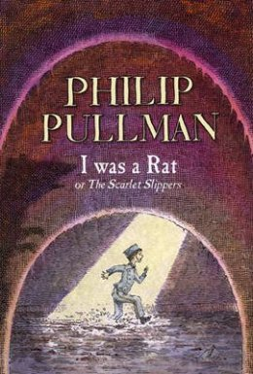 | 8+ | A small boy arrives on the doorstep of a childless couple, politely but insistently asserting that he used to be a rat.  The hapless Roger is first taken from his new home for a ‘philosophical investigation’, then exploited as a fairground exhibit and finally hunted as an alleged threat to society, until the remarkable truth finally emerges.  This is a magical, humorous and well-paced example of storytelling at its best.
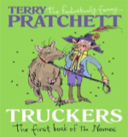 | 9+ | To the thousands of the tiny nomes who live under the floorboards of a large department store, there is no Outside. Things like Day and Night, Sun and Rain are just daft old legends. Then a devastating piece of news shatters their existence: the Store - their whole world - is to be demolished. And it's up to Maskin, one of the last nomes to come into the Store, to mastermind an unbelievable escape plan that will take all the nomes into the dangers of the great Outside...  The first title in the Bromeliad trilogy, this is a funny and enchanting fantasy from favourite author Terry Pratchett. Young readers will be captivated by the world of the nomes and eager to follow their adventures after they leave their underground home in the sequels Diggers and Wings.
Q
R
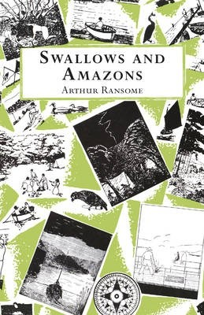 | 8+ | It's the summer holidays, and the Walker children - otherwise known as Captain John, Mate Susan, Able-Seaman Titty and Ship's Boy Roger - are excited to set sail on their boat Swallow and camp on Wild Cat Island. Exploring their new territory, camping in the open skies, swimming in the lake and fishing for their dinner would be adventure enough - but then they meet two fierce Amazon pirates who challenge them to a war.  Arthur Ransome's classic Swallows and Amazons stories begin with this first book, a delightful evocation of a wonderful summer of adventure, discovery and friendship. Inspired by the author's own real-life sailing adventures in the Lake District as a child, this enchanting story is accompanied by Ransome's simple but characterful black and white illustrations.
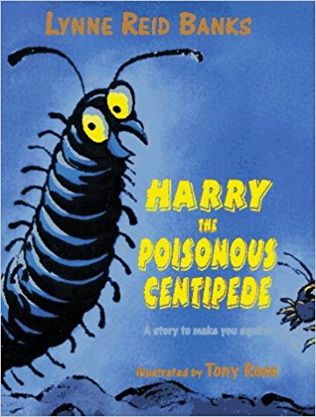 | 8+ | "It's a Hoo-Min! crackled George."  "Walking on its hairy biter feet!"  But now it was Harry who felt brave.  "Come on! Lets's peep at it."  Harry is a poisonous centipede but he's not very brave.Still, he is the star of this seriously squirmy story. Harry likes to eat things that wriggle and crackle, and things that are juicy and munchy! But there are some things that a centipede must never try to eat -- dangerous things like flying swoopers, belly wrigglers, mid the most dangerous of all ... Hoo-Mins!  Harry's mother makes him promise never to go up the Up-Pipe to the world of Hoo-Mins, but Harry's best friend, George, has other ideas! And as every young Hoo-Min knows, when your best friend wants to do something that sounds exciting, it's very hard to say no. So George and Harry poke their feelers out and smell the air....and that's when their adventures begin.  Lynne Reid Banks's storytelling sparkles in this tale of her new centipede hero and his creepy-crawly world. Fizzing with fun, it will be a delightfully squirmy experience for all young readers
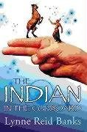 | 9+ | At first, Omri is unimpressed with the plastic Indian toy he is given for his birthday. But when he puts it in his old cupboard and turns the key, something extraordinary happens that will change Omri's life for ever.  For Little Bull, the Iroquois Indian brave, comes to life...
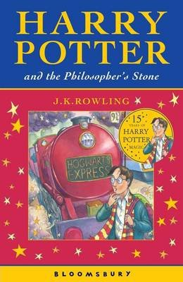 | 8+ | After the misery of life with his ghastly aunt and uncle, Harry Potter is delighted to have the chance to embark on an exciting new life at the Hogwart's School of Wizardry and Witchcraft. Learning about magic and making new friends, he has the chance to use his new-found wizarding skills to unravel some of the mysteries of his own past - and to uncover some shocking secrets about his teachers.  This brilliantly inventive, award-winning adventure story is the first in the phenomenally successful Harry Potter series. With shades of Diana Wynne Jones, Enid Blyton, Roald Dahl and Jill Murphy's The Worst Witch, this contemporary classic of children's literature is beloved by children and adults alike.
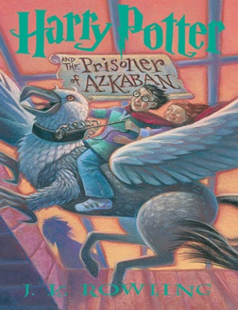 | 8+ | Harry Potter is lucky to reach the age of thirteen, since he has already survived the murderous attacks of the feared Dark Lord on more than one occasion. But his hopes for a quiet term concentrating on Quidditch are dashed when a maniacal mass-murderer escapes from Azkaban, pursued by the soul-sucking Dementors who guard the prison. It's assumed that Hogwarts is the safest place for Harry to be. But is it a coincidence that he can feel eyes watching him in the dark, and should he be taking Professor Trelawney's ghoulish predictions seriously?
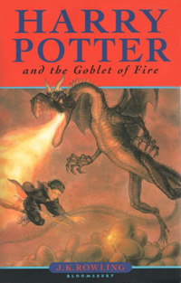 | 9+ | Harry Potter is midway through both his training as a wizard and his coming of age. Harry wants to get away from the pernicious Dursleys and go to the International Quidditch Cup with Hermione, Ron, and the Weasleys. He wants to dream about Cho Chang, his crush (and maybe do more than dream). He wants to find out about the mysterious event that supposed to take place at Hogwarts this year, an event involving two other rival schools of magic, and a competition that hasn't happened for hundreds of years. He wants to be a normal, fourteen-year-old wizard. But unfortunately for Harry Potter, he's not normal - even by wizarding standards.  And in his case, different can be deadly.
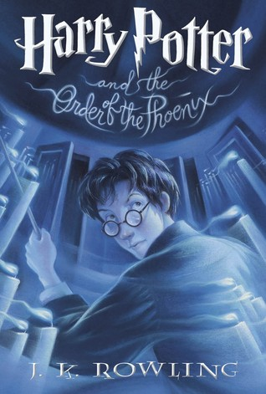 | 9+ | Harry Potter is due to start his fifth year at Hogwarts School of Witchcraft and Wizardry. His best friends Ron and Hermione have been very secretive all summer and he is desperate to get back to school and find out what has been going on. However, what Harry discovers is far more devastating than he could ever have expected...  Suspense, secrets and thrilling action from the pen of J.K. Rowling ensure an electrifying adventure that is impossible to put down.
 | 9+ | The war against Voldemort is not going well: even Muggle governments are noticing. Ron scans the obituary pages of The Daily Prophet looking for familiar names. Dumbledore is absent from Hogwarts for long stretches of time, and the Order of the Phoenix has already suffered losses. And yet... As in all wars, life goes on. Sixth-year students learn to Apparate, and lose a few eyebrows in the process. The Weasley twins expand their business. Teenagers flirt and fight and fall in love. Classes are never straightforward, though Harry receives some extraordinary help from the mysterious Half-Blood Prince. So it's the home front that takes center stage in the multilayered sixth installment of the story of Harry Potter. Harry struggles to uncover the identity of the Half-Blood Prince, the past owner of a potions textbook he now possesses that is filled with ingenious, potentially deadly, spells. But Harry's life is suddenly changed forever when someone close to him is heinously murdered right before his eyes. With Dumbledore's guidance, he seeks out the full, complex story of the boy who became Lord Voldemort, and thereby attempts to find what may be his only vulnerability.
S
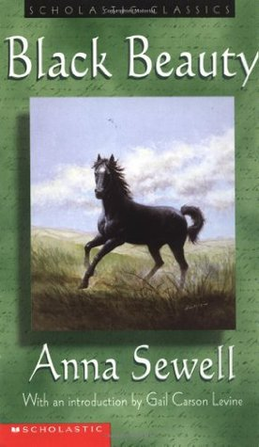 | 9+ | Black Beauty tells the story of the horse's own long and varied life, from a well-born colt in a pleasant meadow to an elegant carriage horse for a gentleman to a painfully overworked cab horse.  Throughout, Sewell rails - in a gentle, 19th-century way - against animal maltreatment. Young readers will follow Black Beauty's fortunes, good and bad, with gentle masters as well as cruel. Children can easily make the leap from horse-human relationships to human-human relationships, and begin to understand how their own consideration of others may be a benefit to all.
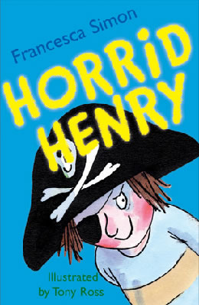 | 6+ | Stories about naughty characters have been told for centuries, and Horrid Henry is a modern-day rogue in the tradition of Dennis the Menace, Pippi Longstocking, Just William and My Naughty Little Sister.  The first in the hugely popular Horrid Henry series introduces us to Henry and his brother, Perfect Peter. The four stories it comprises are long enough to satisfy early readers, yet are short enough to be manageable, with plenty of laughs along the way. Tony Ross's mischievous illustrations are the perfect accompaniment - and children will have great fun comparing their own behaviour to Henry's, hopefully coming out on top!
T
U
V
W
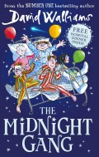 | 7+ | Poor Tom has been hit on the head by a cricket ball and wakes up in the Lord Funt Hospital with a big bandage on his head. In the children’s ward, though, he finds children with worse complaints: Amber’s got full leg and arm casts in a wheelchair; Robin has had an eye operation and can’t see; and poor Sally is too weak to get out of bed.  Worse, there’s a horrible kid-hating Matron watching over them and making sure they don’t have any fun at all – not that there is much fun to be had in hospital (or so you would think).  It transpires that the children are part of the Midnight Gang: an ages-old hospital tradition that makes dreams come true for sick children. But what will Tom’s wish be, and can the kindly hospital porter make it come true?  David Walliams’ tongue-in-cheek fun continues to amuse in this new adventure that also tugs at the heartstrings in just the right way. The Midnight Gang’s various ailments and conditions don’t affect them careering joyously around the hospital in the middle of the night, although Walliams still treats the characters and their conditions with dignity and respect where appropriate.
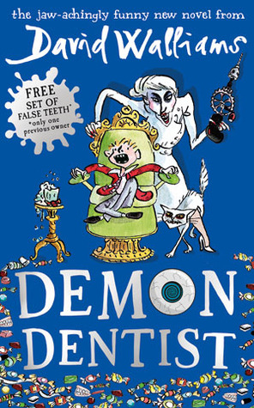 | 9+ | Strange things are happening in the dead of night. Children who put a tooth under the pillow for the tooth fairy wake to find... a dead slug; a live spider; or hundreds of earwigs creeping beneath their pillow. Evil is at work, but who is behind it? Could it be the Demon Dentist?  This delightfully dark offering from comedian-turned-bestselling author David Walliams is certain to entertain young readers. Tony Ross's illustrations work brilliantly with Walliams's text; there's plenty of fast-paced action; and the jokes are gleefully ghoulish (and often gross). The characters are well-drawn, in particular hero Alife, who is also a carer for his disabled dad, and the terrible villain really is truly demonic.  The dentist is a common phobia amongst children, and the more sensitive might find some of the more nightmarish scenes difficult to take, most notably when Alfie gets all his teeth removed without anaesthetic, his arms and legs held in place with metal cuffs. Yet whilst this book is unlikely to dispel any dentist fears, there's enough humour in the mix to prevent it becoming too terrifying for the majority of young readers.
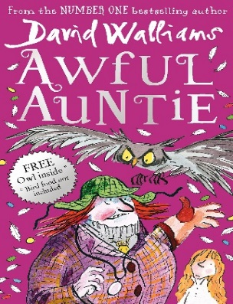 | 8+ | Aunt Alberta is the most awful aunt who ever lived. She is a pipe-smoking, monocle-wearing monster with steel toe-capped boots on her feet and a fearsome giant owl on her arm.  Little Stella Saxby is the only person standing between Aunt Alberta and ownership of Saxby Hall - which means Stella is in serious trouble. As Aunt Alberta and the owl develop ever-more-evil plots to get rid of her, Stella must use cunning tricks and a rather spooky secret weapon to foil their plans.  A conversational writing style and plentiful black-and-white illustrations draw readers into the story from the very first page. Awful Auntie is rude, witty, irreverent, just a bit scary and fantastic fun.
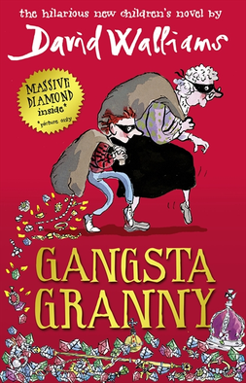 | 8+ | Ben is 11, an only child and a poor reader, whose ambition is to be a plumber. Every Friday he visits his Granny, while his parents go to watch ballroom dancing, and he hates those dull, smelly, cabbage-dominated evenings. Then he discovers that his Granny isn’t quite what she seems, and life takes a dramatic turn for the better.  Tony Ross's entertaining and funny illustrations are the ideal partner for David Walliams's outrageous, laugh-out-loud story. Walliams knows exactly what his readers want, and serves up humour filled with bums, farts and poo; but when Granny is taken into hospital the story takes a more serious turn, leaving readers to examine their own relationships with the elderly.
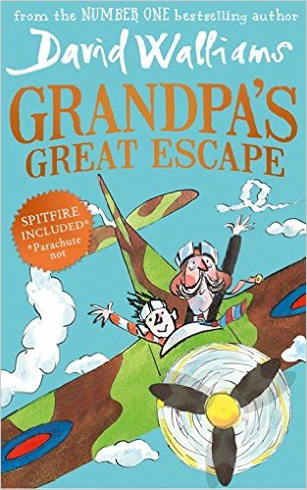 | 8+ | Grandpa is getting forgetful. But his memories of flying war planes are sharp as bayonets. Grandpa and Jack love watching World War II films, eating Spam a la Custard and visiting the Imperial War Museum. But when Grandpa goes missing and Jack finds him stowed away in the Museum's spitfire, Jack's parents decide it's time for him to move to Twilight Towers.  Sneaking in to visit Grandpa under cover, Jack spots the scary matron forging the residents' wills, discovers a room full of pills to keep them asleep and another piled high with ominous coffins, it's up to Jack to help Grandpa escape!  A daring, madcap, blockbusting adventure, full of humour, history, bravery, compassion and affection, from award-winning, best-selling David Walliams.
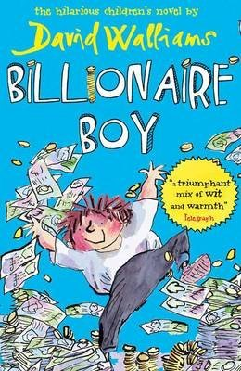 | 8+ | Having started from humble origins, Joe’s father is now a billionaire, and Joe has everything he wants, except true friends. To remedy this he enrols at the local comprehensive school, where he learns the hard way that you can’t buy them, and that family and friends are more important than any possessions.  Ross’s inimitable illustrations capture and extend Walliams’ style perfectly. Despite the book’s length, the large print would make it accessible for older but less keen readers, and the touches of satire could also attract that audience, as well as adults.
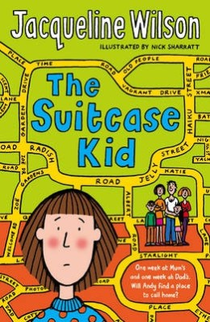 | 9+ | Distraught at her parents' divorce, Andy cannot decide who she wants to live with. She spends one week at Mum's house, the next at Dad's, but never really feels that she belongs anywhere.  This difficult situation, which is worsened by animosity between Andy and her new stepfamilies, has no simple solution. Approached with humour and understanding, this is a very readable tale of confusion, guilt and ultimately optimism, with which many children (and adults) will identify.
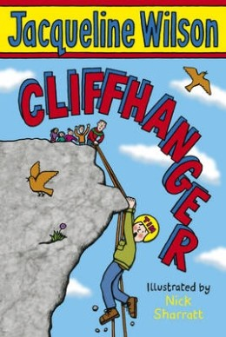 | 7+ | A salutary and funny tale about not giving up from Jacqueline Wilson. From climbing and abseiling to canoeing and a Crazy Bucket Race, the adventure holiday promises to be full of action. There's just one problem as far as Tim is concerned: he is hopeless at sports of any kind. Chapters are short and the writing is clear.
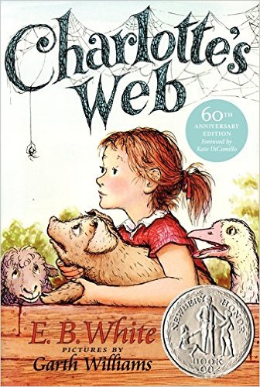 | 7+ | This is the tale of how a little girl named Fern - with the help of a friendly talking spider called Charlotte - saved her pig, Wilbur, from the usual fate of nice fat little pigs.  An unusual and witty story which provides a gentle introduction to questions of mortality, Charlotte's Web is a modern classic.

