Book Bingo Year 1 and 2 Book List
A
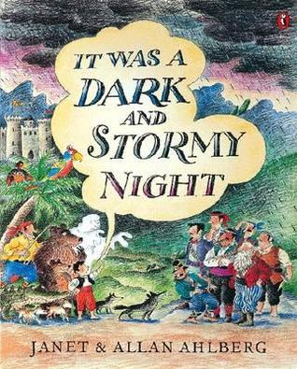 | 6+ | A small boy who has been kidnapped by brigands, passes the dark and stormy night in their cave weaving for them incredible stories of their own exploits. Through the stories he solves his own problem and manages to escape.
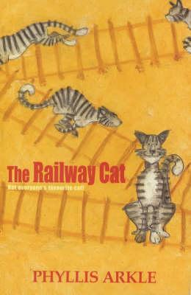 | 6+ | A collection of five adventures in the life of Alfie, the irrepressible railway cat. He gets snow-bound, he saves a life from an out-of-control train, he is kidnapped and taken to London, and he has his usual scrapes and run-ins with Hack, the leading railman at the station.
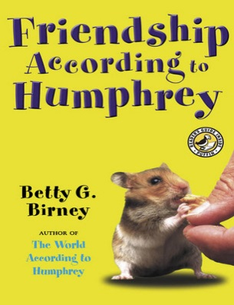 | 7+ | After the holidays, Humphrey is shocked by a big surprise in Room 26-a new class pet! Humphrey tries to be welcoming, but Og the frog doesn't respond to any of his friendly squeaks or visits (remember, he has a lock-that-doesn't-lock). Plus, the students are so interested in Og, they almost stop paying attention to Humphrey altogether. Humphrey doesn't like the mad-bad-sad feelings he's had since Og came, but luckily he still gets to have adventures with different kids on the weekends.  Friendship can be tricky, but Humphrey is an intrepid problem-solver. If any hamster can become buddies with a frog, he can.
B
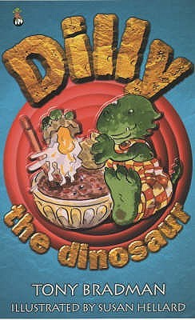 | 6+ | Introducing Dilly, the world's naughtiest dinosaur, by internationally acclaimed author, Tony Bradman. Reissued in a special 30th anniversary edition. In his first four stories, Dilly the Dinosaur gets up to all sorts of mischief. When he decides he doesn't want to wash any more, Dilly ends up becoming a very smelly dinosaur indeed! And when he's told he can't have his birthday every day he gets very grumpy. And you know what happens when Dilly gets grumpy... cover your ears, here comes the ultra-special, 150-mph SUPER SCREAM! Tony Bradman's dinosaur stories are the most fun books for early readers you're likely to come across.
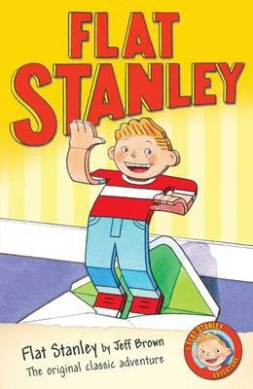 | 6+ | Stanley Lambchop wakes up one morning to find a notice-board has dropped on him in the night, leaving him happy and healthy, but only half an inch thick. It's a little unusual, but he finds he can fly like a kite, be sent on holiday through the post and can use his special skills to foil a burglary at the local art gallery. Still, he's glad when his brother Arthur has a bright idea to help bring him back to his normal shape.  This inventive story is full of wit and humour, and is sure to intrigue young readers. Originally published in 1964, Jeff Brown's ingenious tale has since become a well-established favourite both in the classroom and at home.
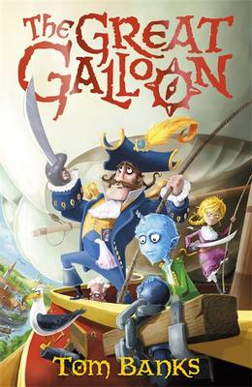 | 7+ | The Great Galloon is an enormous airship, built by Captain Meredith Anstruther and manned by his crew, who might seem like a bit of a motley bunch but who are able to fight off invading marauders whilst drinking tea and sweeping floors!  Captain Anstruther is preparing to marry the beautiful Lady Isabella, but disaster strikes when his evil younger brother comes aboard for the wedding and steals Isabella away onto his underwater Sumbaroon.  Stanley, a clever boy with a small horn, and Rasmussen, a reluctant countess-to-be, are busy waiting for an adventure to begin. Instead they have to fight off BeheMoths, avoid enormous Seagles, encounter the terrifying (but nice really) Brunt and save the Galloon from sinking. How will they ever find the Captain's bride when nothing's happening?
C
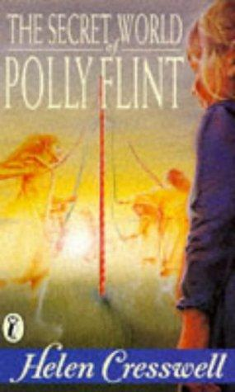 | 7+ | Polly Flint, a girl who sees things other people can't, finds herself involved with the "time gypsies" of Grimstone, inhabitants of a lost village who have become trapped in a time not their own.
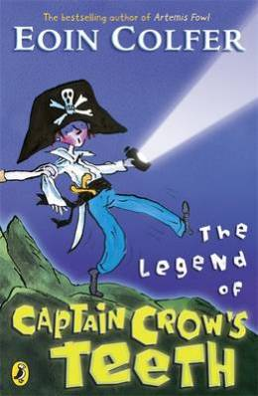 | 6+ | Five brothers are spending the summer holidays in a cramped caravan in Ireland with their parents. They are mischievous little monkeys who are a trial to their parents.  Marty, the eldest, reads his brothers spooky stories, and his favourite is about Captain Crow, a cut-throat pirate who is out to get his revenge on any available nine year old boy. This summer, Will who is nine years old, is to be the butt of Marty's most elaborate prank so far.  With characters last seen in Colfer's The Legend of Spud Murphy, this is another light-hearted adventure for younger readers, in which the issue of sibling rivalry is deftly and humorously handled.
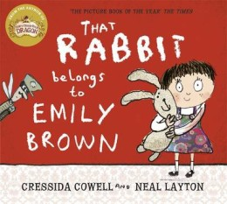 | 5+ | Emily and her toy rabbit, Stanley, love to go on adventures together. One day when they are attempting to launch themselves into space from the kitchen, one of the Queen's footmen knocks at the door and demands Emily give Stanley to his mistress in exchange for a brand-new teddy bear.  Emily refuses but the Queen perseveres, constantly sending her minions to bargain with the girl. In the end the naughty Queen orders for Stanley to be stolen but soon discovers that you can't make someone else's toy your own. Emily rescues Stanley but not before she suggests the Queen has some adventures with a brand-new teddy to make him into a 'real toy of her own'.
D
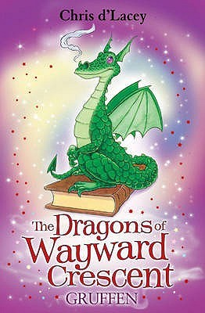 | 7+ | When Lucy suspects there's a 'monster' in her bedroom, her mum knows exactly what to do. Liz makes a guard dragon, Gruffen, to look after her....
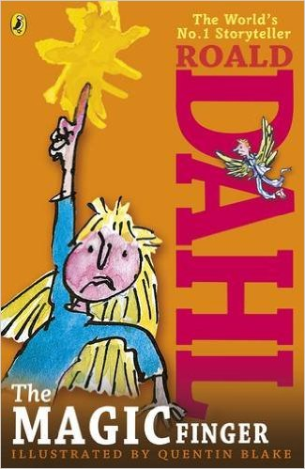 | 6+ | When the girl in this story gets cross, strange things start happening. Above all, she can't bear it when people are cruel to animals. So when her neighbours the Greggs go shooting, her magic finger teaches them a lesson they'll never forget...
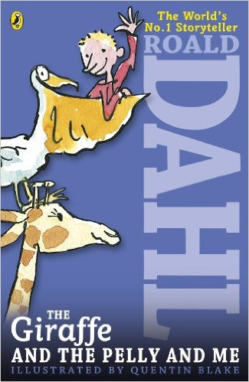 | 7+ | The Ladderless Window-Cleaning Company has just moved in to the old wooden house not far from where Billy lives. He'd rather have a wonderful sweet-shop, but when he meets the members of the Company - the Giraffe, the Pelican and the Monkey - he can't believe his eyes.
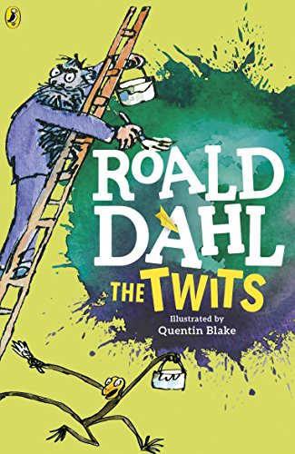 | 6+ | Mr Twit is a foul and smelly man with bits of cornflake and sardine in his beard.  Mrs Twit is a horrible old hag with a glass eye.  Together they make the nastiest couple you could ever hope not to meet.  Down in their garden, the Twits keep Muggle-Wump the monkey and his family locked in a cage. But not for much longer, because the monkeys are planning to trick the terrible Twits, once and for all . . .
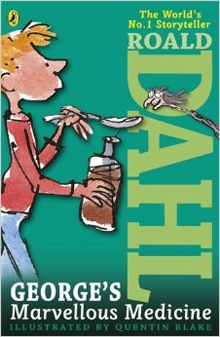 | 6+ | George's nasty old grandma needs teaching a lesson. George decides the best remedy for her grumpiness is a special home-made medicine. But Grandma gets more than she bargained for!  In George's Marvellous Medicine, published in 1981, George Kranky's Grandma may not anticipate the results of the medicine fed to her by her grandson, but like George, Roald Dahl also had fun mixing marvellous concoctions. He called them witches potions and delivered them to his children just before bedtime. They included ingredients like tinned peaches blended with milk and either pink, blue or green food colouring. His were put together carefully, though - none of the nasty side effects George's Grandma experienced..
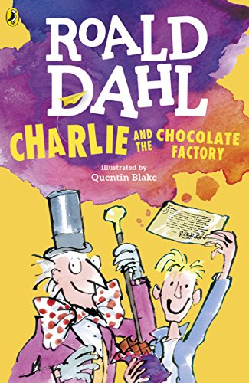 | 7+ | The famous story of Charlie Bucket and his Golden Ticket, and Willy Wonka and his amazing chocolate factory. Mr Willy Wonka, the most wondrous inventor in the world, opens his gates of his amazing chocolate factory to five lucky children.Gobstoppers, wriggle sweets and a river of melted chocolate delight await - Charlie needs just one Golden Ticket and these delicious treats could all be his!
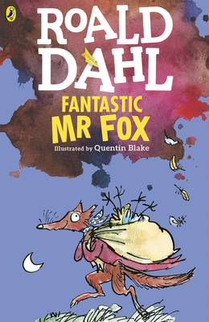 | 6+ | I hope you’ve never had the misfortune to meet anyone as cruel and callous as Mr Boggis, Mr Bunce and Mr Bean. These three men are farmers and a more disgusting trio cannot be imagined. They usually spend their time gobbling down enormous dinners of boiled chicken, duck-filled doughnuts washed down with gallons of cider but now these three repulsive specimens are at war.  For under a tree on the hill nearby live a fox and his friends: Mr Badger, Mr Mole, Mr Weasel, Mr Rabbit and their families. Every night cunning Mr Fox creeps into their farms and helps himself to a delicious dinner, but now Mr Boggis, Mr Bunce and Mr Bean have other ideas.
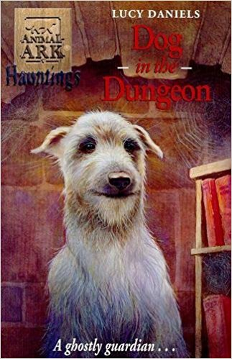 | 6+ | The first in an exciting spin-off trilogy as Mandy and James follow up ghostly sightings of animals and unravel the secrets behind them. This story features an aristocratic deerhound called Aminta. The last in a long line of dogs that protected the owners of the castle Mandy and James are visiting, the ghostly dog has been regularly sighted since the death of the owner of the estate. Mandy and James discover that the land is due to be split up and sold, destroying the family heritage and Aminta, as her last act as protector of the family, has returned from beyond the grave to try and help reclaim the estate. Can Mandy and James help her last wish come true?
E
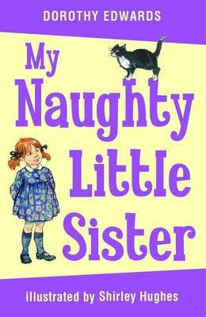 | 6+ | This affectionate portrait of family life is the story of a naughty three-year-old sister who is obstinate, inquisitive and full of mischief. She tries to cut off the cat's tail, eats all the trifle at Harry's party and gets up to all kinds of other antics, involving a wobbly tooth, a visit to the doctor, and a traumatic encounter with Father Christmas.
F
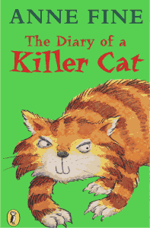 | 6+ | A cat’s eye view of the world is not exactly the same as a humans! Tuffy’s got no problems with the trail of delicious victims he brings into the house. A bird, a mouse – they are both delicious. In fact, he can’t see why Ellie is so upset. How a cat can train an owner is hilariously told by Tuffy himself in this witty commentary on the strange behaviour of humans.
G
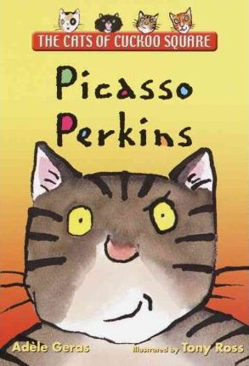 | 6+ | Perkins is a wise old tabby cat with a problem: His 8-year-old owner insists on doing his picture for a “Paint Your Pet” competition. Perkins is very fond of Lexie, but really! All he wants in life is a little peace and quiet. Perkins doesn’t expect to find a surprising talent of his own. . . .
H
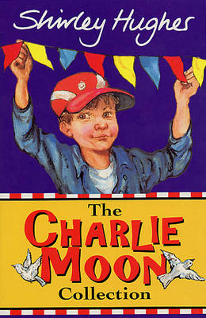 | 7+ | Charlie gets into all sorts of sticky situations when his seaside summer holiday turns into a missing jewellery mystery - and detective Charlie finds himself in the middle of a muddle once again when a gang of bungling burglars threatens to spoil the Big Library Bonanza...
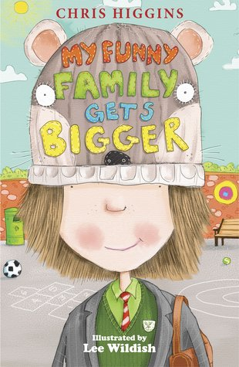 | 6+ | Mattie Butterfield is beginning to get worried (again!). Christmas is just around the corner and there are lists to be made, presents to be bought and trees to decorate. Meanwhile, the baby inside Mum’s tummy is growing HUGE. Is it about to ruin Mattie’s holiday plans? And could an unexpected Christmas gift be on its way?
I
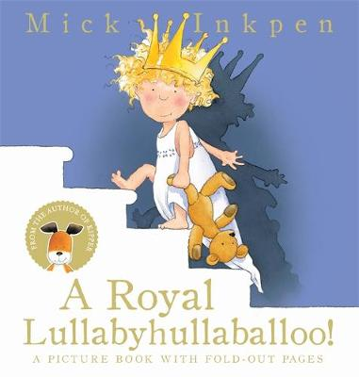 | 6+ | With a host of noisy fairytale characters and a fold-out page on every spread, this is a new edition of a read-aloud classic from the creator of Kipper and Wibbly Pig. Perfect for bedtime! The sun is down, the moon is up, and it is past bedtime. But outside the castle there's an awful lot of noise! Will the princess ever get to sleep? Mick Inkpen has won the British Book Award, the Children's Book Award and has been shortlisted for both the Kate Greenway Medal and the Nestle Prize.
J
K
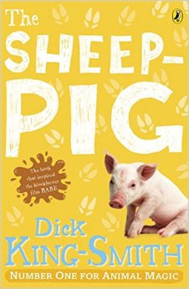 | 7+ | When Farmer Hogget wins a piglet at the fair, he is amazed that Fly, his sheep-dog, welcomes him as one of her own pups. Fly names the piglet Babe and teaches him all he needs to know about the farm and its animals.  As he watches his 'mum' round up the sheep, he decides he would love to try too. However, his legs are too short and he is far too plump to run around after a flock of sheep. He then tries a different tactic; politely asking the sheep to form an orderly line! The sheep are so surprised to be treated with respect that they happily oblige and Farmer Hogget soon notices that Babe has a certain knack with them...  One of Dick King-Smith's best-loved tales, this wonderful book is full of gentle humour. The short chapters make it ideal for early confident readers, and it will be especially adored by young animal lovers.
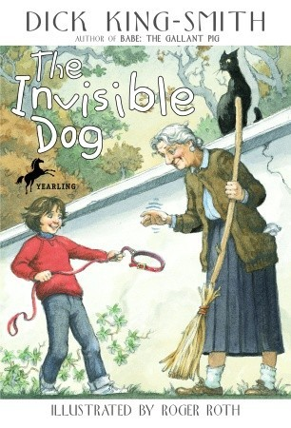 | 7+ | Illustrated in black-and-white. When her parents can't afford a new pet, seven-year-old Janie invents one. Her new pretend dog is Henry, an invisible Great Dane who eats invisible food bought with invisible money. Then some mysterious events--and perhaps a touch of magic--bring the invisible Henry to life.
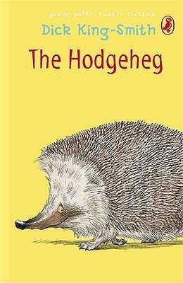 | 7+ | Max's family dreams of reaching the Park. But no one has ever found a safe way of crossing the very busy road. Young Max, who is brighter than the average hedgehog, is determined to solve the problem.
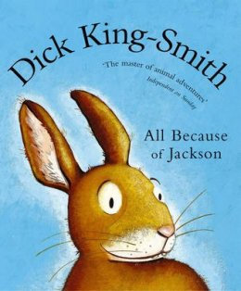 | 6+ | How did the humble rabbit originally find its way to Australia? And what caused the great Australian plague of rabbits? Simple - according to Dick King-Smith, it was all because of Jackson. A superbly-told story of a young rabbit whose dream of travelling overseas comes true.
L
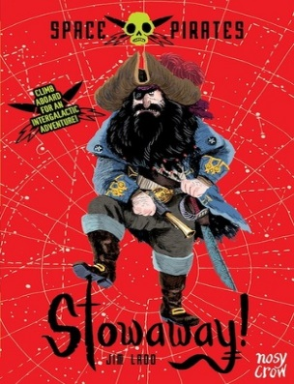 | 6+ | When Sam’s parents are stranded on Planet X, he bravely asks his neighbours, the notorious Space Pirates, to help rescue them. But they’d rather carry on bowling and singing space-shanties, so Sam has no choice but to hide in a barrel of alien slime and stowaway! A fast-paced, funny series with gags galore, this is a chase through space that will have you cackling from start to finish!
M
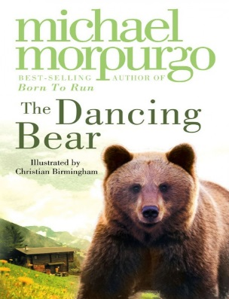 | 7+ | High in the mountains, in a tiny village, an abandoned bear cub is adopted by a lonely orphan child. Soon they are the best of friends, beloved by the whole village – safe, until the arrival of a glamorous film crew who need a dancing bear…
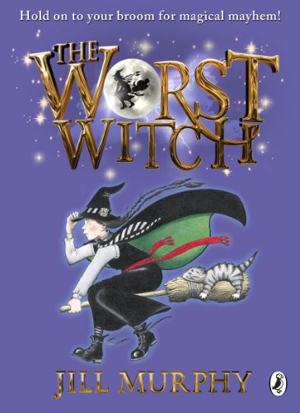 | 7+ | Hold on to your broomstick for magical mayhem! Jill Murphy's much-loved classic The Worst Witch is the original story of life at a magical boarding school, perfect for readers aged 5 - 9 years.  Mildred Hubble is a trainee at Miss Cackle's Academy for Witches, but she's making an awful mess of it. She keeps getting her spells wrong and crashing her broomstick. And when she turns Ethel, the teacher's pet into her worst enemy, chaos ensues...
N
O
P
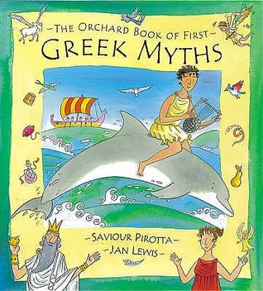 | 6+ | The perfect introduction to Greek myths, illustrated with bright pictures by Jan Lewis. Here are ten of the best loved Greek legends retold with warmth and humour to make them easily accessible to young children.
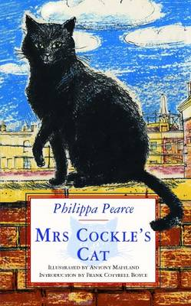 | 6+ | This magical story weaves a delightful fantasy around a simple and touching story of a lost cat. Mrs Cockle lives at the top of a very tall house which has a useful trap door that opens directly onto the roof. When Mrs Cockle is out at work all day selling balloons she lets her cat Peter out so that he can enjoy the sunshine. One day Peter goes missing and Mrs Cockle sets out on a fantastic journey, including walking on the clouds, to find him and bring him home. Hugely touching it's a story to be enjoyed by parent and child together or for a child who is just beginning to enjoy more independent reading.
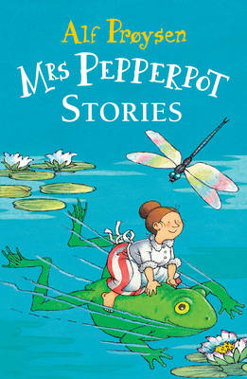 | 6+ | A fantastic collection of much-loved, classic stories for all the family! Mrs Pepperpot can't choose when she will shrink to the size of a pepperpot - it just happens! But whatever she encounters, whether it be a monstrous mousetrap, a crafty fox or a gigantic mountain of ice cream, little Mrs Pepperpot will always come out on top.
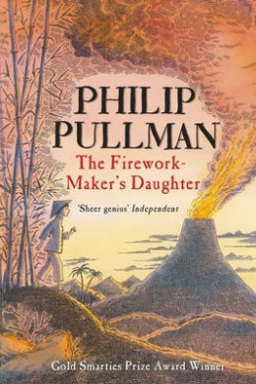 | 7+ | A fantasy adventure story of a determined girl called Lila who with the help of her friend, Chulak, and elephant, Hamlet, proves to her father that she is far more capable than he ever expected!
Q
R
S
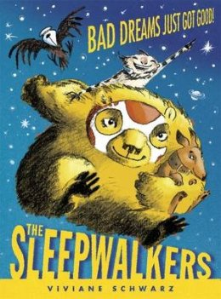 | 6+ | Do you have a bad dream that will not go away? Are you afraid to sleep at night? Call the Sleepwalkers! Write us a letter, put it under your pillow, and we will come and save you!  From their dream-proof Safe House, three friendly sheep known as the Sleepwalkers navigate the world of dreams, rescuing children from the horrors of their nightmares. When apprentice Bonifacius the Bear is recruited to join them, he must master his own fears in order to brave the horrors that lie outside the Safe House. Together with Amali the sock monkey and Sophia the crow, can he rescue the children who need his help?
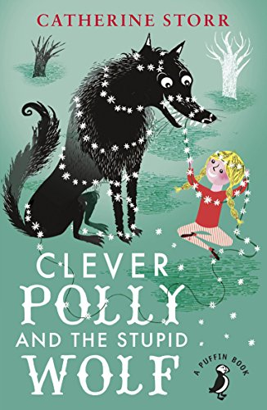 | 7+ | CLEVER POLLY AND THE STUPID WOLF by Catherine Storr has twelve stories written for the author's daughter, who was scared of the wolf under the bed! Drawing occasionally on well-known fairy tales, and skillfully blending fantasy and reality, these stories are bursting with humour, originality and charm. And Polly, not scared at all, outwits the wolf on each and every occasion!
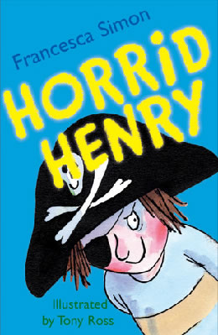 | 6+ | Stories about naughty characters have been told for centuries, and Horrid Henry is a modern-day rogue in the tradition of Dennis the Menace, Pippi Longstocking, Just William and My Naughty Little Sister.  The first in the hugely popular Horrid Henry series introduces us to Henry and his brother, Perfect Peter. The four stories it comprises are long enough to satisfy early readers, yet are short enough to be manageable, with plenty of laughs along the way. Tony Ross's mischievous illustrations are the perfect accompaniment - and children will have great fun comparing their own behaviour to Henry's, hopefully coming out on top!
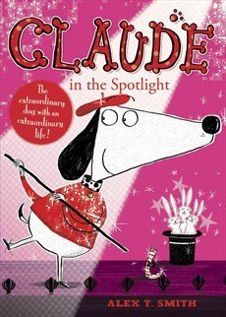 | 5+ | Alex T Smith's adorable Claude - a small plump dog in a stylish red sweater and beret - is back for a new adventure. Joined by sidekick Sir Bobblysock, this story sees a walk into town unexpectedly lead to the Claude joining in Henrietta Highkick-Spin's dance class, performing in a variety show, saving Mr Lovelybuns the baker from terrifying peril, and even encountering a ghost.
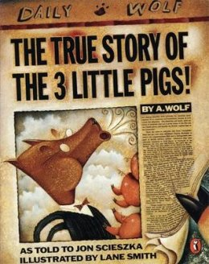 | 6+ | What really happened to the three little pigs and the big bad wolf? Find out the truth in this hilarious picture book.  In revelatory newspaper style, this brilliant picture book exposes the truth about the three little porkers, and one A. Wolf. Putting a brilliantly inventive and very funny spin on fairy tales, Jon Scieszka and Lane Smith bring a refreshing contemporary twist to a familiar original.
T
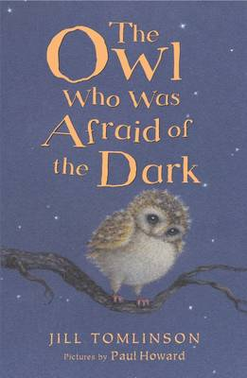 | 6+ | Plop is a baby owl. Perfect in every way - except for one. He's afraid of the dark! But he soon discovers, through a variety of new friends, that dark can be fun and exciting and magical! This is a story for very young readers.
U
V
W
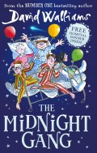 | 7+ | Poor Tom has been hit on the head by a cricket ball and wakes up in the Lord Funt Hospital with a big bandage on his head. In the children’s ward, though, he finds children with worse complaints: Amber’s got full leg and arm casts in a wheelchair; Robin has had an eye operation and can’t see; and poor Sally is too weak to get out of bed.  Worse, there’s a horrible kid-hating Matron watching over them and making sure they don’t have any fun at all – not that there is much fun to be had in hospital (or so you would think).  It transpires that the children are part of the Midnight Gang: an ages-old hospital tradition that makes dreams come true for sick children. But what will Tom’s wish be, and can the kindly hospital porter make it come true?  David Walliams’ tongue-in-cheek fun continues to amuse in this new adventure that also tugs at the heartstrings in just the right way. The Midnight Gang’s various ailments and conditions don’t affect them careering joyously around the hospital in the middle of the night, although Walliams still treats the characters and their conditions with dignity and respect where appropriate.
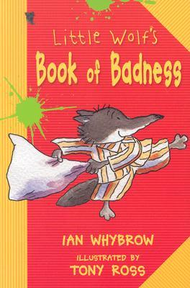 | 7+ | Little Wolf has been behaving too courteously, so his parents send him to his uncle's Big Bad Wolf school to learn to be a proper wolf.
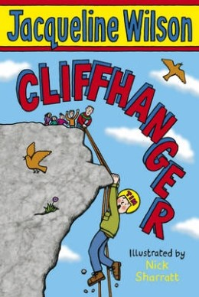 | 7+ | A salutary and funny tale about not giving up from Jacqueline Wilson. From climbing and abseiling to canoeing and a Crazy Bucket Race, the adventure holiday promises to be full of action. There's just one problem as far as Tim is concerned: he is hopeless at sports of any kind. Chapters are short and the writing is clear.
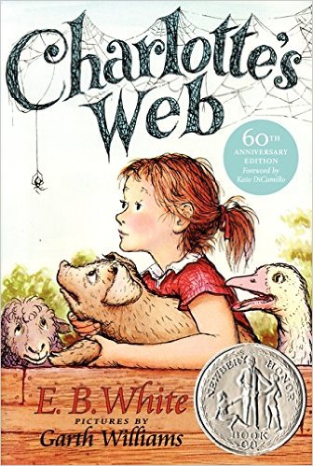 | 7+ | This is the tale of how a little girl named Fern - with the help of a friendly talking spider called Charlotte - saved her pig, Wilbur, from the usual fate of nice fat little pigs.  An unusual and witty story which provides a gentle introduction to questions of mortality, Charlotte's Web is a modern classic.

