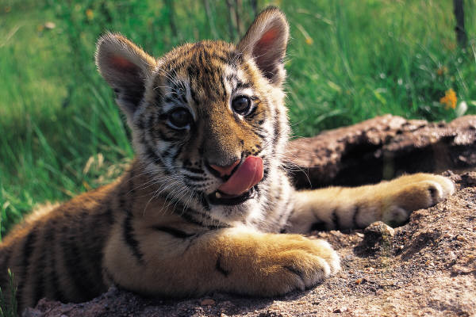***TWINKLING TURQUOISE EYES,***

***INSTINCTS AS SHARP AS A KNIFE,***

***GRADUAL DISAPPEARING FROM EARTH,***

***C:\Users\class5\AppData\Local\Microsoft\Windows\Temporary Internet Files\Content.IE5\XGJZ7P72\MC900446324[1].wmfEYES GLARING AT YOU DARKLY,***

***REGALE AS A KING OR QUEEN.***

***By Archie***

***A JUNGLE DUSK,LIKE A NIGHT IN A HAUNTED HOUSE,COLD&BLEAK, THE FORMER BONES OF A FORGOTEN DEER LEFT IN A DUSTY HEAP,THE MONSTERUS BEAST STILL ROAMES THE LAND, MARKING HIS OWN TERRITORY, HUNTING FOR MORE BUT NOT FOR HIM SELF FOR HE HAS HAD HIS SHARE, BUT FOR HIS CUBS AND NOT FORGETTING THE MOTHER,BUT WHATS THIS SECRETLY A LITTLE CUB HAS SNUK ALONG TO CATCH HIS FIRST VICTIM, A DEER TROTTING BY IMMIDIETLY STUCK DOWN, FOR THESE ARE TIGERS DISGISED IN BLACK AND BROWN.***

***By Archie***