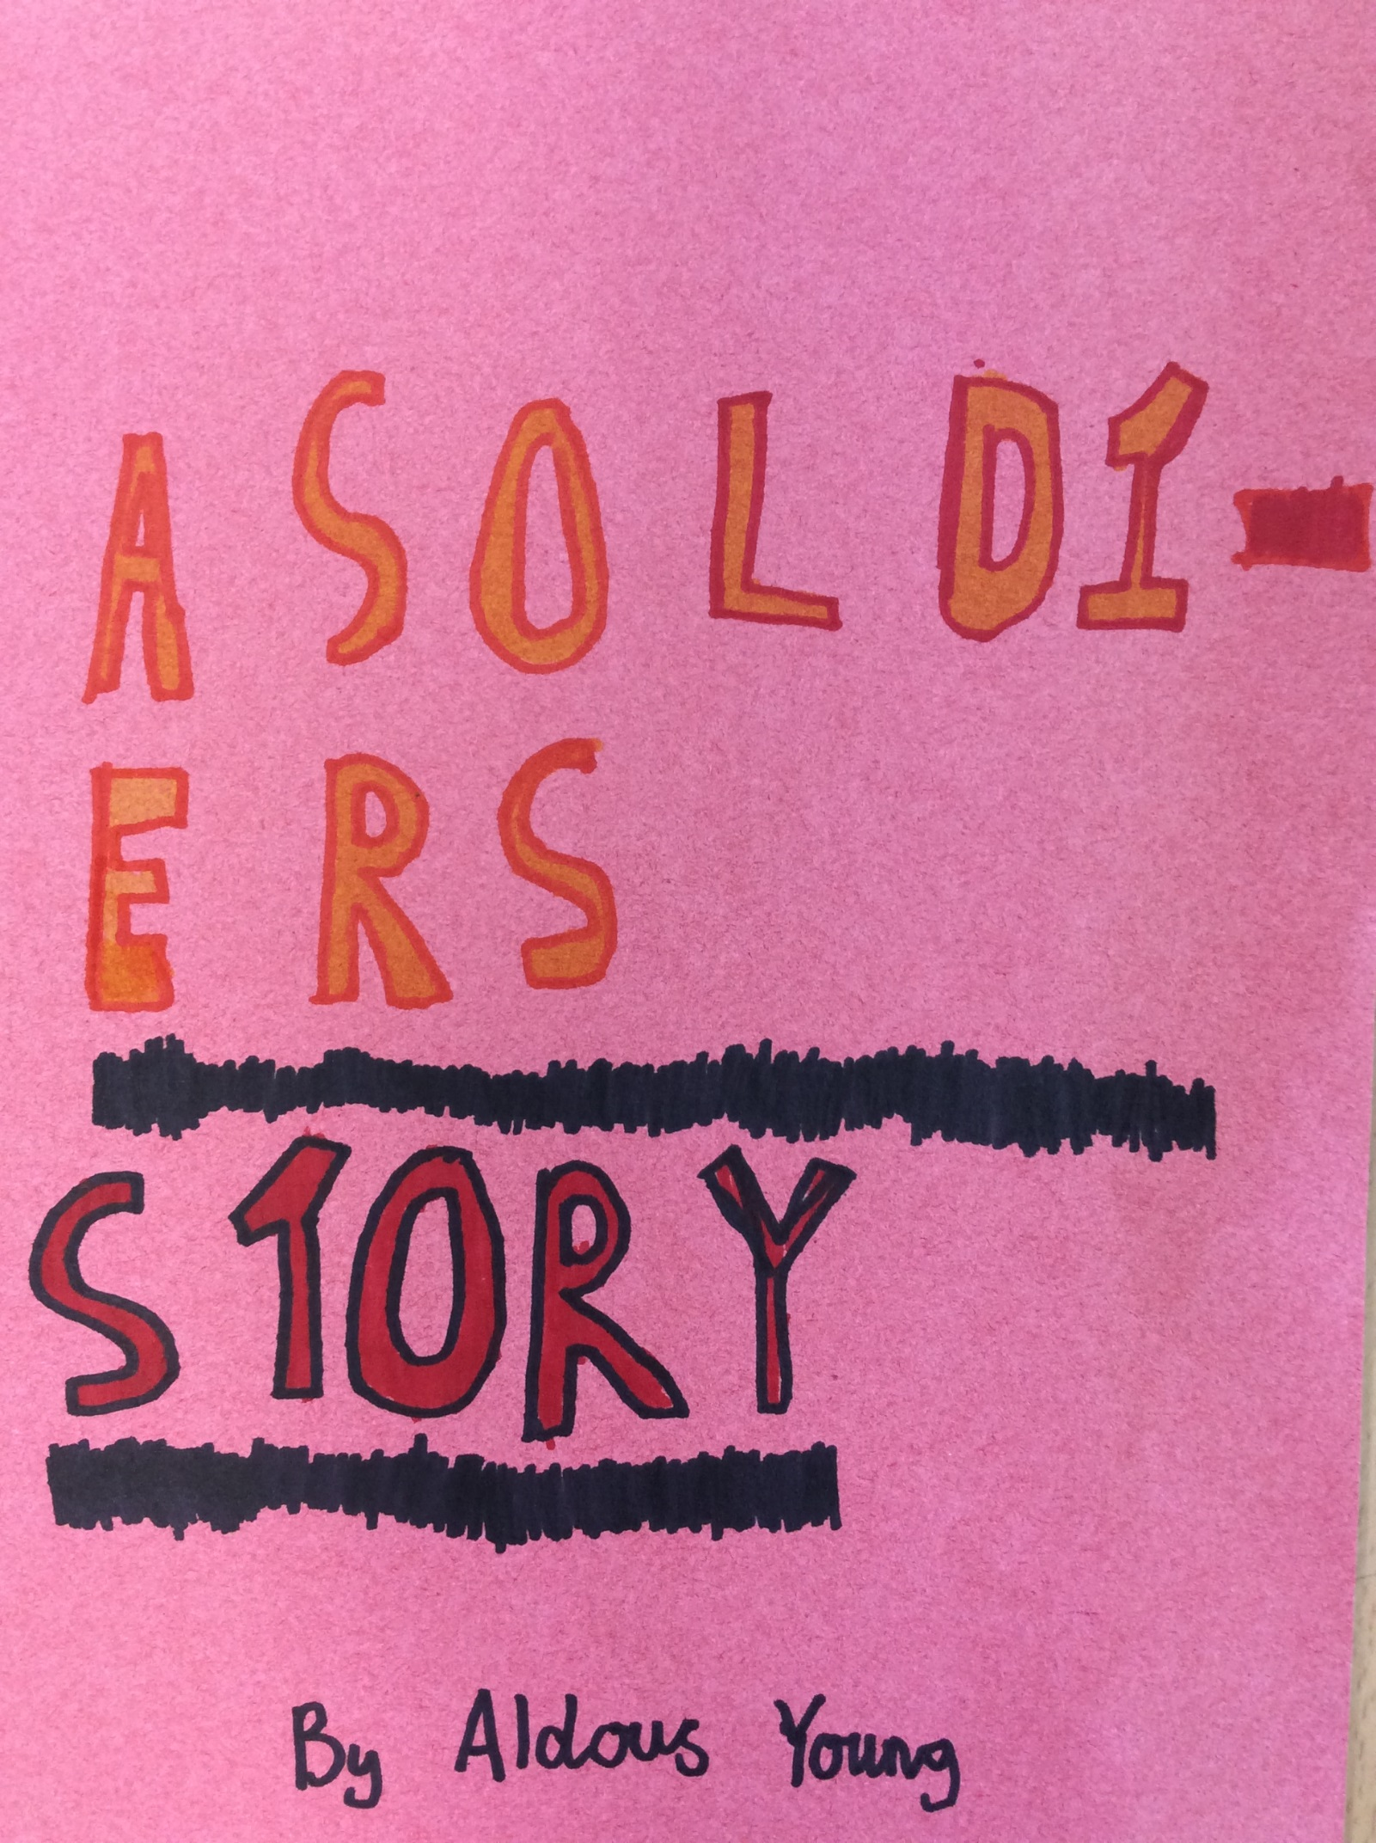

A SOLDIERS STORY
I don’t know why I joined the army, I could barely hold a gun. My name is Wolfgang Horne and I am German, I have blonde hair and blue eyes and brown freckles all over my rectangular shaped face. I was tiny and all I wanted to do was become a General and command an army. My plan was to survive as long as I could get a better rank. Nobody liked me because I was German - they all thought I was a spy for Hitler. For a while, I had a feeling I was just a ‘mindless drone’, collecting information for the enemy.
During the battle for France - I ran away. It’s still hard to believe what I was doing was what I hoped to be suicide. I was hoping I would get shot by someone on either side.
I had run away to the country side to escape the battle. That was when I heard tanks, big heavy tanks and no tank was as loud as the German tiger tank! And that was definitely it. I knew it had two guns on both sides and one big gun in the middle. I wasn’t seen but I could hear it. Then I heard gun shots on the tower. They were grim faced and would not take kindly to strangers. It was obvious to me that I wouldn’t get past the centuries on the tower so I got a grenade and through it at the tank. In the confusion, the tank shot a missile at the tower and brought it to the ground. That gave me enough time to hop into the tank and shoot down the rest of the walls then sneak into a dead soldier’s uniform and run inside.
It was dark inside the base, the only light was the fire outside. They all thought I was still in the damaged tank so I was safe. For now. I saw the light of the flashlights on the Nazi guns. I dropped my gun as it was unwise to walk into an enemy base with an ally’s gun - I took the officer’s pistol. They saluted me as I walked past. I didn’t speak to them in fear of revealing my English accent. Then I saw their arsenal: thousands of tanks, guns and planes. That was why during the battle they seemed to keep coming.
It was clear what I had to do, warn Commander. Well I’m sure they wouldn’t miss one plane…. So off I was in a German Mesmerist (this one was brand new - I could tell because it handled so well. I felt privileged to be flying it. If I could of, I would of just flew off into the distance). I needed to crash-land without killing anyone. And I did! Even though I nearly took old Bobby’s face off! The moment I jumped out, I had eighty-six sub machine guns pointed at me but they put they put them down when they saw it was me. I ran to the general still getting flash-backs of the horrors I had seen.
I’m glad he believed me, if he didn’t I would have lived and I would have had guilt for the rest of my life. I’m starting to think I wouldn’t have been believed if I wasn’t German because of how badly I had been treated by the Nazis. The look on the commanders face was enough to stun a snake, but then he smiled (well I think he did I was still recovering from that awful stare).
Then he ran to the phone and dialled a number that no one knew and grabbed a gun. About nine hours later I heard tanks planes and soldiers, hundreds of them, maybe thousands. I thought of how many weapons I saw at the enemy base. There were far less than this, then I thought of the likelihood of a secret enemy base so there could be even more. I was told to stay inside as I was too important. I was told to play chess with a boy.
The person who I was playing chess with was a very young boy, no older than nine. He had thick dark hair, dancing brown eyes and freckles all over his face (he was also far better at chess than I was) he said he was an astronomer and been recruited into the army for his knowledge of German tank. However, currently he doubted his importance.
I never found out what happened in the battle that was going on outside. All I knew was it was close, enemies got in and the officers around us had to shoot them (I didn’t take much notice as I had to concentrate on the game). Here is the report I got from a soldier in the battle:
It was horrible people were flying all over the placed from horrid explosions. I cowered in a stolen tiger tank for most of it (it was my first battle so you can’t blame me). The tank was fast and packed a repeatable punch (it was powerful). I could have run circles around a Sherman, soldiers gazed longingly for it was faster than anything they had seen before. The blast from its’ cannon was equal to five Sherman blasts. People were piling in and behind it in the tanks for inevitable protection in. I loved driving over other tigers, it was my favourite part. The crunch of the wheels and the look on their sorry faces was so fun to see as they dashed out of the now broken tank. If I survived the War and won, I would do it all again I could to get me one of these!
I am sorry the report was so short. If you want to know more, you might be able to track him down and get him to give you a more detailed report (don’t get your hopes up he is 106 years old but I got a letter from him two days ago). I like to think my “exploring” saved thousand saved thousands of lives and freed France from the Nazis.
So that’s my story. When I look back on it, I think how much it changed my life sixty-four years later.
By Aldous - Year 5

