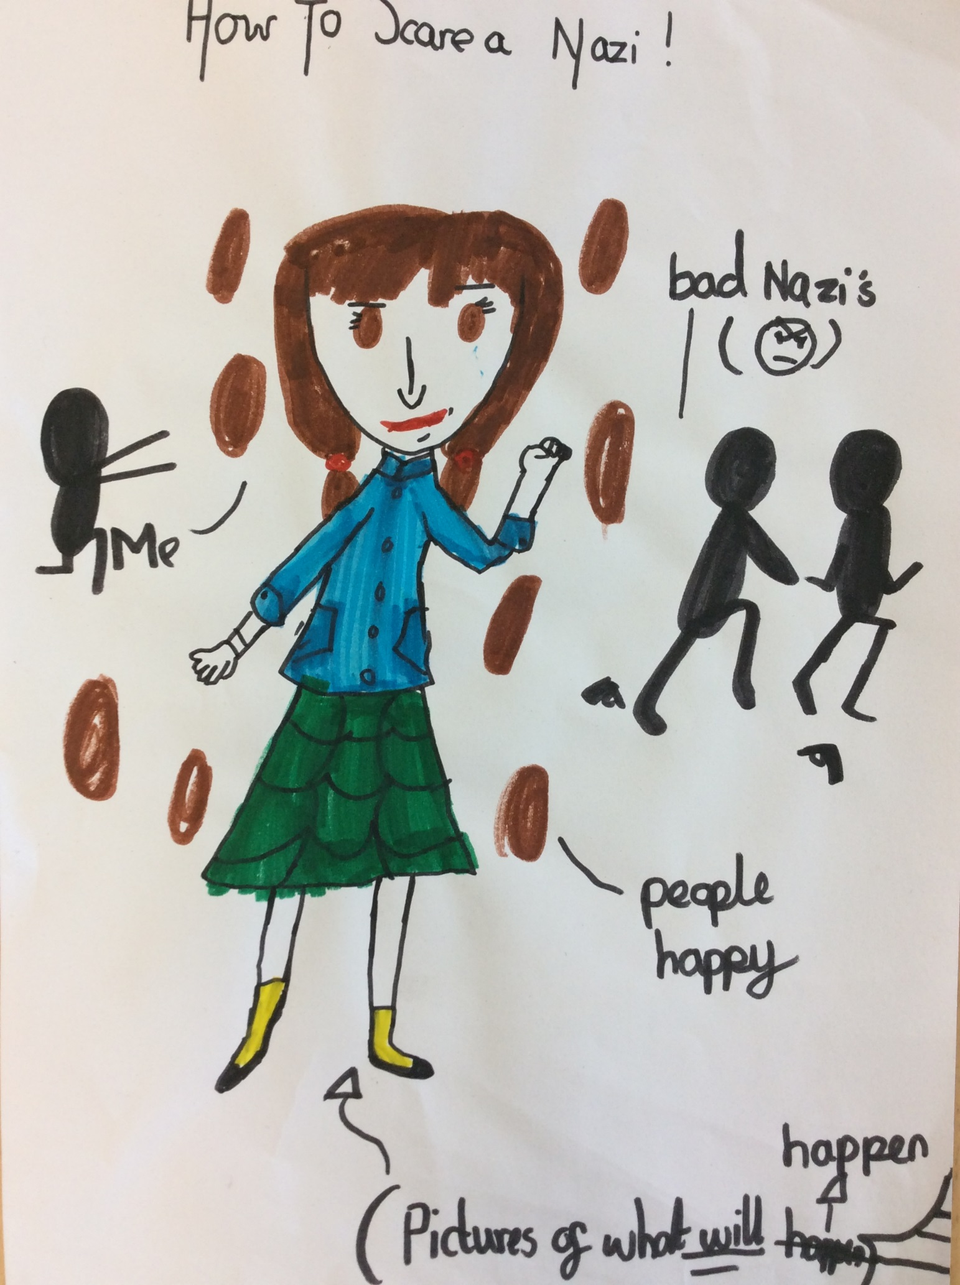

The way to scare a Nazi

Cecilia had turned thirteen. Her mother had been sending letters to Cecilia every day. She had wept so much that her eyes were like crimson blood. On a stuffy morning, Cecilia had been given the latest letter from her mother (Agnes)
Dear Cecilia,
I have missed you so much! Can you believe that it took me 10 years to find a stupid home for four of us? I found an abounded house in the countryside where we will be really safe as there is an Alison shelter fitted in the back garden. If your dad and big brother work hard to fix the house, it will look beautiful and you will love it so much you might never leave the big cottage. We found a little kitten hiding in the abounded house and it won’t leave us alone, so John said we should keep it. Yesterday, we found out it was a female (I forgot to write about it in the letter that I sent to you yesterday.) Also this will be the last letter. At the back of the envelope there is a little map to where you will live. Don’t tell anybody but Mrs Lon-Sera. It is fine if you want to bring someone from the countryside with you. Can you believe the kitten is to be one next month? Can’t wait for you to be here!
From your loving mother, and father, and brother,
Agnes and Joseph, John
“Oh my goodness, I am going to the countryside Mrs Lon-Sera!” rejoiced Cecilia
“Jolly good. Let’s get packing for the journey,” sniffed Mrs Lon-Sera.
Three hours later, Cecilia had finished packing.
“Bye Mrs Lon-Sera. I will really, really miss you.”
As Cecilia went outside, it was bitterly cold and she had to sleep on rubble or in rubble because of the bombs. The wind was like stinging nettles on her face. One night, as Cecilia settled in a bush-like-cave, she found a scruffy yet furry kitten. She felt bad for the little kitty so she gave him/her a fish sandwich.
“I wonder where this kitten came from?” said Cecilia thinking loud. Cecilia did not mind if the skinny kitten was with her as Cecilia felt a little lonely.
The next morning Cecilia left the kitten in peace. “What a terrible morning, oh look at Jack. Hey, Jack, can you hear me? Oh no he can’t be… He is DEAD. Oh I was so fond of him.” Cecilia said, with tears rolling down her eyes. Wiping her cheeks, Cecilia bumped into a boy. CRASH!
“Oh sorry I did not know you were there. What is your name. mine is-?”
“-FELIEENNNN! Oh sorry – that’s my kitten’s name. I’ve been looking for her everywhere. My name is Jan Simpson,” said Jan blushing his head off.
“Are you going to the countryside? I am. I want to stay there for some time to get away from the bombs and eat food. Bye bread! hello pork pie! Mmmm,” said Jan rubbing his tummy
“Yes I am actually do you want to come with me?”
“Course why not? Let’s not tell anybody,” whispered Jan.
Unfortunately, they did not know that a NAZI was behind them. As the evening settled, Jan and Cecilia stopped to camp in the woods. They made a bunker under a tree.
“We will stay here for today,” protested Cecilia. They felt like they were being watched (which they were by a Nazi called Laden).
Laden took a shortcut and in the matter of four hours, Laden was not enjoying the brown water in the countryside. Cecilia and Jan were just TEENS! They took a long journey walking.
As they rested under a mountainous tree, a muscular man came striding past. “We will stay here for a while I guess Cecilia.” Jan puffed as he went off to collect some wood. Just then, Laden appeared.
“I think I know you, you are Cecilia! I know your mother! Come with me and don’t make any noise,” commanded Laden.
After an hour, Laden announced his crime “I HAVE LED YOU TO THE WRONG PLACE LITTLE PIG!” Laden said as he grabbed Cecilia. Jan had followed them and was hiding in the bush. Suddenly, Jan swiped the gun out of Laden’s hand. BANG! Laden ran away in fright.
A few days later Jan and Cecilia had food and they slept peacefully in their warm beds, never daring to think about what could have happened.
By Chisom.

