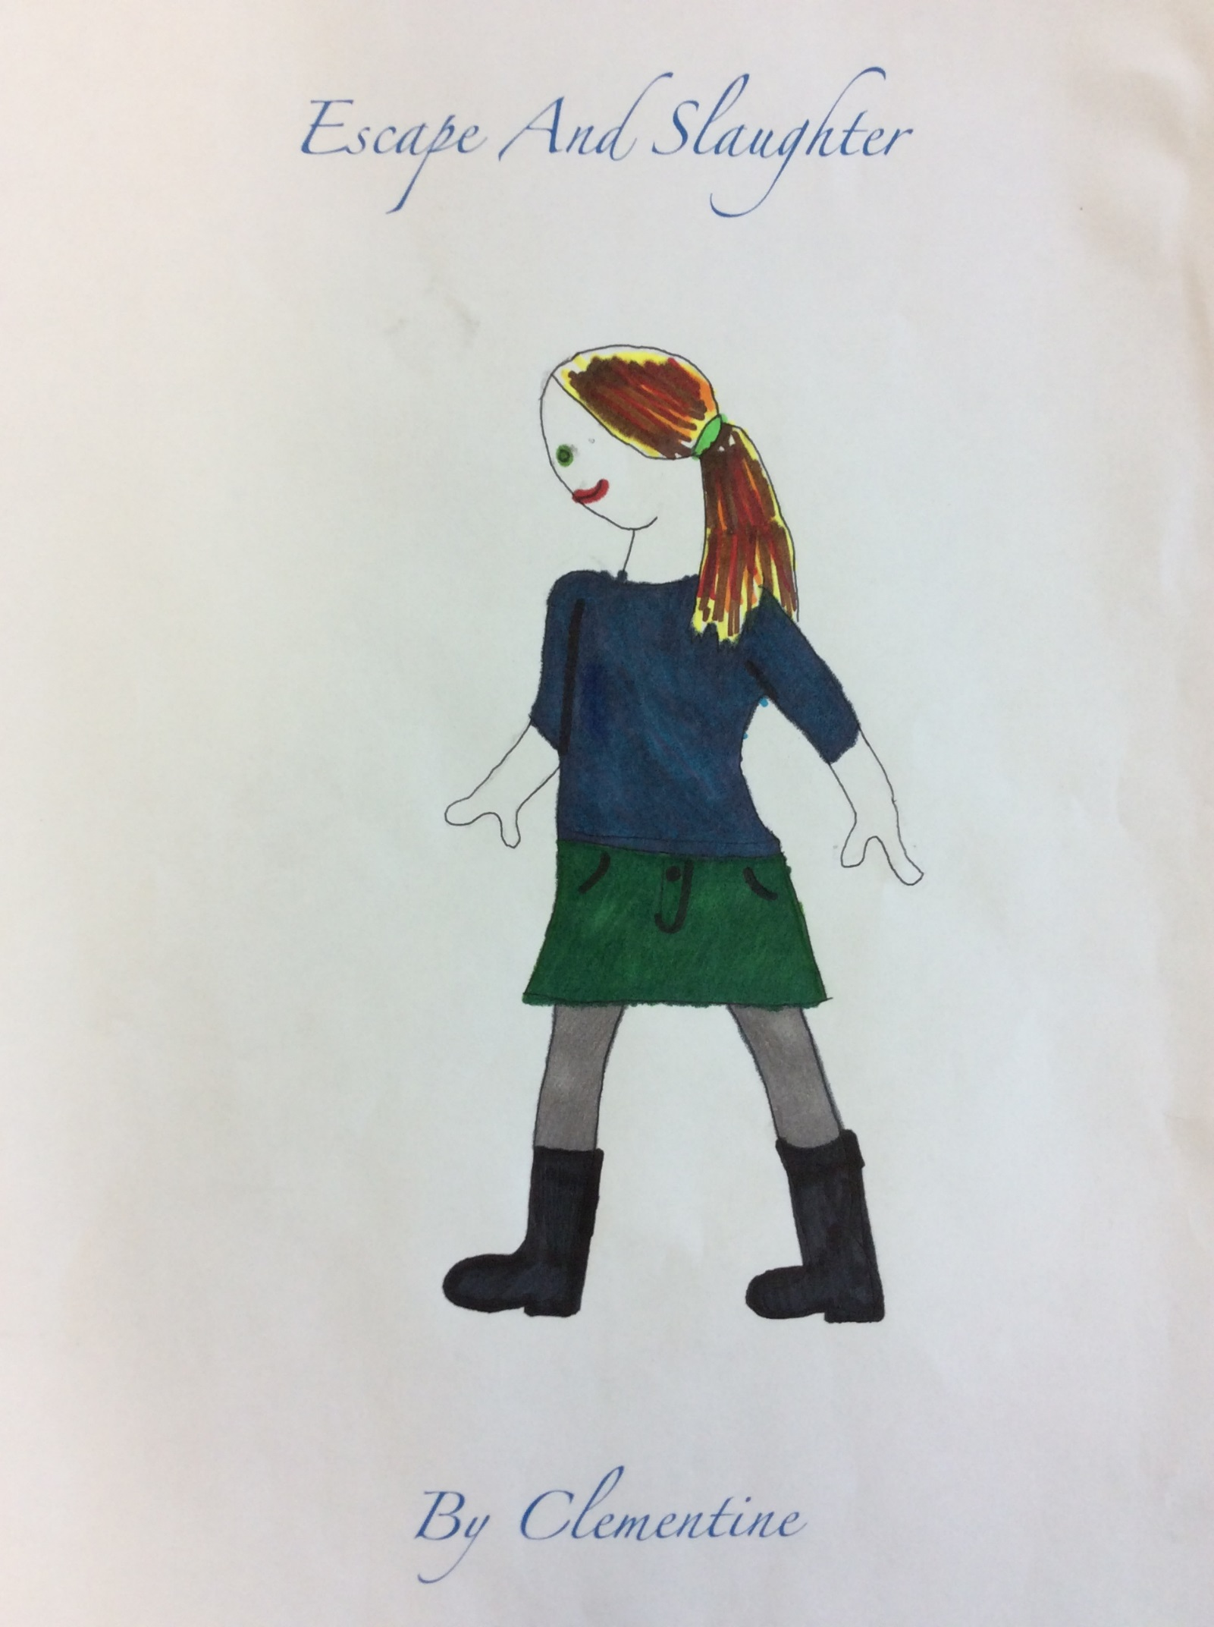

Escape and Slaughter
Isabelle woke up and pulled on her skirt and top. Today, it was a green corduroy skirt with a small navy ¾ length t-shirt, along with her charcoal grey tights. She laced up her knee high black boots, and climbed up the twig ladder that led her up into daylight. Izzie lived in a small underground cave, that provided warmth and a little stream at the back of it gave her water in the summer and ice in the winter.
She dug around in the heather that covered the entrance of her cave, for her and her mother’s ration books. Isabelle’s mother and father had been killed while doing espionage. Isabelle was proud that they were brave enough to do this, and she really wanted to be like them!
Isabelle set off, dodging the German soldiers on the boarders of the forest and the town. Once she reached the shop (which was oddly called Red Leaf!), she got her remaining money from her bombed house, out of her pocket. She bought as much as she could with the little amount of money and the ration cards that she had, and then queued up in the very long queue to pay and leave.
Quite suddenly, a young boy with dark hair in front of Isabelle, dropped his butter and cheese on the ground. Izzie quickly picked them up for him and they started to chat. They asked each-other where they lived.
“So, what’s your name? Mine’s Izzie, short for Isabelle.”
“Oh, erm-er mine’s Max. Are you a follower of Hitler?” The boy said this only slightly louder than a hushed voice.
“Well no, not really…” Replied Izzie, slightly afraid. They high-fived each other in a friendly way, paid for their food and then made their way to Izzy’s secret underground cellar where Izzie hid her food.
“Hide your food here. Come here whenever you like! It’s secret!” She saw a sparkle in his emerald- green eyes.
They started to climb up to street level and Izzie told Max where she lived, but unfortunately a man overheard. He ran to the path that she took home and dug a 2 ½ m deep hole and covered it up with twigs and leaves and then finally, heather. After this, he then darted to a near- by tree to watch the fatal fall happen. I have her now he thought.
Max and Izzie took their separate paths home. Max watched her go for a couple of seconds, when a high pitch shrill filled the air. Then the man ran off, and Max saw what happened out off the corner of his eye. He ran off and slept in the secret cellar. He would try to save her in the morning.
When Max awoke the next day, he got himself some oats and poured some milk in the beautifully carved bowl which Izzie had made. He then picked up a spoon and wolfed it down. Max replayed what he had seen yesterday - Isabelle had got stuck down a trap! He decided to bring some food and milk for her. He then packed all into a rucksack. Max then found 4m of rope, a penknife, a torch and a bucket. Max chucked all of this into his bag and set off to rescue Izzie.
As soon as he got to the place where Isabelle had fallen into the trap, he tied the rope to the handles of the bucket. He then turned the torch on and placed it in the metal holder. Along with this, he added the milk, a small piece of flapjack and a slice of bread. He then lowered this into the 2 ½ m deep hole.
“Izzie - It’s me, Max, I got you some food! And after you eat it I will get you out of this horrid trap”
Izzie yawned and then replied, “Thanks, Oh! Yum my favourite, Flap- jack. I haven’t had this in years! Thank-you so much, now, let’s get out of here.”
After she had eaten all of the food, Max bought up the rope, took up the bucket and then he attached the end of it to a near-by tree. With the remaining 3 ½ metres, he tied knots every 20 or so centimetres so that it would be quicker and easier for the girl to climb up. After 10-15 minutes of heaving, Izzie climbed herself over the edge of the trap. Now all they had to do was catch the man…
Panting, Izzie said, “Quick we need to catch that evil man!”
“Yes! Come on, he went that way!”
They were both really fast runners and had soon caught up with him. A plastic card had reflected the sunlight, and blinded both children. They paused to pick up the card, and what they saw, didn’t surprise them. Izzie’s parents killed Hitler’s daughter, and Isabelle was well known by the Hitler family. On the ID card was a photo of Adolf’s second son. His name was Henrik Caroly Hitler. He was the one who had set up the trap and attempted to kill Izzie.
They started to ask the all of the villages where he had gone, and showed them the ID card. Most of them had said that he had gone into the cave near the forest, and others had seen him heading West. They immediately travelled to the cave, (the one that was hidden to foreigners but one which everyone in the village knew about). They dropped by the secret cellar to pick up two pistols, both loaded, and set off to get rid of him for good.
As soon as they had got to the cave, the two children had their pistols at the ready and said; “hands up and drop your weapons!”
Max started off nervous but then grew confidence. As soon as Henrik came out, Izzie said, “Come here. Now my parents killed your sister and now I will kill you! Get down that hole, the one you tried to kill me with. Unfortunately for you, you don’t have any friends like I do.”
They both skipped away, happy that they had found each other, and that for now at least, the danger was gone.

By Clementine

