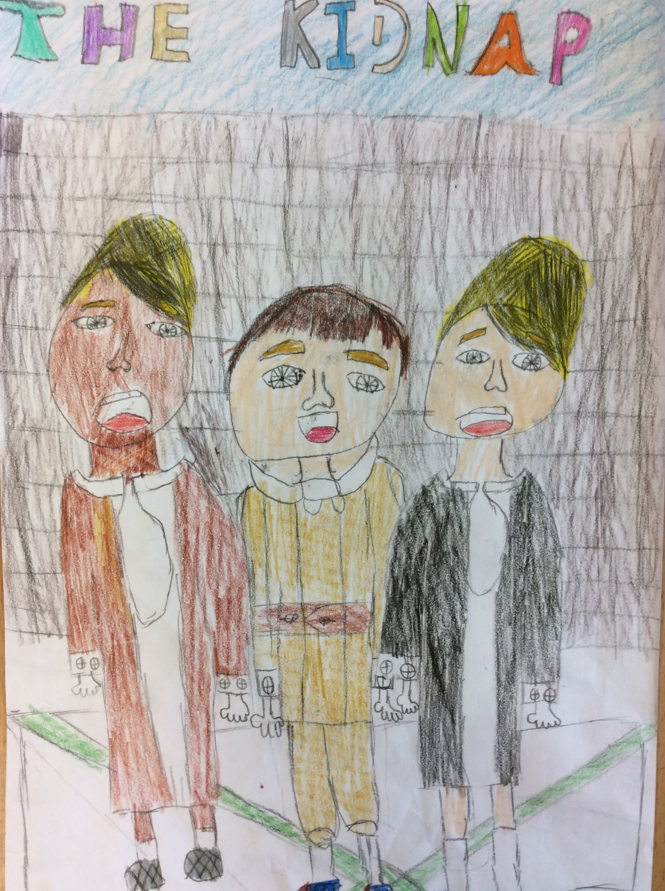

The Kidnap
“What are you doing now?” asked Emily to her best friend Chae’rin. They had been meeting up quite a lot to talk, despite the unexpected sirens. Emily and Chae’rin had been friends even before they started nursery thanks to Emily’s sister and Chae rin’s brother. They both had buns in their hair and were wearing the same shoes but different clothes. Chae rin was older than Emily by fifteen days, but Emily was much taller than her.
“I’m talking to you but also thinking about, when all the men go, what job I will do,” answered Chae’rin. Emily was twenty and Chae rin was twenty-one. Chae’rin had a pale face and stubby eyelashes whilst Emily had a bright face and long eyelashes.
All of a sudden, the sirens went off. They both started running around in circles. Planes were roaring through the sky, bombs getting nearer each second, and people screaming like it was the end of the world. Emily and Chae’rin had no idea where to go. Their houses were miles away. They were scared that if they went onto a tram it would get bombed. Chae’rin tried to calm Emily down but she was worried too, so that did not work. They decided to run for the nearest train station. They started to tell people on the way about the sirens in case they didn’t hear.
Emily and Chae’rin were trying to find the nearest station when they ran into a boy named Freddie. Freddie had hazel nut hair and blue eyes.
“Omg, I’m so sorry I should have been looking where I was… Freddie Fr, Fr, Fr Freddie? What are you doing around here?” Said Chae rin confused.
“Yeah it is me. I was just going to the shops. I moved here so I can see the Royal Family and Buckingham Palace. There is a train station around that area. Do you want me to take you guys there?” asked Freddie
“Sure - we wouldn’t mind would we Chae’rin?”
“Okay come on!” Freddie was one of the girl’s crushes from when they were younger and still played together in school. On Friday the 26th of March, when they were in their playground, their school got bombed. Only ten teachers died because they were inside their classrooms, but apart from that, everyone else was okay. It was a tragic thing to watch and they knew the teachers so well. They went to the teachers’ funerals. Even Freddie came. The girls would even sometimes play basketball or football with him. That is when they didn’t mind getting hurt. Freddie led them to an alley way then to his house.
“We have to go through my house and out the back door for a short cut.”
“Cool, I just want to get there as fast as possible.” Demanded Emily
“But before, we do I have to call my mum just to tell her that I’m okay.”
“Okay but you have to go to my basement to ring her.”
“But there is one here.” Said Chae’rin puzzled at the whole thing. As quick as a flash Freddie answered.
“Ummm… that iss broken the the the the …” Freddie started to look around.
“Line has been cut, um yeah the line has been cut and the only phone left in the house is the one in my basement.”
When they got to the basement, Freddie asked them to go through a room (cellar) to get to the phone. Emily and Chae’rin could see the phone so they both ran into the room (cellar). Unexpectedly, they heard the door close with a bang! Freddie had locked the door and he had lied. There was no telephone - it was just scrunched up newspaper in a shape like a telephone.
“How could I have been so stupid? I should have listened to my head. He seemed suspicious ever since I met him.” Said Emily
“Don’t worry, we were both so stupid to let him take us to his house!” Said Chae’rin. They had nothing to eat and no signal to call their parents or anyone. Freddie had KIDNAPPED them.
A day later, after a hard and uncomfortable sleep, they were ready and raring to start their horrible, unpredictable day. Emily looked around, no-one was there. Then, in a blink of an eye, Freddie showed up with a taser and a few more girls.
“Well, how did you girls sleep? I guess not very well. By the way, I bought you girls’ some company. Meet Ava and Jemma apparently, you guys already know each other.”
“Yeah, we met in nursery and have known them for years now. Well, I guess, it can’t really hurt you to give us some more girls. So then we can have a slumber party can’t we Chae’rin?”
“Yeah, sure Emily!” Emily and Chae’rin were frustrated and scared but they didn’t want Freddie to know that.
“Why did you take us? We didn’t do anything to you!” Said Ava.
“I just need to find out a little more about London and the bombs and the latest gossip from the spies…”
“Hold up, you are a Nazi spy. Unbelievable we were so nice to you and you pay us back by kidnapping, and then you want us to tell you everything about London and where they’re going to bomb in Germany.” Said Jemma.
“Yeah, pretty much. You kind of just worked out my whole plan. Now tell me everything you know!”
“No!” Screamed all of the girls who were scared to death.
“Okay no food for you today!” Freddie walked out of the door with a smug look on his face.
The girls needed to think of a plan and fast.
Two days later, and Freddie had still had not given then food. They had lost so much weight and had also lost their voices because along with no food, they also weren’t given any water as well. All of a sudden, Freddie came in carrying eight trays of food and eight large cups of water. All of the girls scuffed and drank all the water like wild animals.
“Right, if you even think about escaping you will be dead. Also if you have any kind of contact with someone that is not in this house, trust me you will never see day light again. I am pretty sure that soon enough you will tell me everything about what the soldiers are going to do or-”
“Hurry up and finish your sentence dumbnut!” Said Ava in frustration.
“Well what I was going to say, before I was rudely interrupted,” he glared at Ava, “is that this time I might not give you any food or water for a week! Then, you will know that you should have listened to me in the first place and honestly you should not be talking to me like that!” He screamed at them frantically.
“Please, may you bring me something for us to do, like a book, because sometimes just talking isn’t always fun, even talking to you is making me really extremely tired.” Asked Jemma, not wanting to say anything offensive to the stupid boy.
“Hold up, I think I have a plan on how to escape. Maybe if I use the pin in my hair to unlock the lock maybe we might be able to escape but we have to do it when Freddie has left the house.” Exclaimed Emily (thinking that she was the smartest in the whole room when actually she was the stupidest.) She was even more stupid then a nut. I mean, an actual nut, but in that moment, that was the smartest idea she ever had!
Two weeks later, when Freddie had gone to buy some food with his ration cards, the girls began to carry out their plan. Emily took her rusty hair pin out of her hair and jingled it through the lock. When they had finished that, (which took about an hour) they ran outside and went to the nearest police station. When they were running down the disgusting streets they found pictures of them on lampposts saying: Four lost girls - if you find them we will give you £1 and2 rations cards. The girls were shocked. They never knew that people would actually look for them. At school, all of them felt unwelcomed. Even the teachers hated them because all of them came from rich families. They found the police and told them everything. They found Freddie and took him to prison. They never really heard of him ever again.
Ever since that the girls never went too far from home and learnt that it is safer to stay at home than in the streets.

By Deanna

