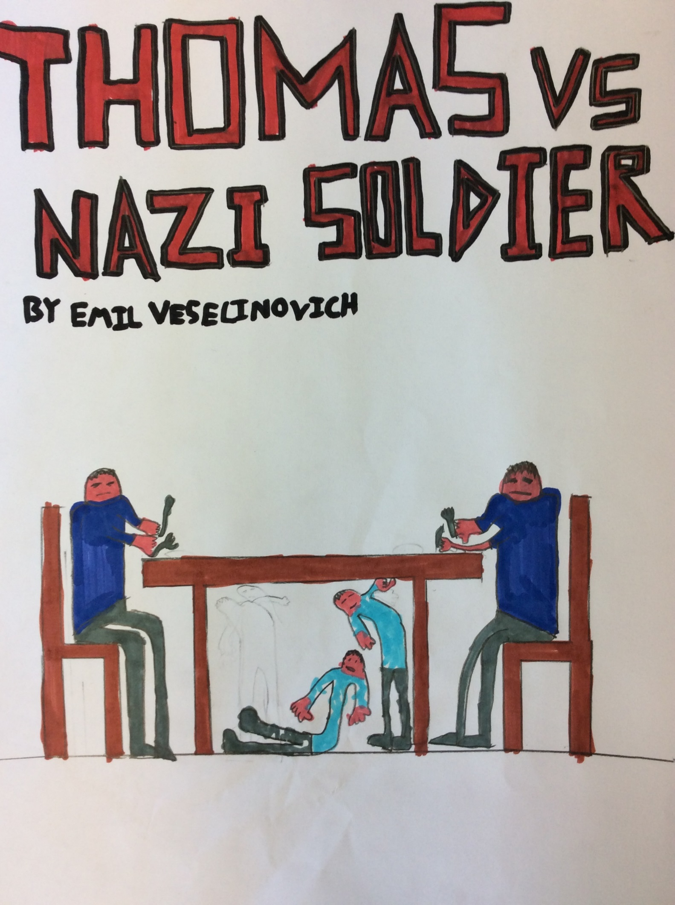
Thomas vs Nazi soldier

Thomas cleaned his rusty gun carefully which he had “borrowed” from a Nazi soldier. He sat in his bombed, dull house. A thick layer of dirt and rubble covered the dilapidated ruin. Frost had painted the house a silver crystal colour. Thomas’ tummy growled like a bear, his dirty cat purred as Thomas stroked him. It felt like running your hands over a keyboard. Thomas had small hands and fingers as thin as pencils. He had a bony face and button- looking eyes and a half broken nose. He was hungry and needed food. His head hammered and his mind was playing games on him.
Shivering, Thomas got to his slim feet. There was a crunching sound of rubble, sounding like biscuits getting crushed in a blender. There was a shallow hole in the debris of where he had been sitting for the last thirty minutes. The cat stayed exactly where he was. Thomas swiftly walked out of the broken door. There were dark skeletons of trees which had lost their leaves. There was white, puffy snow scattered all around. Everything was normal. Thomas started peeking through all the windows for food. All of a sudden, Thomas stared through a foggy- frost covered window. On the other side, there was a Christmas dinner set up still blazing hot. The lovely smell of goose filled his nostrils. The window was open.
Suddenly, as he was about to climb through, he felt a freezing hand tug on his left shoulder. A chill went down his spine. He looked back slowly. It was Jan, his friend. “What are you doing?” asked Jan, curiously.
“I am getting the food from in there,” replied Thomas, pointing in. Jan was similar to Thomas. He had a head the size of a football, a mouth that only smiled rarely and lollipop- sized eyes. His scruffy clothes were torn and had coal- black soot spread all over them.
“Can I go with you?” asked Jan.
“Yes,” mumbled Thomas, hoping he wasn’t going to eat all the food.
As soon as possible, they climbed carefully through the window, one by one. There was a loud thumping sound as they landed on the rich wooden floor. They both had a look around, and there were two Nazi uniforms dangling from pegs. SLAM! The window shut closed from the wind and it started to pour with rain outside. Thomas gulped. They couldn’t get out. Jan was already eating greedily at the dinner. Thomas tried to open the window with all his strength, but he was slim and weak. Alarmingly, Thomas heard voices, Nazi voices. They both froze.
“Hide under the table!” Barked Thomas, running towards it. The door creaked open and in came the two Nazi soldiers.
“I swear there was more food on the table,” growled one of them, they both sat down and tucked in. Thomas’ heart pounded out of him like a drum.
“Its boiling hot in here, let me open the window,” said the other Nazi soldier.
Suddenly, Jan banged his head harshly on the table. “OUCH!” he yelled, rubbing his head.
“Who said that!?” Screamed a Nazi soldier. Thomas felt like kicking Jan, he had given them away.
“It sounded like it came from the other room” said a soldier, running swiftly in.
“I agree” said the other soldier following him like he was his shadow.
“We can eat more now,” mumbled Jan, getting up from under the table.
“NO!” Yelled Thomas, a little too loudly, “they will come back in!” Jan ignored Thomas like he had no ears, this was his chance to have food. All of a sudden, the soldiers ran back in.
“I heard a voice!” said a soldier, forcefully, “there must be ghosts in this house!” Thomas bit his tongue hard, he wanted to laugh. All of a sudden Jan laughed and made Thomas automatically laugh his head off.
A soldier popped his head under the table, “OI!” He yelled, which made Thomas and Jan jump. Thomas got up and ran, he banged his head and there was a shattering sound of a plate on the table above him. Jan followed him. Thomas felt a hard tug on his battered shoe.
“We got you now!” said a soldier. Quickly, Thomas pulled his foot out of the shoe and hurled his other shoe in the soldier’s face.
“Ouch!” said the soldier, running out the room again. The other ran soldier ran away too. Jan started eating greedily at the remains of the Christmas dinner again.
Thomas felt weak after all the scuffle, his sausage- shaped fingers felt like they were going to fall off. His heart began to even out again, beating slower and slower until it was normal again.
“Let’s go now!” Demanded Thomas,
“No way!” said Jan, gulping down a glass of alcohol. Thomas went and climbed through the window. It was bucketing with rain and in seconds, Thomas was soaked through. He ran down the damp valley to his dilapidated, bombed, dull ruin of a house. Dark houses loomed over him like giants. When he looked back, he could see a bright light coming in from where the Nazi house was. Clouds of thick mist snaked around the place. The floor was slippery of snow and rain. Suddenly, there was a screaming sound behind him and the light switched off, leaving the room in total darkness.
“Jan?”

By Emil

