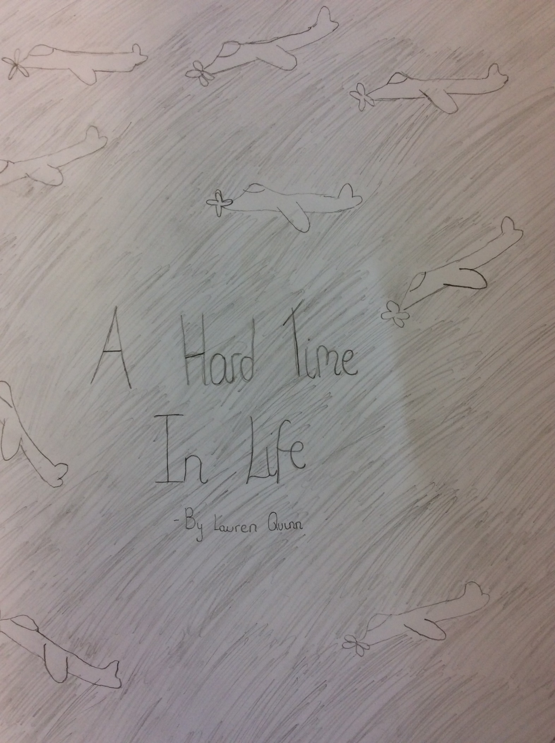

A HARD TIME IN LIFE
The young girl sat in her caged bed, her heart breaking. Outside soldiers were shouting orders. Her pale body shook with fear, where was her mum and what were they doing to her?
All of a sudden, a strong hand shook her shoulder, “Come out here right now girl,” a rough voice said, “and don’t make a noise.” Timidly Maria stepped out of her warm bed into the harsh, biting cold.
Maria’s brain swirled. The concentration camp was worse than she thought it would be and now she would be staying there for the rest of her life! The thought was too much and all of a sudden salty tears ran down her pale face. She was pushed into a warm space where a fire was blazing and a young women was sitting, stirring a pot of warm, hideous looking stew.
“Come here dearie,” she called “Why are you upset?”
“I only had mama and now she is gone.”
“Well doing work will distract you so go and get some bread and butter. HURRY! I don’t have all day.” she said briskly.
“Yes miss.” said Maria timidly
As the little girl walked through the camp, she saw the most horrible sight ever. It was like a nightmare but real life. Suddenly, she closed her eyes wishing her mum wouldn’t have stayed in that terrible place. Unexpectedly, something marched into her and sent her dainty body flying.
“Oh, I’m sorry,” a gruff voice said, “where are you going anyway?”
“Well I was trying to find my way to a bread shop,” she said, “Do you know where I can find one?”
“Yes,” he said and handed her a map,” good luck!” Beginning to walk away, he then changed his mind, and started to accompany her. The soldier ushered her through the gates of the concentration camp, lifting her above the fences topped with spinning spirals (which could easily send a person to their unfortunate death.) After five silent minutes, the soldier came to a stop.
“I cannot go any further with you, for the rest of the way you are on your own. Goodbye! The map will help you so don’t lose it!” and with that he walked off. He ignored Maria pleas to go the whole way with her.
Slowly, she walked on, realising that life is never quite as easy as it seems. There are always difficult parts where without perseverance you couldn’t survive.
Maria’s legs ached like crazy. Her heart was beating twice as fast as normal. Her dainty mouth was choked by the hot dust from the bombed streets. She came to a halt outside a dilapidated building that was half blown up.
“What? You wouldn’t be able to get bread here!” she muttered, “I must have took a wrong turn.” Her eyes scanned the map “No I’ve followed the directions, the war has ruined another of our buildings! The soldier must have known it was destroyed and tricked me.” Salty tears ran down her pale face “Oh no,” she said “I now need to find my way back!” And off she set dragging her tired feet down the roads, struggling to keep her eyes open.
Maria’s eyes widened at the sight of the camp, it suddenly looked smaller than it had before. The walk to the ‘shop’ had seemed so much bigger before. Just as she was about to give up and go back to the kind lady in the kitchen, she saw the soldier in a bright fighting field nearby. She used the last of her strength to haul her legs into the field and perch on a rock just behind where the soldier was standing. He seemed to be waiting for something.
Out of nowhere, a voice appeared and said, “Johnny, have you got rid of that girl?”
“Yes sir, the girl won’t be back for a while.” The soldier said.
Maria couldn’t bear it for any longer and suddenly she leapt out of her hiding space, jumping in front of them.
“But, but-”
“I have come back early,” she snarled. “I am not going to be tricked now!”
Mysteriously a figure appeared in the distance, running as fast as a person could run.
“Mamma?” Maria questioned, “Is that you?”
“Be careful dear!” Screamed Maria’s mum. Maria spun round to see the soldier loading his gleaming pistol and she froze... A flash aimed in front of her, missing her by a millimetre
“Stop! Johnny leave my child alone!” screamed a voice, “You kill me not her!”
“No, I need you but she is useless!”
“I have tried to be nice now but now I will use my secret weapon!” Maria’s mum screamed, doing an army lunge, knocking down the guard. She leaped for the other one and missed but he was too scared to come back. Maria and her mum embraced each other, realising how much their little family meant to them.
“Let’s stay together,” whispered Maria “and I will be more careful of what I believe now.” She said, growing with confidence. They settled down in the comfy fresh heather, getting ready for a good night sleep without any disturbance.
By Lauren

