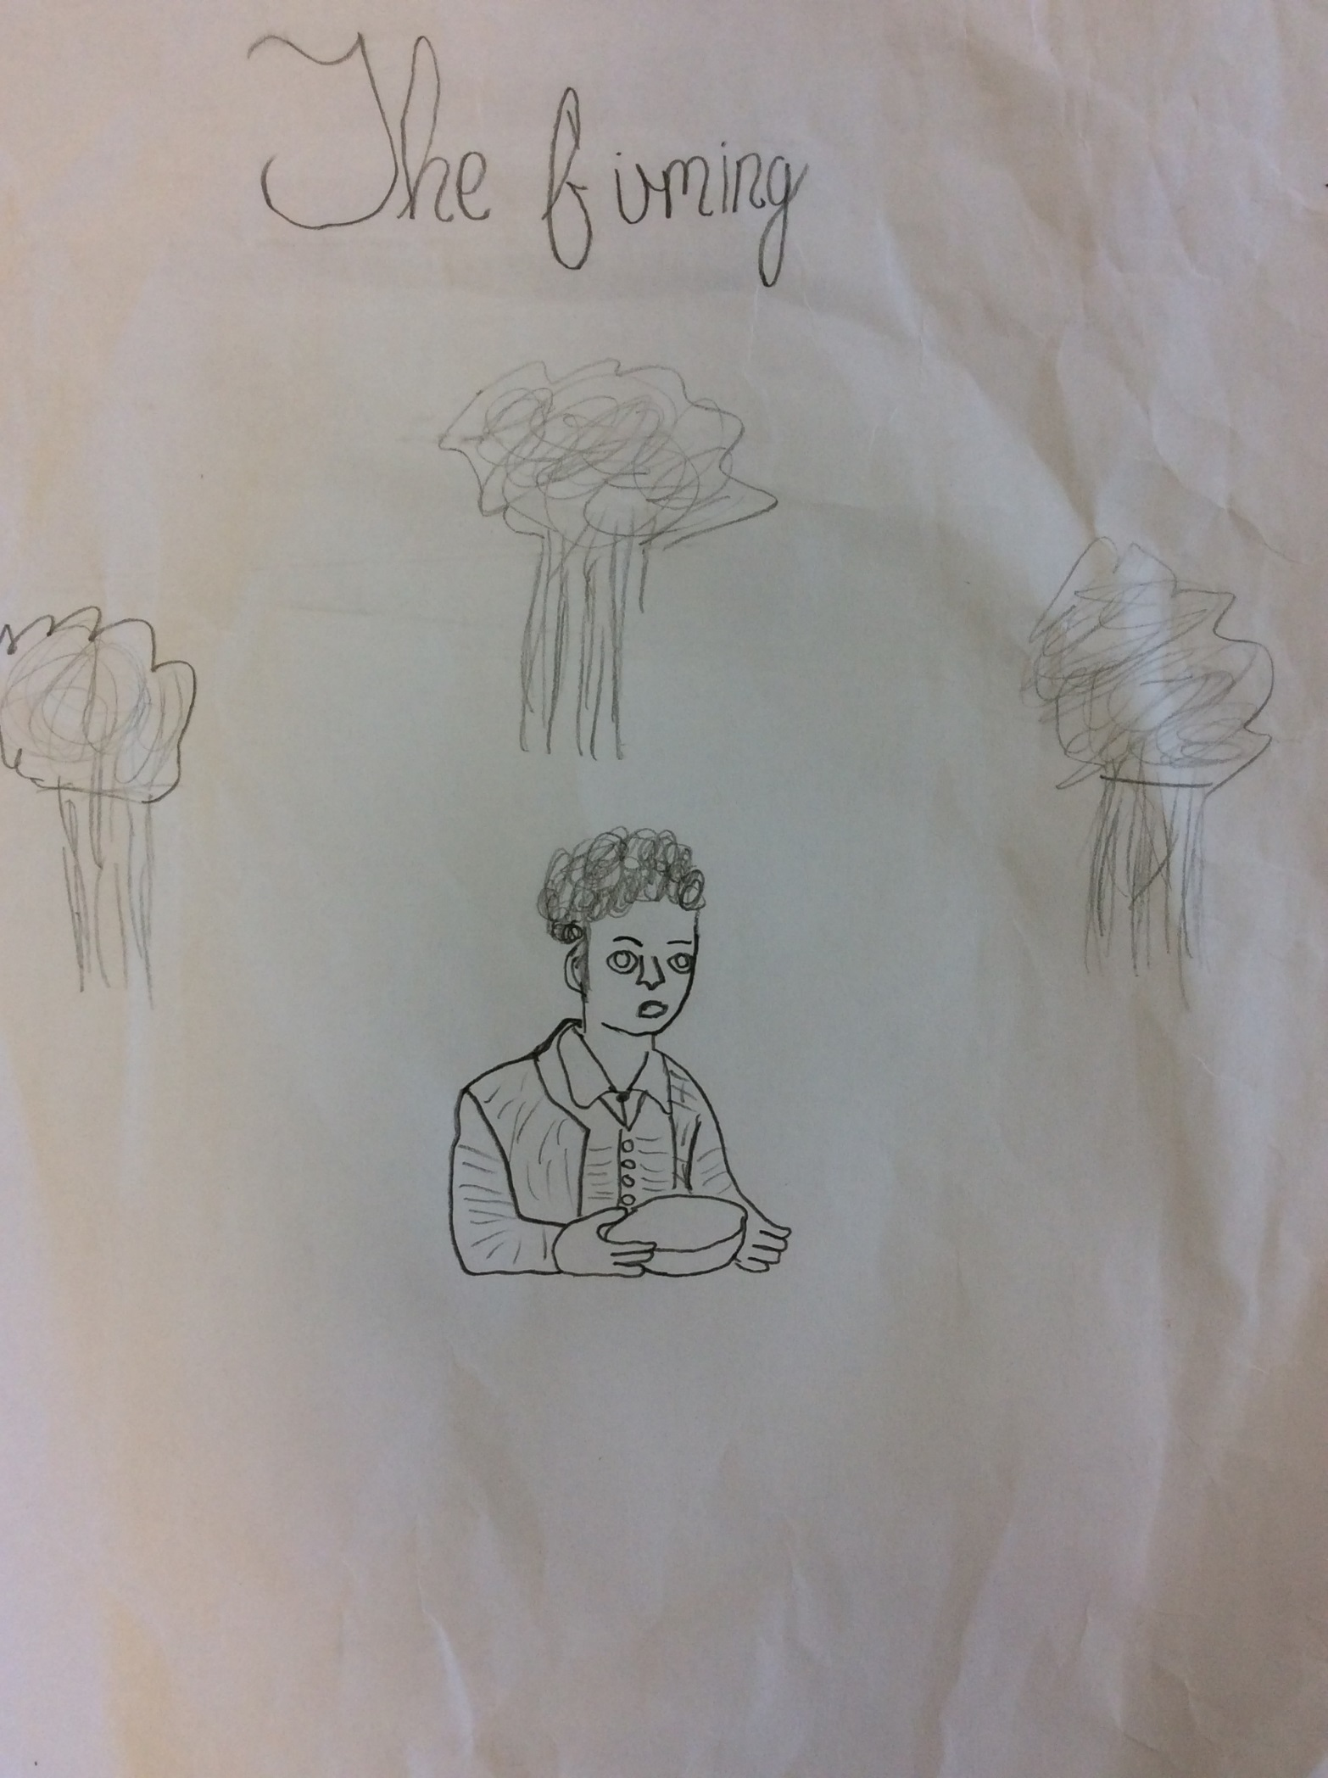

THE FAMINE

It was another day in the War, and Jan was starving to death. He had been hiding from the Nazi’s. His mouth had never spent that long without food, so he decided he needed to go and steal from the Nazi’s.
Off he went on a journey that could decide whether he lived or not, he had no weapons and no one to help him. His feet were aching. He had been walking for ages… his blisters had blisters!
“Help,” cried a boy from the shadows. Jan wondered if that was his imagination or if someone was actually trapped. Every step he took he got closer and closer, then out of nowhere a boy was there all alone. “Can you please help me?” said the boy.
“Of course I will. You can come with me. I’m going to the Nazi headquarters .They’ve got a new shipment of food” said Jan.
“Are you mad? You’ll never make it out of here alive!” said the boy.
Whilst the two boys were involved in their conversation, they didn’t realise that the whole time that they were speaking, a Nazi soldier had heard every word. So off they went, not realising the danger that they were in.
“We have to get there before sun goes down. That is when all the Nazi guards come out.” Explained Jan.
“Why?” Asked the boy.
“This is England. I don’t know where you’re from but here we do things the difficult way, and always traditional.”
“Oh I forgot to ask you, what is your name?”
“Thomas” the boy replied.
“Okay Thomas, follow me, “said Jan.
The Nazi soldier had already arrived at the Nazi headquarters where he was waiting for Jan and Thomas.
They had finally arrived. “Here we are,” said Jan.
“Stop right there!” demanded the soldier. All of a sudden Thomas’ face turned as red as a tomato.
“Oh no. This is it. It’s over for me,” said Thomas.
“RUN!” shouted Jan.
“If you take one more step I’ll shoot, “warned the soldier. Then Jan had an idea.
“If we pretend to faint, then he’ll come over here and then we can get his gun?” suggested Jan.
So that was exactly what they did and got everything they wanted and more. From that day forward, Jan didn’t take anything for granted. He thought about it first.

By Leon

