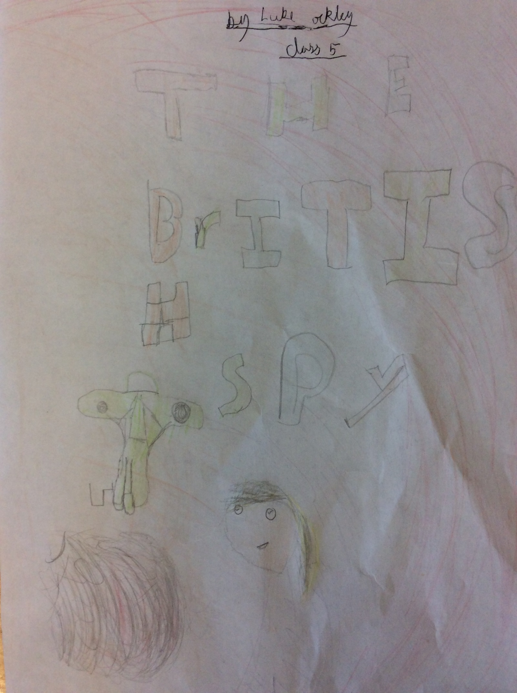

The British Spy
Elizabeth ran as fast as she could. Her feet were killing her not the bullets fling past, eventually she out ran them. She walked back to her base. The General walked up to her and said, “Elizabeth you need to go to Germany and collect information about the tiger tank.”
“Give me a break,” she said.
“No you’re a spy” he yelled.
“Ok, ok” she said. “Now go,” he yelled.
On her way to the Train station she heard a voice. “ELIZABETH!”
Did she dare turn around? When she turned around she said, “How do you know my name, and who are you?”
She looked at the person who had shouted her name. He looked well fed and clean but then… Ruth, Elizabeth’s dog appeared.
“Get that dog away from me!” shouted the man.
“Why?” Elizabeth asked.
“I am, achuu allergic.” he said.
“Ok ok.” she said.
“Come on Ruth. I need to tie you up.” she said.
“Grrrrrrrrrrrrrrrrrr,” Ruth growled loudly.
“There’s some information about the tiger tank in the SNA camp,” he whispered.
“How do you know this?” questioned Elizabeth.
“Ur ur I have some bread if you want it,” said Hans (the man) as he changed the subject.
“No thank you,” she replied. “Now will you help me as I need to collect information about the tiger thank and you have the information that I need?”
“Yes. Yes I will,” he laughed.
“Why are you laughing” she asked.
“I am not laughing…. I am… er… chocking,” he lied.
“Oh no. I am so sorry,” she said embarrassedly.
“Where is the tiger tank?” she asked.
“I will take you there.” he said.
They were walking for one or two miles and Elizabeth asked hundred questions. Why are you here? What your name? How old are you? Who sent you here from our base? Where do you come from? Are you here to help me?
“Hello are you there?” asked Elizabeth.
“Shhhhhhhhhhhhhhhhhhhhhhhhhhhhhhhhhhhhhhh!!” he said.
“Ok why?” she whispered.
“We are here.” he whispered.
“Well come on then. Let’s go.” she said as she was running towards the base.
“5 4 3 2 1…” he whispered under his breath.
She saw a hole in a tent and she ran for it. As she got closer she saw something shiny. However, when she went in, it was a trap and she was in a cage. Hans shut the door and looked the door!
“Why are you doing this?” she said confused.
“I hate you” he said.
“Why?” she said.
“You achowuu!!” he sneezed.
“Grrrrrrrrrrrrrrrrrrrr!” Ruth had escaped and come to Elizabeth’s rescue.
Elizabeth took the cage keys from Ruth’s mouth and unlocked the cage. She ran and she ran – never looking back.

By Luke.

