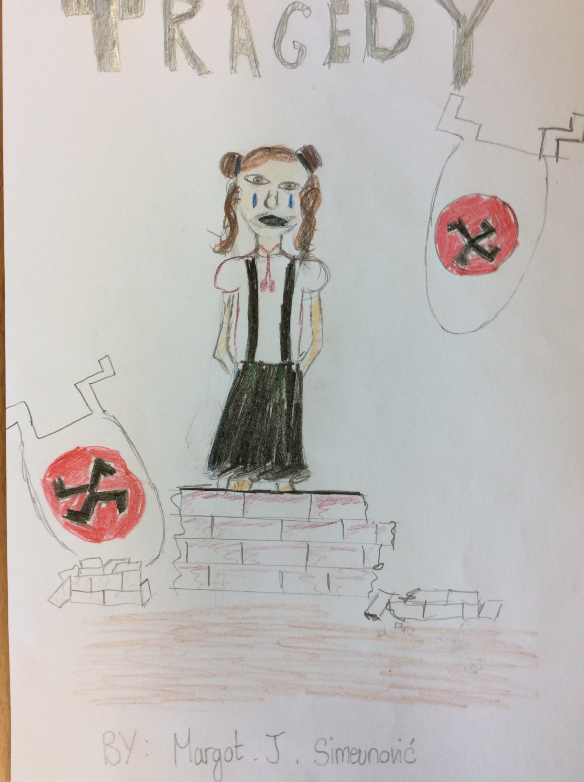
TRAGEDY

The dull ache in Jasmine’s stomach grew, she clutched against a small loaf of bread she had to steal from a working market to her chest, as she hid behind an abandoned fruit stall. Jasmine was a pale girl who had auburn hair with some red strips. Her desperation for food began to grow and was playing games with her mind. The loaf of bread she stole just wasn’t enough to keep her body sustained. She was getting thinner and thinner by the day, her skin was getting paler and it appeared to lighten up more and more each day. Jasmine knew exactly when the supplies would come to the local German Camp, not that she would get much out of it. She thought that she had to go and get food.
So with a determined look on her face, she set off on a risky journey to go and steal food from the Germans. Suddenly, on her way she saw a Nazi Soldier and hid. Jasmine’s body started to tremble with fear, she was in two minds, whether she should go back to her boring, old but safe home, a hidden cellar underneath a clutter of her old house ruins. However, Jasmine knew that she had to go on - it was for her own survival. So that is what she did. Creeping slowly, she went in the direction of the creepy German Camp. When she came to an abandoned market, she hid behind a fruit stand when a Nazi saw her but she made a quick and lucky escape. When the coast was clear, she rushed down an alleyway, before turning a corner. It was a dead end.
“HALT!” called a deep voice, Jasmine couldn’t tell or see who it was but she knew it wasn’t very familiar. The voice echoed. She was in a pitch, black alleyway tunnel. Jasmine shuffled a couple of steps, when a lantern lit half of the tunnel up and a face appeared in front of her; a broad, manly face. She looked up and saw an army General’s cap. She froze of shock when she could see the cap was printed with the red and black Nazi flag. Jasmine turned and started to run. When she was a metre away from the tunnel exit, a hand grabbed her and tugged her away from the exit. Jasmine turned around to see again the face of the Nazi General. She looked back at the exit and standing there was a gigantic clutter of Nazi Soldiers.
A van pulled up next to the tunnel, Soldiers grabbed her. Jasmine was frightened for her life, what were they going to her? What if they were going to kill her? Surely they wouldn’t do that, I’m too young to die she thought! So they chucked her in the van very, very harshly and carelessly.
“Take her to Auschwitz!” ordered the General.
Auschwitz was horrible, Jasmine had never seen anything like it before! She couldn’t believe what they did to people - especially children. The time came when Jasmine had to get her camp number. When she did it, it burnt. All she could feel was pain and see hot steam coming out of her arm. Jasmines number was 213098650117421.
Jasmine hated it in the concentration camp. It was 1944, so she hoped the war would end soon. Well she was partially happy because at least she made some friends that she didn’t want to lose. Jasmine and her friends Millicent, Gretl, Brigita and Leisel. They knew they had to escape, but Auschwitz was maximum security. So they had to work quickly, quietly and carefully.
They had to get the soldiers weapons and keys, so that they could free all the prisoners and give them weapons so they could defeat or knock out all the Nazi soldiers so that they could blow the camp up and be free. They were worried about what would happen to them if something went terribly wrong.
The following evening when the soldiers were changing shifts, Jasmine pulled a bobby pin out of her auburn hair and unlocked her cell. She shivered with fear whilst unlocking her friends’ cells. Then they rushed off to get a set of cell keys each and as quickly as possible - released everyone.
They had to hurry up. The sound of Nazi soldier feet worried them - they only had a couple of cells left. They believed in themselves - they could do it! Finally, in the nick of time they released the last of the prisoners. Jasmine ordered everyone to get weapons - whatever they could find to knock out or seriously threaten the soldiers.
Once all weapons were taken, the Nazis marched into the ginormous, open courtyard. The Nazis stopped in surprise, to see a courtyard cramped with released prisoners.
“Drop your weapons,” shouted Jasmine to the Nazis, “What are we waiting for, attack!”
All the prisoners started to rush towards the Nazis with all sorts of weapons. However they were terrified, so they all fled for their dear lives instead of staying with Jasmine to fight the Nazi’s. Suddenly, underground bombs started to go off and there were explosions everywhere. All people in the camp fled for their lives.
Piles of rubble fell on Jasmine, but she was still standing strong. She also wanted to flee but her feet were stuck in heavy piles of rubble. There was a gigantic explosion under her feet and she collapsed onto the rigged floor. Dead.
The next year the Allies defeated the Axis Power. All who were in Auschwitz thanked Jasmine in their prayers and mourned for her when they heard that she was dead. Where she died (in the ruins of Auschwitz Concentration Camp), the people who she freed built a statue of Jasmine in memory of her bravery and how she freed everyone.

By Margot

