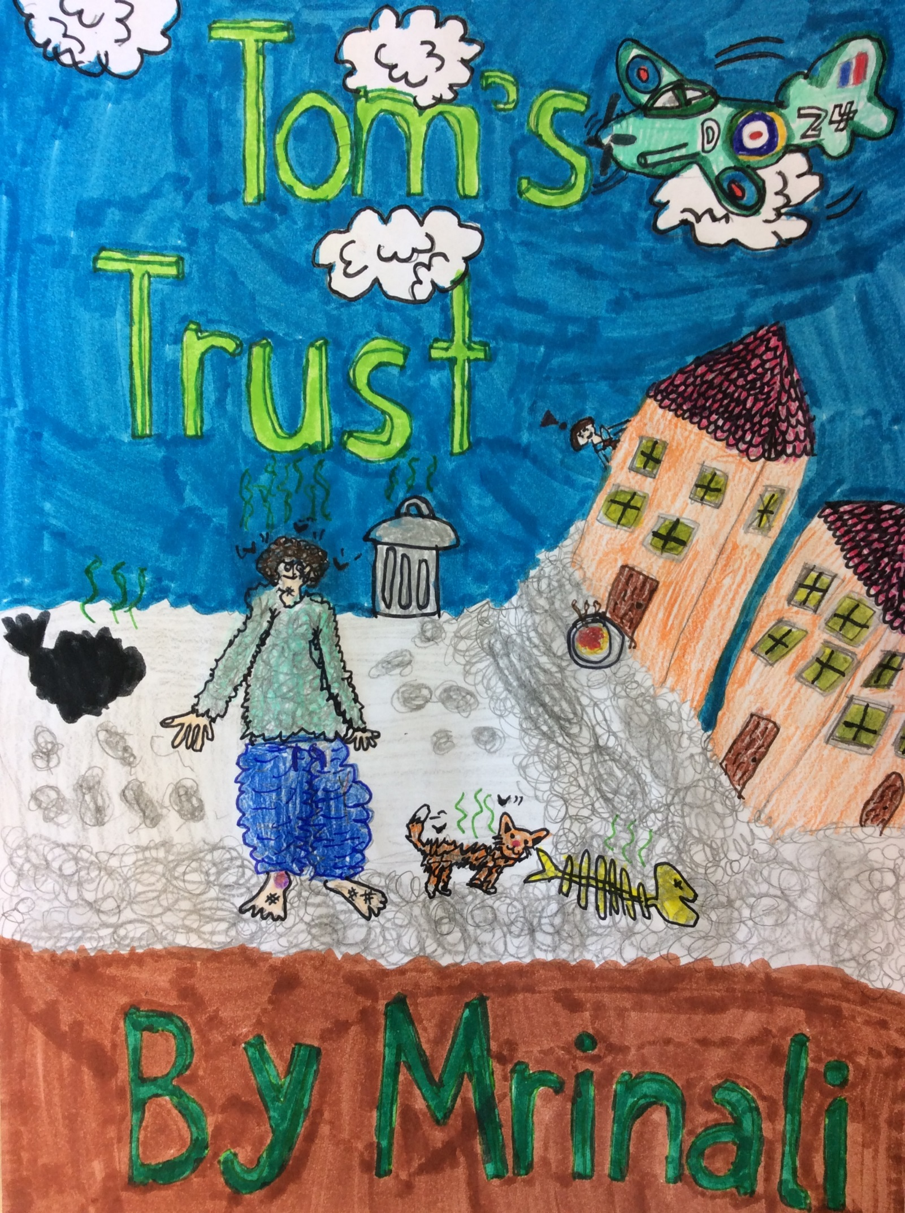

Tom’s Trust
In the middle of the burned, ruined streets of Poland, lived a 16 year old boy, with jet black hair, and a few streaks of dusky grey hair. He was nearly as thin as a stick man and he only wore a thin knitted jumper, that was a faded green turquoise colour, and a baggy tracksuit, which was pretty loose. The only reason why he was surviving, was by drinking from the puddles produced by rain, which were often contaminated by smoke and pollution.
“Right, it’s high time now that I went and looked for food Tom! It’s winter, Christmas is coming, so I’m sure people would be courteous enough to offer me food and drink. Any type would do, because at least I can get food!” So Tom started to swiftly crawl. You could see the cautiousness on his face, and tension built crazily in his tummy, just like 1000 bees in his tummy busily buzzing everywhere, and his tummy being the hive.
He crawled in and out the bramble bushes, his eyes shut tight, so they aren’t damaged. Although he had to control the pain and discomfort of the thorns that pierced through his cheeks and fingertips. Gory blood trundled down like the gushing rain in April. Suddenly, he felt a slight tap on his nit infected head. That was when his fear progressed eventually. At first, he thought it was his sleet grey, bony cat, Pussy. Because of her bones, it gave her a ghost like appearance. Then, he heard a chesty cough, so he thought it was a Nazi, but as he hesitantly looked up, with his chipped, yellow teeth clattering, his blood freezing, and fat goose bumps popping up one after the other. He could see it was actually his friend from primary school! Albert!
“Hi A-Albert! I really haven’t seen you since I was eleven, it’s been four years now!” Spoke Tom, with a sigh of relief.
“Oh, hi, Tom.” Muttered Albert, seeming puzzled.
“W-What’s the matter? Anything wrong?” Asked Tom, nervously.
What was Tom was up to? Just a few seconds later, Albert gave a response. “Um, ugh, no. It isn’t really anything. It’s just that…”
“Yes, Yes, I know what you are talking about. Unfortunately, I don’t have parents anymore. They p-p-passed a-away. This is the reason I am fully famished. N-no one maintains my health and safety. I-I am exclusively isolated.” Sobbed Tom, with deep sorrow.
“Oh, I see, sorry. But hey look on the bright side! You know, when I was walking here, I did see a hot bowl of, I think it was spaghetti bolognaise.” Albert confidently said.
“Wait, no, you did? Well I guess in that case, I’d better get going! Where is it? Where would I stay?” He said with pure excitement.
“Yes, indeed.” Replied Albert. Staring at Tom with sly eyes, and a cunning smile. Little did Tom know that Albert would be following him, watching every move that Tom makes.
He stumbled and tripped, on the rusted metal, with his foot aching and throbbing with splinters that had pierced through his reedy, scrawny feet, and his few verruca’s stung with additional soreness, once it gratified the ground.
“OW! EE! OUCH! OOH! AAH! EEK!!!” Although, he didn’t let his pure, priceless hope turn into cavernous distress. Soon after the fifth time, his skeleton like face hit the dirt filled creased newspaper, in the corner of his infected blood-red eyes, he could see a twinkle and a polish shine of a –
“A plate! That’s the one! Spaghetti bolognaise, only about seven steps away from me!” Tom screamed as thunderous as he could, not being considerate about anything or anyone. Tom ran as fast as his legs could carry him, but as he was diverted by his charming bundle of happiness and joy, his pains throbs and aches were cured by his long lost thing that was essential for him.
He sat next to the food, totally overwhelmed, but just before he hogged a handle of spaghetti, he noticed a tablet that looked precisely familiar to him.
“What is it?” Tom enquired himself. “Come on Tom, you know it!” He picked it up and gave it a sniff. His dad regularly told him two days before he went to war. “POISON! That’s it!” And therefore, he threw the no more precious plate of “nutrition” at the back of himself, with an energetic hurdle. He turned around, the glossy plate hovering in the air, and suddenly, just as expected, a CRASH!! Tom could hear the miniature chips of piercing ceramic tinkling onto the ground. Although additionally, he heard a lonely squeal, a lonely squeal of wholesome agony, therefore Tom observed what was going on behind his skeletal back, and Tom’s squinted eyes opened precisely broad, as they were jam-packed with astonishment.
“What, Albert? Really? Seriously? You were following me all this time? For what?” Asked Tom, pretty perplexed. Albert suddenly felt his delicate, petite skin drain off himself. Tiny goose bumps popped up on his shoulders, one after the other. His weak, wobbling adult incisors clattered together, every millisecond. But as soon as Albert was biting his razor sharp nails, Tom finally understood.
“IT’S YOU! ISN’T IT? YOU WERE THE ONE THAT LACED MY FOOD, WITH POISON? YOU WANTED ME TO DIE!!!” Raged Tom. He squinted harshly, his septic blood red eyes had transformed into mountainous, bulgy eyes, although one thing that remained the same was his blood red eyes. They weren’t inflamed anymore, instead they had become gruesome fiery red eyes, full of fury. Albert shivered and gulped with fear.
Barely alive, Albert finally surrendered in. “y-y-ye-yes!!! I-I H-Ha- have p-p-poisoned the f-food! Whatever y-you said is tr-tr-tr-true!” Albert let out his fear, and hoping silently in his troublesome mind, that Tom was not going to punish him, behind his back. Just before Albert could flee, Tom gave him the beady eyed, squinty look. “Don’t you even think about it, Don’t forget, I’M WATCHING YOU.” So Albert stayed there, just like an obedient puppy. Tom knew that Albert’s “surprise” punishment was still due, and therefore got on with it, immediately.
Pussy, Tom’s trustworthy cat, sat beside Tom, hissing inaudibly at Albert. Abruptly, as soon as Tom glanced at Pussy, he knew just what to do. Tom mutely whispered in Pussy’s bony ear. Albert looked perplexed, although he tried his best not to express it in Tom’s presence. But just what was he saying? After two minutes, Pussy meowed, while shaking the oxidized bell on her filthy collar. Pussy took a swift run up, and leaped indignantly, onto Albert’s face, and gave him a large, wet lick on his right cheek. In a blink of an eye, Albert’s whole face began to swell up like a plump tomato. “AAHH! SAVE MEEEEEE!” And Albert ran off, into the obscurity, dullness and emptiness of the night.

By Mrinali

