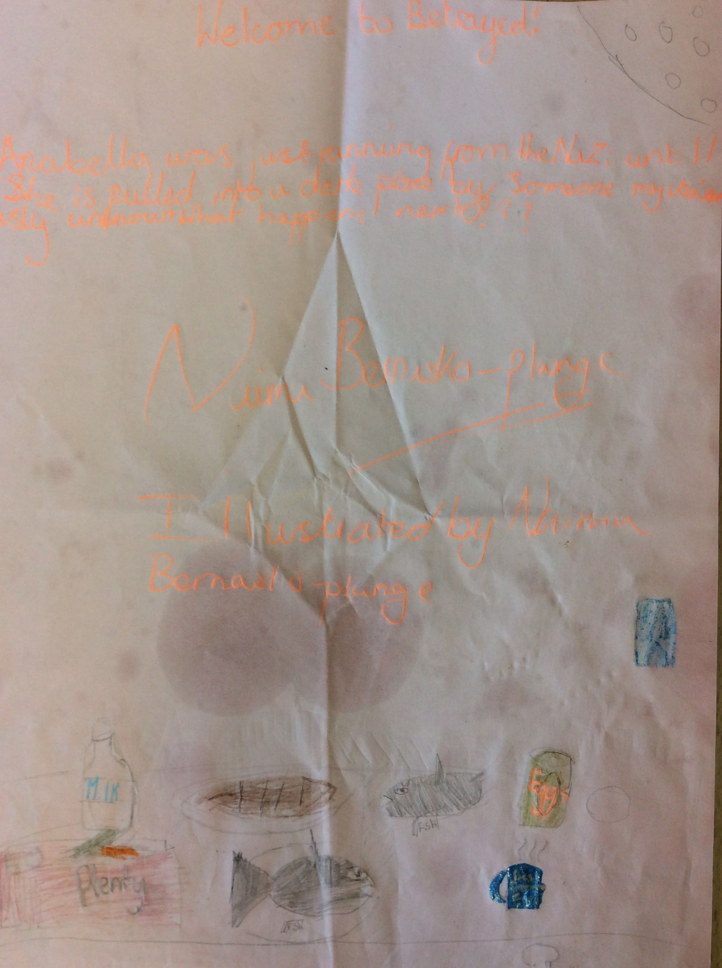

Betrayed
Panting heavy, Anabella ran as away as fast as she could - just to get away from the Nazi’s. She was wearing a brightly coloured dress. The reason that she was running away from people in her own country, was because she stole food from them. Stupidly, Anabella ran into an alley way and became cornered.
“I got you now!” said a German soldier and looking proud about it.
“Don’t you mean WE’VE got her,” said his partner, with an angry look on his face because he did all the work.
“Well… I ran after her whist you guys were walking,” said the first German soldier. While the two soldiers continue to argue, Anabella was pulled into a warehouse.
“Mmm…” mumbled Anabella. Anabella was trying to breath but she couldn’t and fainted. She woke up with her head resting on a rock-like-pillow.
“Where am I,” said Anabella. Anabella threw a raged old cover off herself, and entered a big warehouse where she found a group of three people altogether. “Claire, Tom, and John??”
“Anabella, is that you?” Said Claire. The three children now slowly turned around, eyeing Anabella carefully to see if she was not a fake Anabella.
“Yes, I’ve missed you all,” said Anabella. The three children ran up to each other stated hugging. They thought that they were united once again, but one child was thinking something else, thoughts of betrayal, thoughts of trickery, and thoughts of how the Nazi’s would reward him for his loyalty.
“Can Anabella join our group? “Said Tom. When the war began, Claire, Tom and John’s parents all died in the same street, the same place and the same pub. So the group decided to make up a name for the group ‘The Lost Children.’
“Of course she can - our best friend to the end,” said Claire. John envied this already. John had tried to introduce one his friends into the group, but at once, before they had even met him, Tom and Claire had said “No!” because the whole group had to know the person. However, John had told his friend the address of where they were going to meet. He knocked on the door, but Claire and Tom were inside and didn’t answer the door, because they were too tired. A Nazi saw the boy and shot him for being outside late at night. He lay there dead and alone, without anyone to grieve for him. John had found him the next day.
Suddenly, John felt angry and frustrated. “Well you can’t just join the group, you have to do something for us,” said John.
“John. I don’t it’s a good idea, she could get hurt,” said Claire.
“Shut up Claire. Go to the Nazi camp. To get food. Now,” said John.
“John, I think your over-reacting and plus it’s still daylight,” said Claire. John stormed out angrily.
“We go at 8:00pm and return at 3:00am,” said John. John thought to himself - what am I saying? She’s not going to return until she’s dead.
8:00pm
“John, are you sure this is a good idea? I mean we could do something else?” Said Anabella. John said nothing. Once they got to the Camp, John finally said something.
“Ok you go in through the front and I’ll go through the back.” Said John. Anabella nodded her head. The moment she walked into the camp she was immediately captured and was knocked out…
“Where am I? Why is it so stuffy?” said Anabella. Anabella’s eyes immediately were wide open.
“You’re in a prison cell.” Said John. John knew she would suffer just like his friend did, dead and alone.
“John is that you?” Said Anabella. “Why are you in a Nazi suit? You’re not a Nazi soldier!”
“Anabella – I am a Nazi soldier, and I don’t like you or your pathetic friends,” said John. Anabella moved back in fear but hit her head against the wall. “Don’t worry - I won’t be here to scare you,” said John. “Get a number tattooed onto her arm by tomorrow. Got it?!”
“Got it boss!” Said the Soldiers. Anabella thought to herself what am I going to do now? I am going to die here. Just then she noticed a red button. Wait I’ve got it! All I’ve got to do, is press this red button on this machine and I’ll be out of here in no time so I don’t have to worry about anything.
Anabella tried to stay positive, but kept thinking to herself - what if they don’t come? What if they are like John? A traitor? Out of nowhere, John came inside the prison cell.
“So Anabella, I’ve heard that you are very popular to the children that are on the streets - tell me where all of the children are!” said John. “If you refuse, I will keep you in here forever.”
Anabella shook her head, “I will never give away where my friends are,” said Anabella.
John laughed, “You’ve made the wrong choice,” said John. However, before he could finish his sentence, Claire and John burst through his door and Claire and Tom knew immediately what was going on. They pushed John into a cell and got Anabella out of hers.
“Let me go!” said John. “Anabella did all of this. She even told me to dress as a Nazi!”
“Save it John - we knew you would do this the minute you saw Annabella.”
“Tom, just leave it – don’t waste your breath. Let’s go home,” said Claire, who was feeling betrayed.
“Wait before we go, can we all get some food and drop some arsenic into the tea?” said Tom.
“That’s a great idea Tom!” said Annabella.
“Let’s go” said Claire. Quietly and swiftly, they dodged out of the way of getting caught, and put arsenic in every little teacup they could find and ran away with nobody hearing about where they went and what they did.
By Naima

