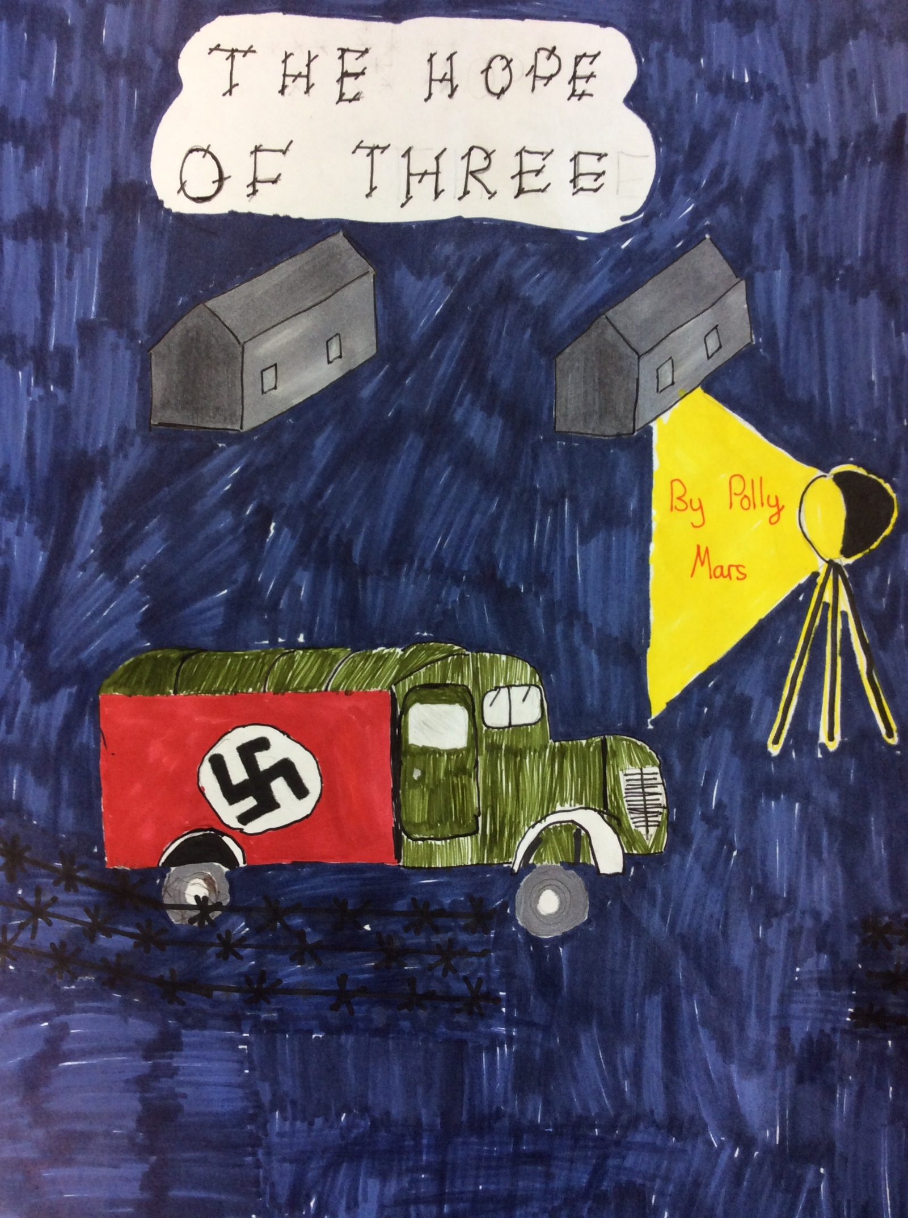

THE HOPE OF THREE

The house was silent. All that could be heard was the heavy breathing of the Watson’s children tucked up in their beds. Little did they know, but flying in the sky above Warsaw, was a group of German fighter pilots. They swooped through the sky hidden by a thick curtain of clouds. An army of bombs cascaded down from the night. All of a sudden, hundreds of explosions went off at once. Fountains of fire shot up into the air like orange fireworks slowly fading into the darkness.
Lucy Watson woke up with a start. The ceiling had collapsed on top of her, a huge cloud of dust floated up into the air. She scrambled out of the rocks to try and find her siblings. First, she found Gretle, she was the youngest and only three years old. Then Lucy was ten, and then her brother, Peter, was the oldest at twelve years old. Lucy lifted up Gretle and struggled over the ruins until she found Peter. They were all relived that they had survived the bombing. If they hadn’t been sleeping in their cages they would’ve been killed.
“Mummy, Daddy!” wept Gretle.
“Of course, we have to check if they’re ok!” shouted Lucy. The three children rushed to where their parents’ bedroom used to be. There wasn’t a person in sight. They tried to clear the rocks - throwing them rapidly over their shoulders. Underneath lay the bodies of their dead parents!
“What are we going to do?” said Peter.
“I want mummy!” screamed Gretle clinging onto Lucy.
“We need to find somewhere to stay!” exclaimed Lucy, “We can’t stay here.”
“I know,” said Peter, “we can go and stay at Granny and Grandpa’s in Wales!”
“But Wales is miles away,” cried Lucy,” We would have to travel all the way to England!” The three children pondered about what to do. They decided that they should try to get to England but either way they should set off. They walked down the dark, dreary street. Many houses had been bombed, they lay in ruins still crumbling loudly to the ground. Suddenly, they heard a whimpering coming from the alleyway next to them. A young boy in German uniform was sitting on the floor leaning against the wall.
“Are you all right?” asked Lucy softly.
“Yes… I’m fine.” He stuttered.
“Lucy, he’s wearing German uniform!” whispered Peter into Lucy’s ear. The expression on her face suddenly changed. She grabbed Gretle and Peter and started to run.
“No, please stop,” shouted the boy.
“I don’t want to hurt you!” Lucy stopped. She cautiously walked back still holding her siblings hands tightly.
“I’m not with the Germans,” he said, “I’ve just escaped from them, I was forced to be a soldier!”
“I don’t believe you!” said Lucy.
“Come on,” said Peter, “I believe him!”
“What’s your name?” asked Lucy.
“I’m Edek,” said the boy, “who are you?”
“I’m Peter, this is Lucy and that’s Gretle!”
“They’re nice names.” Edek said.
“Why did you escape?” asked Peter.
“Because I was secretly working for the allies when I was meant to be working for the Nazis!” he said.
“You were very lucky!” said Lucy.
Ever since Edek had escaped The Nazis had sent out a search party. As soon as they found him, he was to be sent to a concentration camp and killed. He had to lurk in the shadows so he wasn’t seen.
The children were starting to get to know Edek better. They were so engaged in a conversation that they forgot that Edek had to stay hidden. The children started to walk out of the dark alleyway. They strolled down the street not paying attention to who was walking towards them. Coming up the street was a large group of Nazi soldiers. By the time the children had noticed it was too late. The soldiers violently grabbed Edek and the rest of them.
“LET GO!” screamed Peter. But it was too late, they were thrown into the back of a strange van.
They were in the van for hours! They were ferociously bumped around as if they were doing it on purpose. Finally, after hours and hours the van slowed down. The door was flung open by a man in a smart grey coat. He pulled out Edek and pushed him to his knees. He pulled out his gun and BANG!
“NOOO!” screamed Lucy! Edek lay lifeless on the floor, his shirt turning red with blood. The rest of them were taken by the guards. They were flung into a cell in the concentration camp. They didn’t know what to do. That sat there still in shock from the ghastly thing they had just seen.
Peter, Lucy and Gretle were in an awful state. They had been in the camp for three weeks now. They smelt and they were starved. They had to find a way out. Luckily, one of the prisoners had been eavesdropping on some of the guards. There was a rumour going round that there was a provisions van entering the camp tomorrow night. It was heading to Warsaw. The children had to make their move.
The next night the children planned to make their escape. As soon as the sun had gone down, they started. There was a small trap door in the top of their cell. Before the war had started, Peter had been in scouts. He had learned to pick locks. He took Lucy’s hair grip and fiddled around in the key lock. There was a click and as if by magic the trapdoor flung open. They scrambled out, Lucy clinging tightly to Gretle. It was punishingly cold outside. The cold, winter air tickled their spines. They crawled along the roof of the prison cell searching franticly for guards. Once they knew the coast was clear, they carefully slipped of the roof and rushed into the shadows. The van was waiting exactly as planned. They waited until the driver came out and then snuck into the back of the van. They made themselves comfortable among the boxes and went to sleep.
They woke up with a start the next day. It was six o’clock in the morning. They were in Warsaw. The children peered gently out of the door. They were waiting for a good place to hide so they wouldn’t be seen. Suddenly, Peter saw the perfect place to hide. There was a small alleyway on the side of the street. They decided to make their move. The three of them jumped out of the van and made their way to the dark, deserted alley. The children were now safe they took refuge in an abandoned house and life was ok. They found food and water from bombed homes and locals invited them to dinner once in a while. They still went back every month to visit their dead parents and their house. They might have lost their parents, but they still had each other.

By Polly

