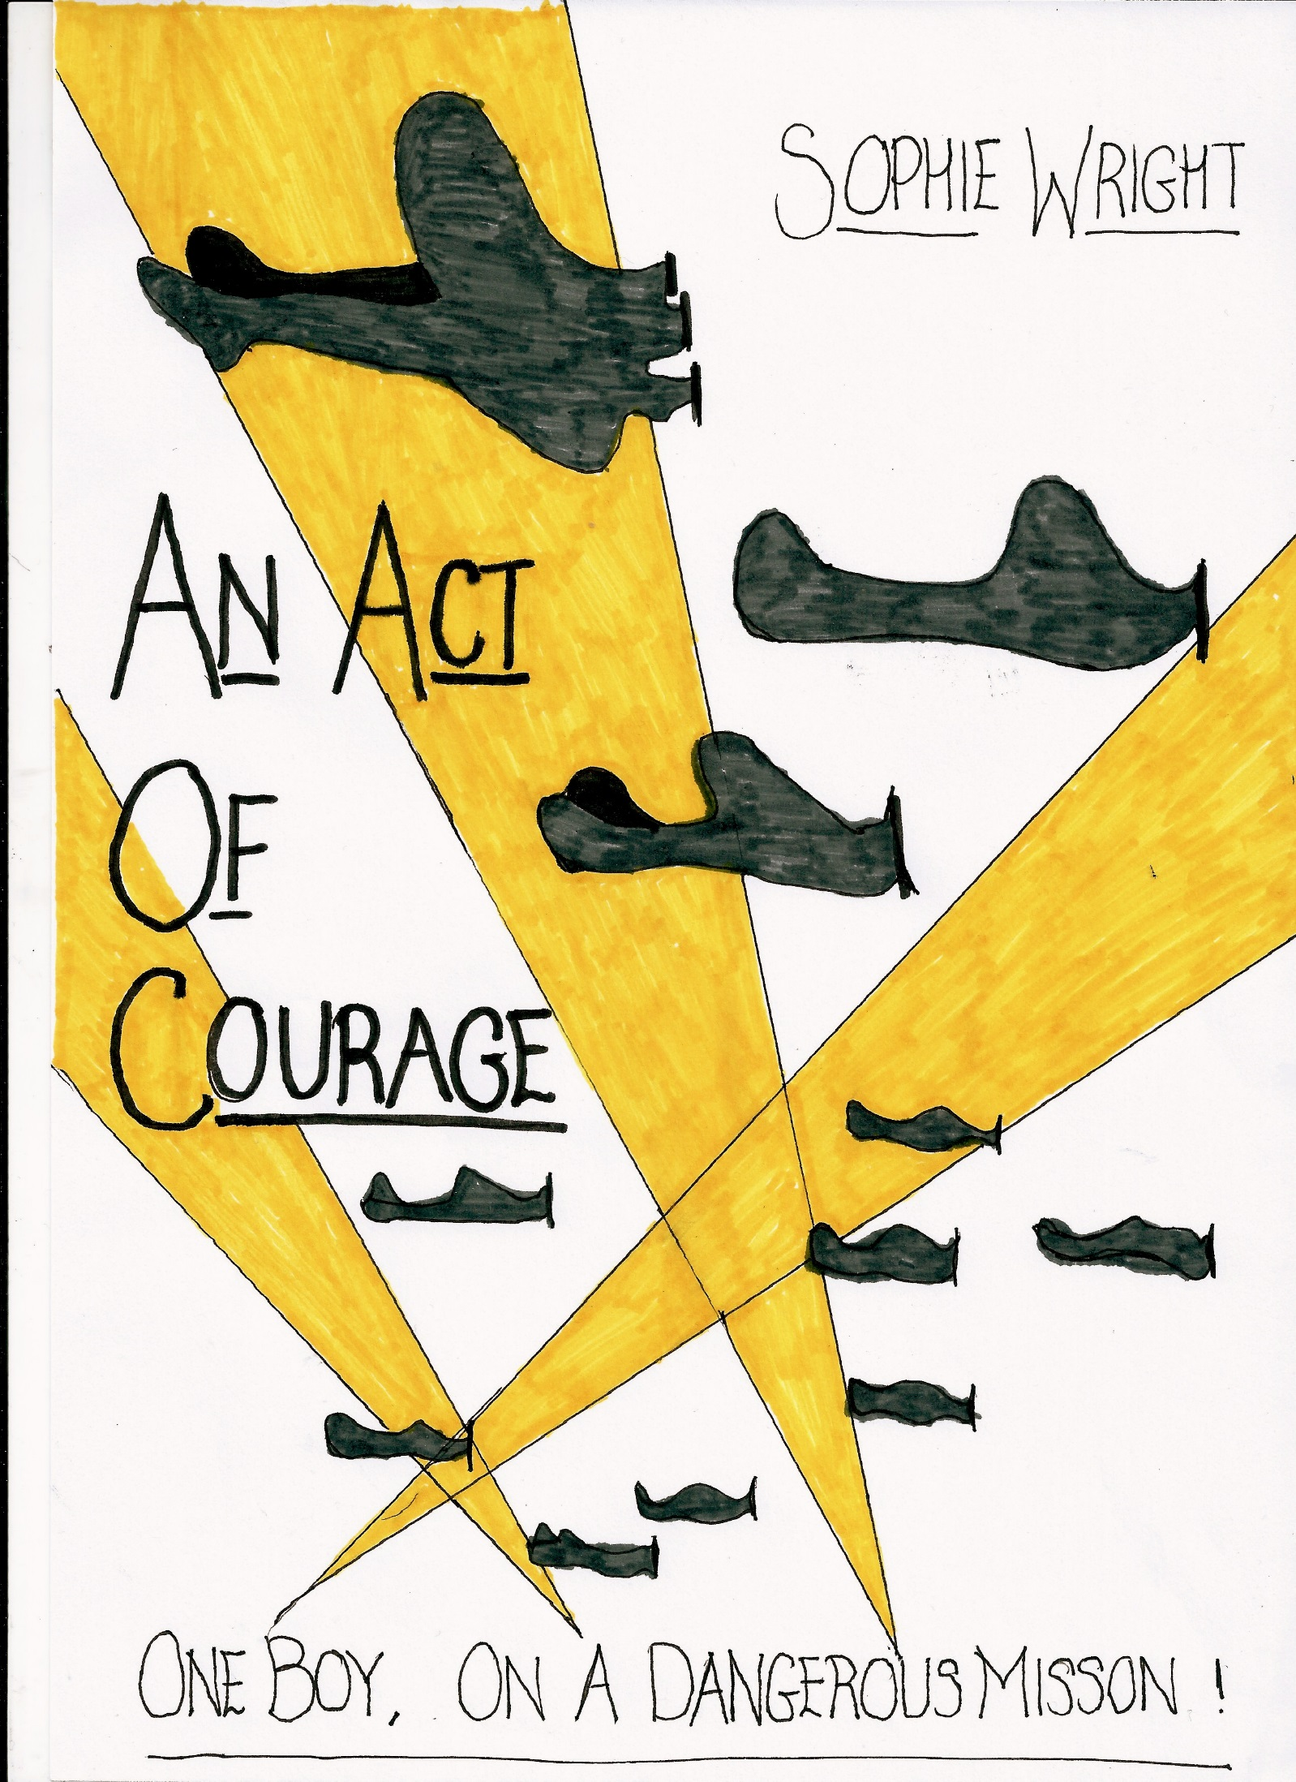

AN ACT OF COURAGE
It was September, 1942 and the war was getting worse…
Peter woke up to the sound of German voices shouting in the room next door. FATHER! He stood up, startled and ran to the door. It was locked. He darted to the cupboard and took out his rifle, he then pressed his head against the door and listened…
“Mr Thomas Smith, under the command of Hitler himself, we have been ordered to take you away to the German camp Shenael.” Peter froze. His face turned pale and a sickly feeling grew in his tummy.
Outside he heard the door of a van shutting and an engine beginning to start. In a rush to see where they were going, he held his rifle up and aimed at the door. Sparks of wood flew in all directions and when it was finally cleared, he ran through the door frame. He was about to run to his mother’s room, when he remembered… he had lost his mother and was determined not to lose his father.
“Slow down!” sweat trickled down his face as he ran. “Nearly, nearly, nearly, YES!” he grabbed the ledge at the rear of the van and swung himself on it, making it safely inside the vehicle. Catching his breath, he sat there, staring at the dilapidated and ruined streets of Poland.
Screech! The van came to a halt. “What, where am I?” Peter seemed to have dozed off and he had forgotten where he was. “Quick, run!” Voices approached him and he remembered the danger that he was putting himself in. He jumped off the ledge and hid behind some barrels. Just then, two German soldiers came out from behind the van and opened the rear doors. Out stepped his dad: cuffed and chained.
He gasped to see his father in this state, and then sunk back into the shadows. He had blown his cover… Thankfully they hadn’t seen him, but that was too close to repeat.
If he was going to survive, he had to hide. Desperately, his eyes searched the scene, looking for a possible hideaway. He crawled into a barrel that was open. Thankfully it had nothing in it and just in time too.
Armed men’s voices grew louder until they were just next to him. He inhaled the air and held his breath…
“Can you smell something?” the soldier asked his colleague suspiciously. Peter’s clothes were rank, they hadn’t been washed since his mother passed away (and that was almost two years ago!) The soldier grasped his nose and walked off.
“Phew! Let’s go somewhere else.” Peter’s malodorous clothes had saved his life! He scrambled out of the barrel and crouched behind some sandbags, peering through a hole in the wall. He watched his dad as he got thrown violently into a cell. It was now or never, he had to save his dad.
Peter crept silently towards his father’s cell, constantly checking for possible threats. BANG! He fell back on the floor, his head spinning violently. A blurred object crouched down to pick him up, but when he noticed the arm band on his arm, he dropped him. Peter was a Jew. The corpulent guard flung him aggressively at the cellar and slammed the door shut.
Peter stood up, his whole body on agony. “Oww!” he fell back down and lay on the floor, not moving at all. All of a sudden a dark figure emerged from the corner and bent down over him.
“Dad!”
“Peter!” His dad lifted him to his feet and gave his son a gentle smile…
Meanwhile, overhead, an enemy fighter plane was soaring through the skies. The pilot had a severe cold and was constantly sneezing. “AAACHOO!” The pilot’s head shot forward, the trapdoor opened and a deadly bomb came flying out. A deafening sound echoed though the valley and the steel railings on the cellar door begun to vibrate.
Peter and his dad got thrown across the room by the sudden hostility of the bomb. Then, all of a sudden, the heat radiating from the bomb caused the railings the warp. The two boys glanced at each other and smiled… They squeezed their way through the oddly shaped bars and ran out of the camp, dodging the obstacles they came across.
Together they set off in the direction of home, over mountains, through forests, but their journey didn’t end there but at least they had each other for the adventure…

By Sophie

