The Grand Oliver Twist

By Amaan

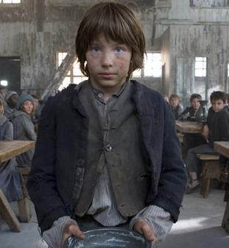

Jack walked down the road and went to town with Charlie and Oliver. He wore a blue waistcoat and a black top hat, white shirt and a black bow tie. The area was a rich and the streets were cobbled mud and poo and the air was smelly. Later, he saw a book shop with a rich man outside. This man was called Mr Brownlow.

Jack told Charlie and the boys started trudging towards the book shop. Jack put his firm hand behind Mr Brownlow’s back pocket. Jack was feeling scared in case he got caught and would have to go to jail. Jack was pretending to be reading a book but he was really waiting for the signal from Charlie.

At last the sign came and the theft was done. Jack ran away and began to act like he never did anything. He waited for Oliver to get the blame…

THE END

