Oliver Twist
By Freddie Daniels-White

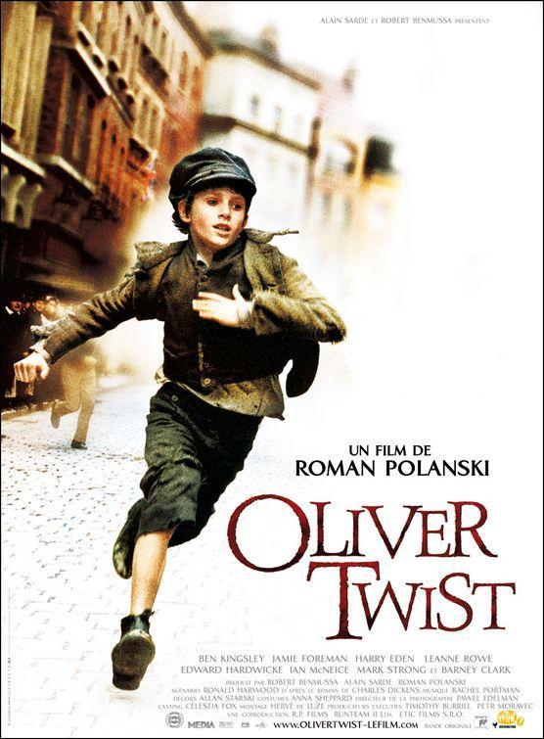

Just then Jack walked behind a rich wealthy man. Suddenly, his arm swiped something from his leather jacket and ran even though Oliver was not. The man turned round and saw Oliver so he told him to give his wallet back. The poor boy froze in fright. He stumbled back turned and ran - his dirty blonde hair gliding behind him. The man started to run as well. His turquoise leather jacket slinging behind him as well as his plump belly flopping up and down while he shouted ‘stop thief!’
Oliver saw Jack and ran over to him. But… the police came running round the bend! Jack grabbed Oliver by the arm and dragged him to the butcher shop where he shoved Oliver inside animal casing. Suddenly, the butcher pulled the casing off and screamed. Oliver jumped up and ran but the policeman did not realize until he was up on the train tracks. One policeman climbed up the ladder and told him to get down. But just then a train came zooming down the tracks. Oliver just lay down and the train went over him. He was alive… but now he had been caught.

