MY VERSION OF OLIVER

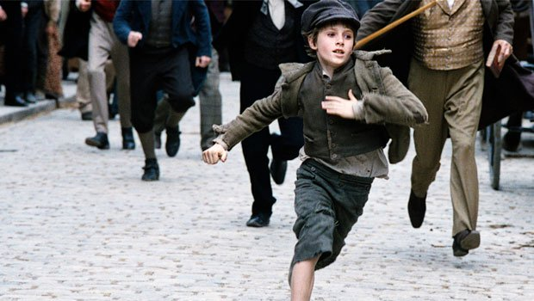
Written by Harriet Stevenson

“This is a spectacular book and recommend it to any of you readers who like long stories.” Daniel Barbashin

Oliver Twist

As the crisp morning air settled, the men and women started going out to work. Trees waved at each other in the welcoming breeze.
Oliver was curiously gazing at Charlie and Jack strolling down the street casually. What were they up to? They didn’t have anything to sell or a place to work or make things. Then to Oliver’s astonishment Charlie walked over to a posh lady with a massive bustle and long winding scarf. He quickly reached his strong, muscular hand, followed by his long, bendy arm, into her silver purse and pulled out a gold encrusted necklace.
Oliver was so shocked and taken aback that even his hungry, slim belly stopped growling at this awkward situation. His dark brown hair stopped swaying in the noiselessly wind and his deep blue eyes couldn’t have been taken away from Charlie and his successful face.
Jack was staring even more intently than Oliver was. Now it was his turn, Jacks turn. He put his light brown hand into a posh man’s pocket and returned with a black leather wallet. They were at a book shop. The rich man had just chosen his favourite book from the shabby little shop, and he put his hand into his pocket to get his money out his wallet. Jack knew that they were about to get caught so he grabbed Charlie and pulled him to a nearby pie shop.
The posh man was so angry that his wallet had been stolen that he kicked the chair and a ladies’ shin. He stormed out the shop and guess who he saw?
A dirty blonde haired boy, around twelve with deep blue eyes and a guilty, piggy little face…OLIVER!!!
“Oy you boy!” shouted the brown haired man. “Come here you little thief!”
“What me? I aven’t done nofin,” said Oliver his voice quivering with fright and worry. “Nofin at all, sir.”
“Oh yes you ave you little thief, oh yes you ave and the police will ave a right interest in it, they will.” He said with pleasure in his voice for catching the thief in his tracks.
In the police station, a rope was tied around Oliver’s arms and legs so he couldn’t run or move in any way.
“I didn’t do it! It was Jack…” but before Oliver could continue a piece of dirty cloth was stuffed into his open mouth.
“Sir … it … was… Jack… Dawkins… not…me…sir!”
“Stop right there you Bobbies!” said a growling voice from the corner off the dark room. It was Fagin!
“Fa … gin… fina…lly” stammered Oliver.
“If you knew what was good for you you would step away from the boy now!” bellowed Fagin so everyone could hear.
“I have found my thief and will not let them go again to you you old rat Fagin, “said the brown haired man.
“I have your thief, Brownlow, not the boy that you have there.” replied Fagin.
To everyone’s astonishment, he pulled Jack from behind him.
“What?” said the brown haired man. “You told me that he was your own son and it was him that did the crime last time.” He pointed to a skeleton. “Then you said it was her the time before that.” He pointed to a skeleton with two stands of white hair coming out her head.
A tiny mouse scampered across the hay-covered floor and Fagin stomped on it with so much force that even Mr Barnlow winced like he was that mouse getting kicked.
“I have no son.” He bellowed.
Jack stared at him with anger and a tiny bit that the naked eye couldn’t see of worry and sadness.
The next thing Oliver could remember, was him and Fagin standing in front of the secret hideout.
“ I bet your wondering why I gave I Jack and saved you, it’s because you are special Oliver, very, very special, and you will soon find out why.” whispered Fagin.
Oliver was left in doubt and confusion from then on till the day that Jack Dawkins walked into the secret hideout and Oliver found out his power. He could bring back the people he loved and missed right to where he was at the time. The only thing Oliver could not do was make them forget the stuff they should. He brought back his mother, his farther and his one brother.
But… Jack still wanted revenge for being in prison for fifteen years!

