By Isaac Guenda

The Mistake!!!

‘An amazing surprise’ –Glennis Poku

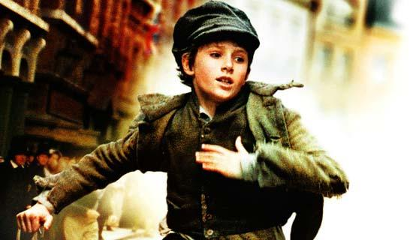

As Jack (Dawkins) confidently walked through the town, Charlie followed him with a polite manner. And then there was Oliver, following them and thinking that this was his first time of having proper freedom in his life.
“Now listen carefully,” Jack said with a little sneaky voice, “When I get his handkerchief, SCRAM!” he said with a surprising voice, whilst Charlie was inspecting Mr Brownlow to see if he had any more goodies left to get.
But as Jack was inspecting, his face changed like a fox speeding towards its prey. At the right moment, Jack took his handkerchief and flashed the other side of his pocket and started a conversation to make it look obvious.
It was good way how Jack’s plan worked but it failed when Mr Brownlow sneezed and tried to take out his handkerchief but, he couldn’t find it. Who could have possibly take his handkerchief without knowing? Jack Dawkins, but no, Mr Brownlow saw Oliver!
Oliver started to put his hands behind his back and had started sweating. He moved his head everywhere and his eyes even went everywhere! Mr Brownlow immediately asked Oliver politely to give it back, but Oliver didn’t know want he wanted, so instead, he started running like a rabbit hopping away from a snake.
Jack didn’t realise until loads of people protested Oliver and said, “STOP THIEF!” like a tropical festival. Oliver started running faster and faster while Charlie and Jack started moving and thinking, “Where should we hide Oliver?” with their hands on their chin.
As Oliver was running, a lady who was selling nutritional meat encouraged and determined them and thinking that she would be a hero for encouraging the citizens to help catch the illegal criminal and his crime.
Frightened and anxious ,Oliver climbed up the terrifying ladder where the horrible ,rusty but helpful train coming through where Oliver might die but not today because Oliver had chosen to lie down at the exact and perfect time when the train comes through with the most rustiest metal that had been made in Europe. He survived the fierce train track because of his skinny and bony body he was able to make it. But before Oliver had chance to catch his breath, the bulky, strong and powerful policemen came up to the boy. Oliver was in trouble.

