Wrong

Thief

“Enchantingly brilliant”-Heidi Thwaites
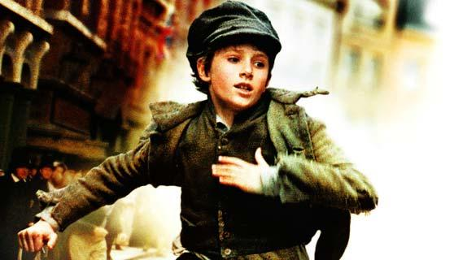
JAMES REILLY

The

Jack was walking down a busy Victorian street with Oliver closed behind him. He had remembered Fagin’s words and so he needed to get something. Jack had a damp, yellow men’s coat and it went down to his knees. It was originally designed to go up to a man’s waist. Little children and adults were staring at him like he was mad, but Jack didn’t care. He liked to be unique. His ragged shoes were very dirty because he didn’t have enough money to polish them or get new ones. That’s why he was a pick pocket. Jack stared at rich people, hoping to find some wallets.
As Jack continued to walk down the hard cobbled road, his stomach started to rumble and he rubbed it. He hadn’t eaten a full meal for three days, and whether he ate tonight depended on how successful he was. Oliver was not as tall as Jack Dawkins despite being older than him, so every time he was close to Jack, Oliver straightened his back to reach his height. Jack peered from shop to shop to try and find anyone to rob, but then he realized the amount of police officers in the area. He knew that Oliver was amazed by the amount of wallets he had, so Jack tried not to spoil it.
Jack’s heavy coat was making him warm and sweaty, and his cheeks were going red. Jack didn’t want to take it off because it would give away his face, so he un-zipped his jacket instead. He peered behind him to see if Oliver was still there, and he was. Jack was getting worried about him because Oliver had little footsteps. Not because he liked him or anything silly like that, but because Fagin might whip him for losing him.
Jack saw a nice looking pastry shop with delicious smelling pies that sat there waiting to be gobbled up by someone rich. He really wanted to eat something, but he knew he needed to steal something. Jack’s belly was rumbling more now and he was getting weaker. If only Fagin would be so kind to share something with poor Jack.
In a split second, Jack saw a tall, rich man peering through the bookshop window. His name was Mr Brownlow. The bookshop was very empty, so Jack thought it would be an easy steal. He sneakily crossed over the road and stared over the man’s shoulder to see what he was looking at. All of a sudden, a hand popped out from Jack and stole a full wallet from the gentleman’s leather pocket. It happened just like that. Jack started to run and Oliver didn’t have a clue what was going on, so he decided to follow Jack. Suddenly, the man noticed his wallet was gone, and saw that Oliver was running away.
“Stop! Thief!” shouted the Mr Brownlow as he started running. A few bobbies joined in with the chase. Jack heard all the shouting, and saw Oliver close behind him, running for his life. Jack tried to distract the chasers, but eventually they were back on track. Jack wrapped Oliver in some meat casing, but the butcher picked it up and Oliver jumped out.
All Jack and Oliver could do was run. Jack pretended to chase Oliver, but really he was trying to help him. Oliver rushed past a huge crowd of people, and climbed up a ladder to a train track. Suddenly, a train started zooming towards Oliver. Jack thought that Oliver’s life was over, so he walked away. But maybe Jack thought wrong, because Oliver ducked and the train narrowly missed him. As soon as Oliver was seen again by the huge crowd below him, there was a loud gasp. Then the police officer was catching Oliver again. Jack carried on walking back to Fagin because he didn’t really care.
While Oliver was still running away from the police man, Jack was saying what had happened to Oliver. Fagin listened very carefully and knew that Oliver shouldn’t have gone out of the house. He was disgraced.
While all that was happening, Oliver had been caught. There was a cheer from the crowd, and an especially loud one from Mr Brownlow. Oliver was then sent to jail for absolutely no reason. He was very confused. Why did he run away? Was Jack actually a pick pocket? He had so many questions to ask himself. Oliver was searched from head to toe, the police officer asked him where the wallet was. “It wasn’t me.” Replied Oliver.
“What do you mean it wasn’t you? Course it was you!” said the bobby, slightly laughing.
“It was Jack. Jack Dawkins.” Said Oliver guiltily.
“Jack Dawkins hey. He’s wanted all around the world!” shouted the police officer.
With that, the police man let Oliver go, and held a search party for the Artful Dodger. Would Jack ever be found...?

