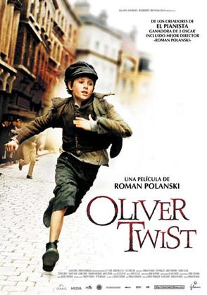

By Malikyle Gayle

Today, Oliver was happy because Fagin gave him a place to stay and gave him food. Right now, Oliver (who was fourteen and was wearing a short ragged jacket and a rusty hat) was going to work.
That morning, Oliver, Charlie and Jack went into the Victorian street and when they crossed the road a horse galloped past them and almost hurt Charlie in his legs. When Oliver saw that the carriage was going to hit Charlie he pushed him out of the way and saved him.
Oliver saw Jack approaching a rich man at a bookshop and he thought that he was going to recommend a book to him but oh was he wrong. Jack slowly reached his hand and snatched the man’s wallet then suddenly dashed away without telling Oliver. The wealthy man turned around thinking Oliver had stolen the wallet and said “Give it back boy!”
Without thinking, Oliver ran off and in the distance he could hear the man shouting, “Thief! Get that thief!”
Oliver ran and ran and ran until the police finally caught him than tied him up using the rope.
When Oliver got to the police station, the police asked him for his parents’ number. ‘They’re dead,’ came the reply, and they let him off with a warning.

