The Story Of Oliver Twist
By Sasha Collonge
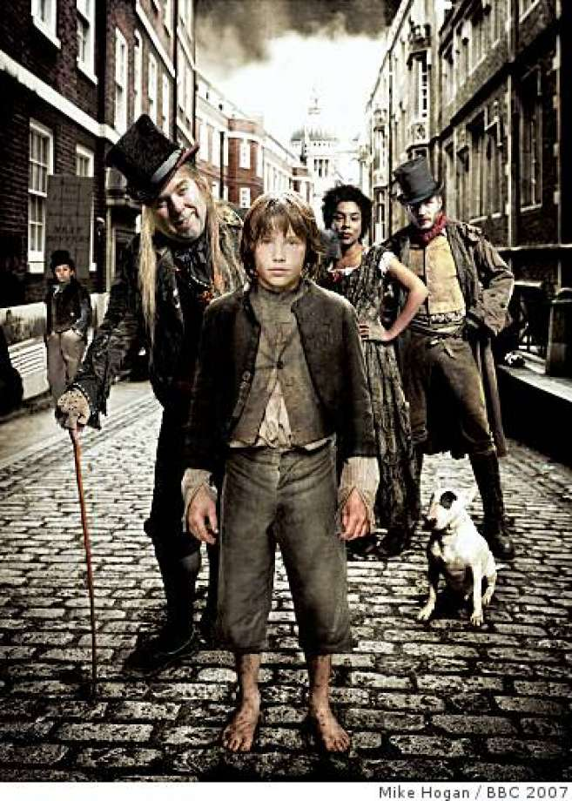
Jack was walking down the cobbled street with Oliver and Charlie. They were scanning the area for rich people. Jack and Charlie felt pressured because Fagin told them that if they didn’t bring back something over £10 they would not deserve any dinner, and they would have to sit on a splintery chair and watch everybody else eat all the tasty sausages.
Oliver was not feeling the pressure at all because Fagin hadn’t told him he had to steel anything, he was actually feeling quite excited to finally be outside.
They walked on a bit further into the filthy stench of the town. They arrived at a big fancy book shop where only rich people could buy the books. Jack sneakily spotted a very rich man. He had a black top hat and he was holding a golden pocket watch. His shoes had gold buttons and laces with silver at the end. He slowly walked to the man. Jack slowly reached into his deep pocket. Then, he rapidly took an item. The man turned around and Jack said, “How are you doing?” The man reached for his wallet, but then it was gone. By that time, Jack had already run away so Oliver was left alone.
The man turned around and Oliver had done something he shouldn’t have done, he ran. He ran as fast as he could. He pushed through the crowd. The man shouted out, “Thief, he stole my wallet! Police, you catch that boy!” Oliver hid behind a big cow’s leg. The man ran right past him. Oliver ran up a ladder that led to a small train track. The police were making their way up to the track, but, just at that moment, a big, heavy steam train was racing up towards Oliver, who was still helpless on the track.
The train was speeding up, faster and faster. Then, the train passed right over him. He ducked down, just before the train was about to squash him to death. The police ran up him and asked the man if Oliver was the boy who stole the wallet.
Meanwhile, Jack had returned to Fagin and his gang. Jack said that Oliver was very kind and he sacrificed himself just to save Jack.

