Oliver Twist, the Framed Mistake

by Zakaria
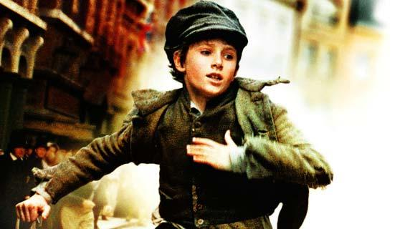

Your text here

THE FRAMED MISTAKE BY ZAKARIA GUENDA (OLIVER TWIST)

Jack was defeated by his need for food. Fagin hadn’t allowed him to eat for the last three days which had surely beaten him by far, he was kicking an uneven rock like it was minuscule football. Oliver had been following, but he was slightly anxious like a fish whose just made friends with a hungry seagull. His assistant (otherwise known as his shadow), Charlie had been tracing his every move like a scared baby duck following his mother. Jack’s eyes fixed on an old multi-millionaire man, whose fabric clothing flew in the air like a vicious bird attached to a tree. Jack decided to blend in with the crowd near the bookshelves, this is where the trouble begins.
Jack’s beady eyes located a stuffed wallet, fat as a fully fed calf, the question was where was the opening? Charlie and Oliver wandered off like street children who suffered a bankrupt or were sadly forced out of the comfort of their homes, Charlie and Oliver had succeeded not to get foiled up in the heist which took place those few moments ago when Jack had nearly took the wallet without suspicion of anyone else expect the culprits (Charlie and Oliver), Jack had finally found a mere opening, the old man, otherwise known as Mr.Brownlow, was looking at a factual book which was called “Logic and Laws.”
Mr.Brownlow summoned the bookseller and asked him if he could buy the collection of typed on paper which was about “Logic and Laws”. Just then, Jack made a swift unlikely move which took the wallet out of place, the feeling of soft leather and paper notes and gold coin shifted in Jack’s hands, although the heist was an success, Mr.Brownlow had felt his packed wallet taken from his right pocket. His eyes lay on Oliver, who had just stood there, like a paralysed victim in a horror movie.
Mr.Brownlows wrinkled and worn out hand blindly inspected the pocket which had once been the home of his overweight wallet. Nothing. His old worn out and wrinkled face had a stern look in Oliver’s presence, “give it back boy” he said motionlessly, “it’s going to be good for everyone if you just give it back, now please give it back.”
Oliver backed away, his walk soon turned into a jog, his jog soon turned into a run, which stetted every one off, “get that boy, get him!”
Mr.Brownlow’s brain had soon made him remember something about that ragged boy’s face. But he couldn’t remember what, it was like magic, those words made more and more people join, the race had soon turned into a mascaraed with posh old ladies, pickpockets and even Charlie and Jack had joined in (just to get rid of suspicion although no one would care to take even the slightest look back) all chasing one ragged, innocent boy who was surprisingly out running all of those people who just want a top prize or just for the sake of justice and heroism although they were chasing one ragged boy, who was far by innocent.
Oliver’s feet had been going over his usual limit (which was 1MPH, and had incredibly raised to 11MPH) Unfortunately, Oliver’s luck had run out. A speeding carriage had thundered past and stopped at the presence of the poor, ragged face of Oliver. “You’re crime has come to an end” exclaimed one of the armed Bobbies (the police’s name in the Victorian times) although they were facing one skinny and powerful less boy, the Bobbie was almost exceedingly right, Oliver’s crime has come to an end ( which was knocking over owned property on accident during the chase ).
Thousands of needy and money thirsty people stared at the young scraped teenager (who was only 12 in a half) Oliver sweated like how a water bottle squirted when squeezed, his heart pumped like it was being punched by the most strongest man ever, thoughts flowed through his mind, would he be sent back to the workhouse? Or even worse... he might go to prison and get executed .But as soon as he remembered that he didn’t have that damned wallet he was safe.
“Nothing!” “You got to be kidding me, you searched everywhere and NOTHING!” yelled the head Bobbie.
“Check for yourself sir,” said one of the Bobbies with a hard and stale voice. After the head checked, Oliver had been left free like a pigeon that had been released from a closed in space. As Oliver wandered off to Fagin along with Charlie and Jack, Oliver kept in his fiery rage so it won’t set off another chase and get eventually captured, he returned to Fagin.
Oliver felt like staying in the house for days or weeks or even months but still, Oliver had felt lucky he wasn’t caught this time, or today or tomorrow, as for as long he (Oliver) knew, he didn’t think he was ready yet. It was strange because in all the stories Fagin told him, all the main characters were always good when they first tried things that were incredibly hard.
“Hey Oliver, how did it go?” asked Fagin without any emotion. Oliver went silent and remembered all the tragic mistakes that were made the last two hours, Oliver had faintly replied with “ss-sir I don’t think I’m rr-r-ready.”
Oliver had walked away with the faintest smile of all time, the boys played “Pick the Wallet” like no other game existed and which they’ve stuck their entire lives to, for all the tragic misfortune which didn’t have to happen (although it did) Oliver deeply regretted standing there at the wrong time and the wrong place. Although it was over, Oliver felt some type of bond with that old man who had been stolen from, a type of family bond, his last name was made up by people he hated and barley knew so there could be the faintest chance .Oliver had still been thinking deeply about it, for what could be, for all the sake of humanity, what could be of the short life of his.

