Victorian Horse and Cart
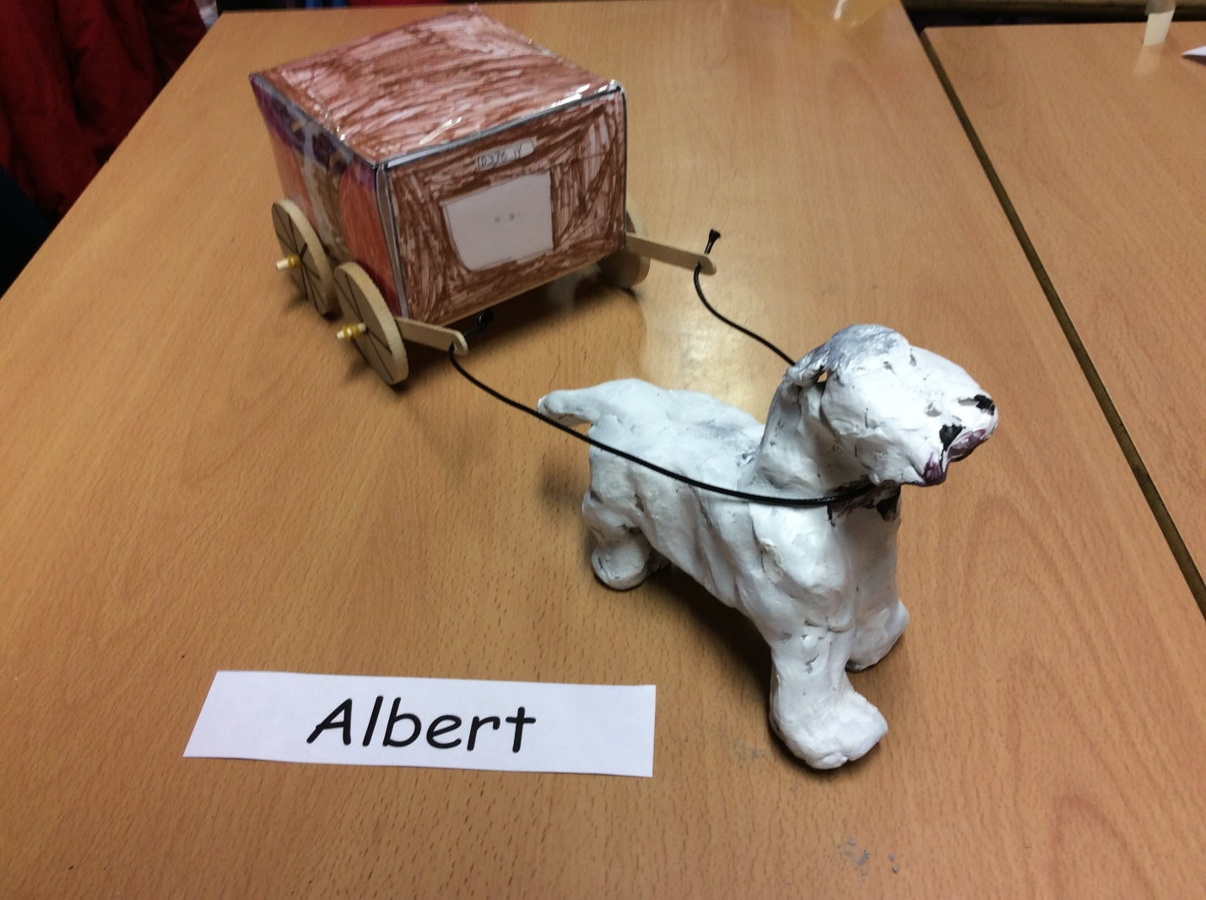

Resources
- Ruler
- Sharpener
- Pencil
- Dowels x2
- Clay
- Lollypop Sticks x6
- Elastic Bands x6
- Wheels x4
- Paint
- Colouring Pencils
- Net
- Leather string
- Tape
- Laminator
- Drill

Instructions
- Firstly, download the net of the cube of our blog.
- Next, colour in like a cart. The images should face outwards.
- Afterwards, use the laminator to laminate your net.
- Fourthly, score the flaps with a pencil.
- Carefully, cut out the net.
- Then, fold the net to make a cart and tape it together.
- After that, stick four lollypop sticks together and stick it to the underside of your carriage.
- Drill a hole into both ends of your remaining lollypop sticks. Get an adult to do this.
- Push the lollypop sticks on to one dowel. Maybe you will need to sharpen the end of the dowel.
- Put a bunched up elastic band on the two sides.
- Stick wheels onto both dowels, using elastic bands.
- Tape the dowels to the carriage, and move on to the clay.
- Now, mould a horse using the clay. Leave it to dry for a week.
- Then, paint the horse with acrylic paint.
- Next, use the leather strings to make the reins, tying them through the hole in the lollypop sticks.
- Finally, you can play!
If the horse breaks, you may use a glue gun to reattach it. But get an adult to do this.

