How to make a Horse and Carriage!

Resources
1. Clay
2. Water (maybe)
3. Glue Gun
4. Wooden Wheels
5. Elastic Bands X4
6. Lollypop Sticks X2
7. Dowels
8. Acrylic Paint (or normal paint)
9. Tape
10. Pencil
11. Scissors
12. Leather (your choice)
13. Ruler
14. Wire
15. Felt Tip Pens

Instructions

Firstly, get a big lump of clay and move the clay around in your hands to make a nice round sphere.
Secondly, divide half of the clay (for the head and the neck) and the other half for neck head and body and the legs if (if you have more you can make eyes but you can also make the tail)
After that, split one half to four thick sausages to makes legs.
Then, make a big chunky body so it won’t split easily.
Make a stable neck and head so it won’t fall off. Then in the meanwhile, make a net. (That will be your carriage.)
On the following, use a pencil to correctly make a net ,and then use a laminator to laminate the paper that you are using to make net. (But also create the net to make it looks like it’s from the Victorian period.
Now, as the clay is in a dry position, you can paint the clay you have made (Whatever colour you wish but try to make it more horse like.)
Meanwhile the horse is drying, now (back to the net) use tape on each side so you can properly be able to make a cube or cuboid as a carriage.
Now try to make paper wheels (Decorate) then laminate.
After that, get wooden lollypop sticks (make holes at the tiny end of the lollypop sticks at the end of each side) and then get wooden wheels and attach the paper decorated wheels to the wooden wheels.
After that, get a dowel and squeeze it through the wheel (get another wheel and do the same)
Get elastic bands and tie it onto the wood so it won’t fall off.
Then attach the carriage use leather on the end of the lollypop sticks then attach the horse and you’ve finished! (Making a horse and carriage!!!)

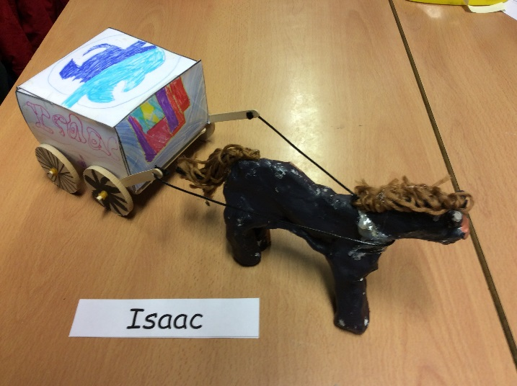
For example:

