Alfie Wilhelm and Lui 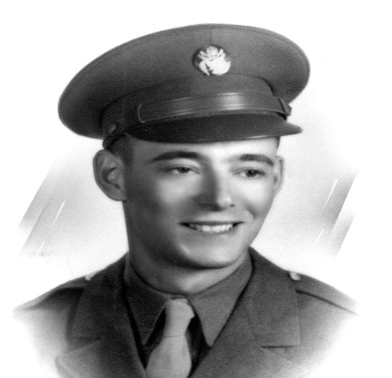
Wilhelm was in London all of a sudden the alarm sounded, he heard the sound of spitfire’s blades, ‘thunk’ the bombs were dropping. He tried to run but it was no use so he hid. There was fire all around him but he looked down in distress out of the corner of his eye he saw a hatch that led to the outside. He climbed through he stood up and he was furious all he saw were bombs and fire.
He tried to run to the underground by the time he got there it would be night he had starved to death he had to run 15miles he would live if he’d found food along the way so he began to hunt. If he’d be found he would be slaved down to Adolf Hitler which would be a big mistake. ‘Boom!’ a bomb exploded he was launched onto the grass burning his arm in the cause of the explosion also caused the roof to cave in the bricks crumbled smashing together in the making he went inside and saw a man “your name is…”asked Wilhelm “Lui” replied Lui.
They both left the house trying to get away from the Nazis. Lui was 4 years old he was frightened of the war. The year was 1939 when the war started the day was 1st September was the exact day of when the war started the war was a huge impact on small children. They tried to get underground making sure to duck down when the spitfires went overhead. All of a sudden German soldiers broke down the door smashing it to pieces.
Lui tried getting away he shot him in the should forcing him to scream in agony Lui ran out the door and into another house he tried hiding but it didn’t work the captured him and forced him to be their ally but he refused they threatened him by saying they were going to assassinate him (kill).
They had locked Lui in an iron bared cage they’d given him some rations to eat but there wasn’t a lot Lui had found a pin on the floor he had an idea to lock pick the hand cuffs. he could see the lieutenant from afar he saw a lock on the cage he was unable to get through the lock but he tried his best he found a key for the cage and opened it he escaped through the back door not realising there were two Germans in the security cameras he saw them but it wasn’t too late he could still make his escape so he signalled a Nazi plane and it fired down.

