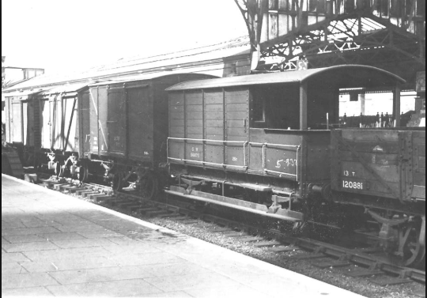
Louie`s exiting adventure
“Louie!” shouted Louie’s mother.
“Yes,” said Louie running down the stairs.
“What? “Said Louie.
“Um…, you’re going to be evacuated “said her mum sadly.
“Um oh I better start packing ,“said Louie.
Louie ran up to her room and packed a book, toiletries, snacks, water and a photo album
“I’d better go,” said Louie hugging her mum tightly.
“Bye then, “said her mother as Louie ran out the door. Louie dashed down towards the train station. Eventually, Louie reached the train station. She ran to platform 1 it was out of London. (Hopefully she wouldn’t get bombed). She dashed towards the train and jumped on.
One hour later
Maybe I should read a book the book was called sleeping beauty. As Louie opened her book her orange hair flicked into the book page .
Five minutes later
Louie started to cry because she missed her parents .
“um I feel hungry maybe I should eat my fish paste sandwiches “ said Louie .
5 mins later
“num, nom yummy those fish paste sandwiches tasted delicious but what should I do now maybe I should look at the view,” . Louie looks out the window and saw animals , trees and mountians
“we have finally arrived in the country, “ said the train driver.
Louie gets off the train and walks towards the little house in the country and knocks on the door .
“ hello ,my name is Alice and my name is Wolfgang come on in, “ said alice and wolfgang .
At the end of the day
“I hate today, “ said Louie with a sigh .
“ I will run away, “ said Louie .
When louie is at her mums door .
Knock , knock
Her mum answered the door
“Louie ! “ said her mum .
Louie hugs her mum tightly !

