CATHERINE’S WW2 STORY

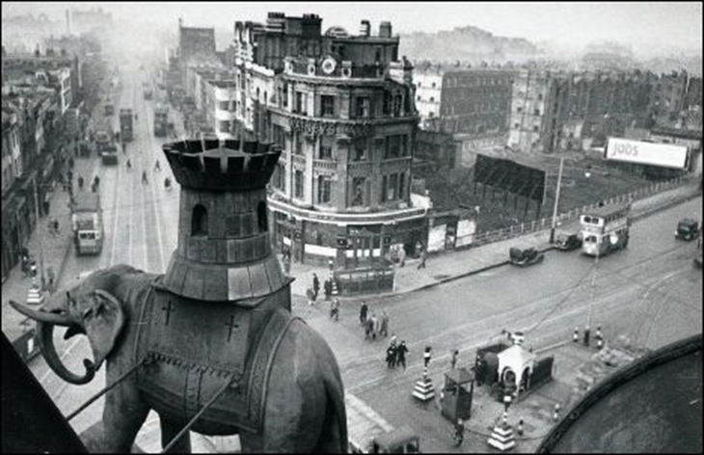

13th September 1940-9pm
Bang, crash, boom. The ground shook. The tall red-brick houses swayed. One collapsed. Just seconds before, an 11 year old girl was in the house…

Three hours before-6pm
Esme Wells was lying on her bed. Curly golden hair surrounded her head. Her blue eyes stared up the cobwebby sealing. Dust fell from the boards above her; where her parents where pacing their room, discussing important matters. Esme was lucky, her beloved father was still with her. In three weeks, she would be on a steam train, heading to a lonely Wales village.
Esme was extremely clever for her age. Everything she learnt, stayed in her mind. Her memory was as good as any elephant’s. Esme’s parents where extremely proud of their daughter, ever since she took her first breath, something special hung around her.
Now her school was bombed, week days seemed a bore to her. Her love for learning pleased the teachers, and if she wanted more, they gave her more homework.
Back to the present
An explosion sounded in her ears. Shards of glass flew everywhere, along with timber and bricks. A big hole in the wall showed the living room destroyed.
A small element was unharmed. It was a photograph of her parents holding her hands on a bridge, the stream sparkled beneath them, all black and white of course. Esme picked it up. She had made the frame, only four years ago she was presenting this to her parents-it was their sixteenth anniversary-and she had made them a present.
Now, four years later, the little pink roses still shone and the white ones reflected her face.
Her eyes glistened with tears as she looked around the room. Every night, she used to sit by the fire with her family, listening to the crackling sound it made. Now, it stood in ruins. The tree patterned tiles where strewn across the floor. The wood was lying on the other side of the room, between two wrecked armchairs, both on their backs.
A ticking noise came to her ears, what was it? She must find out.
She climbed down the steep, creaking stairs, her heart thumping. The noise was louder now, ringing in her ears. A single tomato tin lay in the wash room, the noise came from within…
Three hours later-12am
Shivering out on the street, Esme reflected on what she had just done.
The ticks had become faster, and she realised it was a bomb. With just seconds to spare, she raced out of the room and into the garden. Even though it was a mid-summer evening, the cold seemed to overpower any heat.
An hour passed, the two, then three. Her belly had begun to rumble, and the longing for food was unbearable. The sound of wailing came to her ears. The siren. Panic stricken around terrified, she ran to the underground.
The spiral stairs seemed to go on forever. At last she came to the bottom. All around her people lay on blankets or cardboard boxes. Everyone was covered in dirt and soot. Children were hopping over sleeping figures, whilst babies cried.
Explosions echoed through the station. Any movement was stopped, as everyone waited in anticipation. The sounds grew fainter and fainter, at last the murmur of voices grew louder.
Esme ran up the stairs, desperate to find her parents.
An hour later-1am
The streets of London looked different now. The church was squashed, and every building had at least a dozen smashed windows. The bus stops where in ruins, and a crowd of people surrounded an old lady, one of wich was the local warden. As Esme approached, a young boy explained what had happened.
“This lady here, the small one, with grey hair, was going to the shops in the raid.”
The warden was explaining to the lady what she was to do during an air raid. “When you hear a wailing sound go to the underground.”
The little old lady who clearly liked annoying people, asked, “Which station? Waterloo?”
“No.” Sighed the Warden. “The closest station. Elephant and Castle.”
After two days-15thSeptember
The nearest shop, (that wasn’t bombed) was all the way in London Bridge. Esme plodded along the pavement. The rain was falling heavily, she thought of the saying “Raining Cats and Dogs” and imagined a ginger cat falling into her arms. She would name it Gershwin-after the man who composed her favourite peace, George Gershwin.
Finally she arrived at the Bakery. Her ration book was slightly damp (because of the rain) but the man didn’t object, he gave her a large slice of bread, along with a small bun.
“Thank you?!” said Esme questioningly.
“I Give young girls and boys like yourself more bread, as they are growing, and the might have lost someone close.” After that he smiled. It was a big smile. Esme hadn’t seen many since the war had started. Everyone was always worrying about things, but this man was calm, and peaceful.
Outside, she thought about being evacuated. Her parents had told her she had a ticket for a train going to Wales. The train left at 2am, on the 16th of Septmber.

