Edward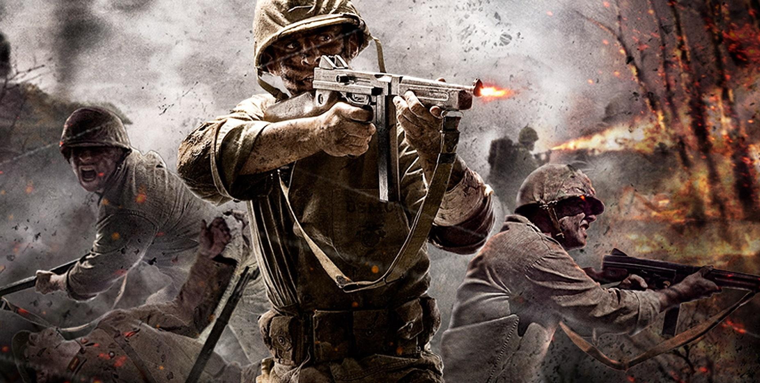
BANG! BOOM! The sound of the gun fire wiped out the peacefulness. The battlefield was a horrific place to be. The troop of British soldiers ran up to the sandbags to take cover from the bullets.
“I’m out of ammo cap!” said a soldier from the British troop. He was a 23 year old who had left his family in London when the war had begun. His name was Todd. Then suddenly, a German soldier ran up behind Todd and whacked him round the head with an ammo clip hardly.
Todd was knocked out. Todd quickly turned his head. His eyesight was blurry. He suddenly saw a German Captain holding a handgun and aiming it at his Captain. Then Todd quickly grabbed his handgun and then BANG!
The bullet zoomed out of the handgun and shot the German Captain in the heart. Suddenly, the German captain stopped dead straight. Just as the German Captain fell, he had quickly shot the British Captain.
“Noooooooo!” screamed Todd. Todd’s closest friend was his Captain. Then he said “I shall avenge you cap”. Todd then retreated back to the countryside…
CRUNCH! CRUNCH! Todd crept through the woods quietly. He had no ammo or weapons to defend himself with. Then CRUNCH! Todd turned around sharply. Something was wrong. BANG! A bullet had just missed him by an inch. Suddenly, he turned around to see a man. He was German. The man quickly dropped his sniper and ran.
A memory then came to Todd’s mind. In his mind there was the exact same man. Then he had remembered. The man’s name was Wolfgang. His arch enemy… Then Todd picked up the sniper.
2 hours later, Todd came across a small wooden hut. He then suddenly saw a girl come out of the hut. She was in a navy suit and had a commander medal on her top. Then, he thought that he had recognised her. ‘Could it be…’ he thought carefully.
Then suddenly, the girl quickly turned around. She then said “Who are you?” Todd then ran towards her. “Annie? Is that you?” She then ran up to him and gave him a hug.
Suddenly, there was a loud BANG! Then a woman ran up to Annie. She was bleeding badly. But then, the fragile, old woman dropped. Behind her was a German…
“Why you little!” She swore at the German angrily. “How could you do such horrific thing to a poor old, lady!” Just then Todd picked up his sniper and then shot the German in the leg. “You may do the pleasures Annie.” Said Todd happily. “Thank you brother, I may do the pleasure” Then BANG! She had got the ladys revenge.
Meanwhile, hiding under a bush was Wolfgang. He then spoke on his radio and said “Target with sister and got an armed Sniper 2000. Did you get all of info cap?” Then from the other side of the radio came a voice saying “Copy that, thanks for the info.”
Todd and Annie walked through the woods. Suddenly, they quickly hid behind a rock. Todd peered over the rock. Germans were holding villagers as hostage. He quickly ducked back to the rock. “There holding villagers as hostage” said Todd sadly.
Then Annie and Todd sat there in a sad silence as they listened to the Bangs. “No, no, no, please I’ve got children” pleaded a woman who was held hostage. “No mercy woman!” shouted a German at the woman.
Then BANG! The woman was gone… Todd aimed his sniper at the German an then BANG! Todd had killed all three of the Germans with one shot. Annie quickly ran to the villagers and untied the ropes around there wrists. Annie saw that one of the ladies wrists was all swollen and sore.
Annie and Todd quickly retreated in case any other Germans came to kill them. In the bushes nearby, Wolfgang was spying on Annie and Todd. Then Wolfgang spoke on the radio and said “G2 I know where they are going to.” On the other side of the radio came the captain of the groupG2 saying “k thanks for the info Sargent Wolf.”
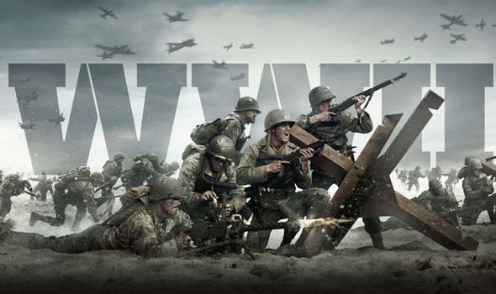
Todd looked at a cave. In the cave were a group of Germans with boxes of ammunition and weapons with grenades. Annie suddenly spotted a rocket launcher near the captain of the group. She then thought ‘If only I had my hands on that rocket.’ Then suddenly a man walked up to the Germans and shouted “Why aren’t you lot hunting Annie and Todd eh!” Then Todd realised. It was Wolfgang his arch enemy. Annie suddenly shot a bullet at a grenade and then BANG! BOOM! All the Germans got killed, but only one was surviving. Wolfgang…
Wolfgang stood up and held a button. It was an atomic bomb button. “I will press this button” said Wolfgang angrily. Then suddenly Todd quickly pulled out his pistol and BANG! The bullet shot out of the gun and zoomed into Wolfgang’s head. Wolfgang dropped the atomic button and dropped to his knees. Wolfgang then collapsed. He was dead. Todd had gotten his revenge…

