Glennis

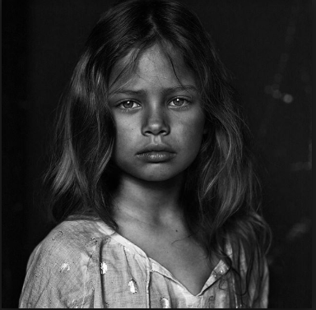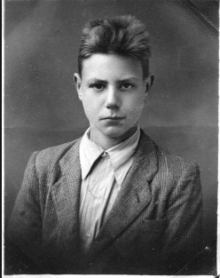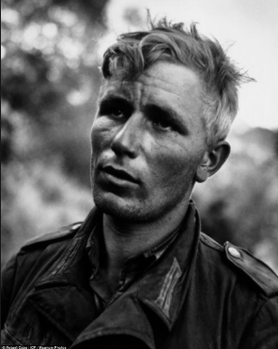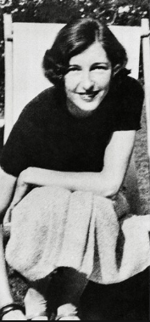

**Chapter1**

**The sad beginning**

The bitter wind flew past Leo pale face. His hazel eyes scrunched up as the dust from the camp floor got into his sandy, irritated face. He just stood there, depressed with his pastel face looking down at the concentration camp floor. Streams of tears ran down his red cheeks as he sobbed his heart out. He ruffled his brunet hair the way his mother used to do when he was upset, but it never calmed him down. The room was vacant, it was just him on his own. Once again, Leo was brought into the freezer room. Luckily for him it was a fine July afternoon so it wasn’t that wicked as they thought it would be.

It was midday and a German man gave Leo an immense shock, he went white in the face.in a blink of an eye, the Nazi’s man- handled Leo’s mum and his siblings in to a sturdy, filthy van and following was him as well. In the van was their chance to escape.

**Chapter 2**

The Escape!?

His sister, Violetta held her breath the whole way. She kept on twirling her amber hair, Leo could see in her eyes that she was panicking. She kept on fighting away her tears but it was use. Her rosy cheeks became redder than ever. Violeta went from tears to panicking. “Leo, mother are we gonna be okay” whimpered Violetta, her mother’s hand was shaking frantically as she directed it to Violetta’s shoulder. “We have each other that all that counts” comforted Mother. She tried to hush Annette to sleep as she was crying so quiet no one could notice until Mother looked down.

Eventually the door opened, and there stood a German man holding a whip in his filthy hands and smirking with an evil smile. “Get out! Quickly now!” shouted the German man. On the right side of his beige coat- pocket said the words **‘ELIAS’ “**that was probably his name” thought Leo weirdly he had never thought that deeply about something before, it was a new skill to him. Once again, Elias forced Leo’s mum out of the van again she was really weak that she told Leo to carry Annette out of the van. Annette started to cry with fear, tears came running down her chubby face. Leo cautiously came out of the van as well as his mother following Violetta, but the problem was she started too over-react by whining that she wouldn’t come out and she wants go to her dad her Switzerland. Suddenly Clarica (there mother’s name) had come up with an idea.

**Chapter 3**

The Decision

“Violetta if you like you could be sent to your father in Switzerland where I think you will be safe, I think… I mean I hope.” Cried Clarica she stumbled on her sentence. The German man slowly let go Clarica and stood next to her instead. “I think you have the choice to see if your children can be evacuated or not or instead you can allow your children to choose for you” assumed Elias. He carried on “or you can allow your children to decide where they go you know Switzerland might be the safest choice you know,”

Clarica eventually started to agree with Elias, but it took her a while to see what will be the best option for her children. Since Leo was the oldest, Clarica decided to ask what he wants to do. "Was möchten Sie tun?" said Clarica

“I really don’t know mother, I really don’t know” whispered Leo “but you want us to be safe, right,” Clarica nodded.

Elias even said he wouldn’t take them away to the camp since they were going through a lot. “You know I didn’t actually wanted to be like this, I was taken by the Germans I’m actually polish the Germans took me and forced to worked for them otherwise they would hurt my children. “My little Sammy where on this earth are you. And Rachel you know where to find me I hope you do. I love you guys so much please find me"

“What about you mother aren’t you coming with us to Switzerland?” said Leo

“I’m afraid not I’ll stay in Austria If our cottage gets bombed I know where to find you, have fun at your dad’s house and stay safe” replied Clarica.

“Mumie you can’t let us go there you how vati and you have not been getting along don’t you remember how he tried to kill I don’t think it’s safe for us to go what if he tries to do that to us” cried Violetta.

“And he has a new lady but behave you have about an hour to pack and get on the train to Switzerland you can trust I can be safe” Mother said.

**Chapter 4**

New Beginnings

Then on, Violetta, Leo and little Annette kept their mouths shut and listened to their mother so they went back into the cottage to pack, they packed clothes, toothbrushes, food (lots of food!) and other important supplies they needed. Eventually they came out of the cottage and said there last goodbyes.

“Take care meine kleinen kinder von mir” said mother Leo was confused

“Aren’t you leaving at the train station?”

“I couldn’t bare the pain so I called father for the first time in forever and asked him to pick you guys up at the train station I can never look him in the eye ever again. I can’t look at him the same way that I did before, children have a weak heart I don’t want to go and row with him it’s not healthy for the both of us, you understand” when she says that you have to say yes whether you understand or not.

“Give mama a big squeeze before you go” she enjoyed what may be her last hug from her children.

“Now go now you don’t want to miss your train home”

“Bye… mother”

They started to into a future of no one’s hands

“To a new adventure” Leo said

“So we’re not actually gonna live with dad” questioned Violetta

“Exactly!”

“To a new adventure” Violetta said

They smiled and walked onto a new world ahead.