Mahima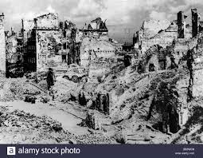
“Ouch what was that? Oh no! The bomb siren!”
With pressure, Jacqueline headed past the ruins of the buildings. Despite her house being blown up, she still tried to survive as much as she could. The dull ache in her belly grew and grew each day. It had been two days since she had eaten a thing and games were playing up with her mind. Each step that Jacqueline took felt like her feet were melting. Her hands were crowded with several scars and bruises. She badly needed a home. Nearly about to faint, she peered around if she could see any.
All of a sudden, she heard a rhythmic tapping of a bunch of German soldiers. She was frightened. Without warning, everything was silent and not even a word was said. It was pitch black. It was a Blackout! Jacqueline was trembling with fear. She was dragged into a shelter. Loud stomps were heading her way. 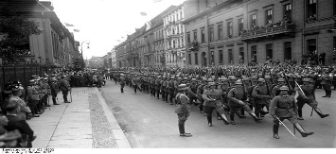
She had a torch; but before she could turn it on, it immediately got forcefully snatched away from her. Finally it was over, Jaqueline was covered in layers of dirt.
As slow as a snail tears were streaming past her red cheeks. It was hopeless. There was no life. Her wretched sandals were torn apart and she heard the crying noises. “This is terrible! How could this even happen?” she cried. She knelt down to the bumpy hard ground started to cry buckets and buckets. Spitfires were hovering around everywhere.
All of a sudden, she found someone that was her ‘friend’ (who was actually a Nazi disguised as her friend) with ‘sorrow’ she said “are you alright?”
“Shirley! “She said happily “I missed you ever so! Where were you? Is everything okay?”
“Oh don’t ask it’s terrible” as she was discretely trying to hide the Nazi badge in her pocket.
“Come along dear, I’ll keep you somewhere safe” she lied hiding her snigger.
“But…ww...haat if a bomb drops on me?” she worriedly said.
“It’ll be fine, nothing will happen” she cried
That was the point when Jacqueline had a slight doubt on her.

She took her to the factory being ever so pleased that she fell into the trick. It felt like they were running a marathon until they reached. She heard stitching and washing machine noises.
They took the secret entrance as the factory belonged only to the Nazis. Before she was about ask where she was the evil lady threatened her and said “I saved you so need to give me all of your money! Or else... I will lock you in this room” she shouted
“Bb…ut you sent me to an Nnn…azi factory am I right?” looking scared and puzzled at the same time. The room was petrifying she had a huge worry on her face. Rats were running around the room. It was absolutely dull and the wallpaper was torn. The stench of the smell caught her nose very badly.
All of a sudden, she took of her mask and a huge evil laugh came out of her mouth.
“Greetings ha ha ha!” the wicked woman said
“Let me get out of this Nazi factory!” she cried
Without warning, out of the blue, her true best friend shouted “how dare you!”
That horrifying lady was about call the Nazi Bobbies but before she could, Jacqueline snatched the keys and forcefully locked the door. As they both left, they heard the screams from her squeaky voice. “Good for her!” Shirely and her friend both before they got caught, they ran as fast as they could.
Out of breath, the scurried past the ruins and tried to avoid the Bobbies as they were searching back and forth for that cunning woman.
They were both looking for furniture on the cobbled roads. They found some in the Nazi furniture truck. Secretly, they attempted to take the softest furniture of all. As swift as a cheetah, they ran to an Anderson shelter (as both their houses got bombed) and finally they could be at peace.

