Malikyle
Click, clat, click, clat. As the train ran up to the tracks and stoped waiting for the restless children to get onto the train. When the triplets called Rodger, Dawn and Makala. “Why did the Germans have to bomb London I was so happy there. “ Complained Makala “I don’t know, they might be angry that we declared war on them” Explained Dawn “Don’t worry you guys our new parents will be great, and after the war is over we can go home and see our mum again”
PSHHH. The train came to a stop, the triplets came off and ran out making sure to stay together. Once they had got to their new house they knocked on the door and the maid answered then let them in and took their bags then showed them to their new dad. “Umm hello MR” studdered Makala “hahaha call me dad, children” said their dad.
“Your room is upstairs to the left why don’t you go check it out” He explained. With excitement Rodger, Dawn and Makala all ran upstairs to see their room, when they got in their Makala jumped onto her bed and other two froze with surprisement it was just like their room at their home in London. Later that day they heard a knock on the door and went downstairs to see who it was but their maid came and said they cannot go downstairs because the visitor was very important.
The same thing had kept on happening for five nights and the kids had had enough so they planned an escaped they are going to go out the back door very early in the morning and go to a new person’s house.
The Next day, at 5:00 am the kids snuck downstairs then went through the back door then ran but through the window their maid watching them and went to tell their dad… “Kids how could you, I thought I trusted you, but then you go and do that, UP TO YOUR ROOM NOW YOUR GROUNDED!” he shouted
For the next week they had to stay in their room and they were really quiet not making any noise and when the week was over he congratulated them for being so quiet so with no regrets he gave them each £20.When they all went on the train they went on it with a big smile on their face.
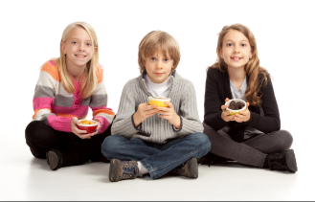
When they got home they ran to their house and knocked on the door with excitement. Surprisingly their whole family was in there waiting for them and jumped with joy when they came through the door. Once they had all said hello the kids told them how they tried to escape the house because their owner left them in their room everyday and there was a lot of people visiting and making so much noise. After everyone had gone home the kids tucked up in their beds and had a very nice sleep.

