Mollie Mosquito Mayhem
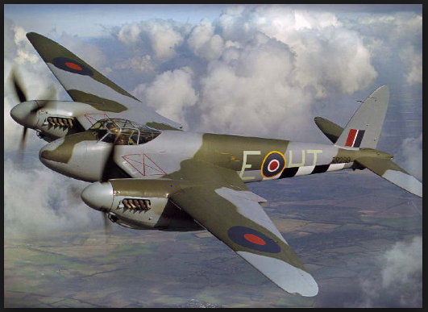
Chapter 1

Boom! Yet another bomb dropped in London. “Jack, you’re the only man for the job. You are so talented and no one else is as good a pilot than you. Please… go for your country it would mean a lot to us, “Said the general reassuringly, “It is called mission MBD, it stands for Mosquito Bomb Drop.” Jack ran his strong fingers through his sweaty hair whilst sighing. It was a complicated decision. He could die! “I might need some time to think about it but for now I will say yes… first I need to talk to my family. I will come back soon to confirm my decision,” said Jack slightly hesitant.
Chapter 2

“Sorry I have to. It is my duty, I can’t say no now Alison. I will come back soon… I promise,” said Jack, a tear in his eye.
“Oh Jack, you could get killed…but I understand, you have to go and fight for our country. Good luck,” said Alison.
“Daddy, I don’t want you go,” said Leo (Jacks son).
“I don’t want to go either Leo, but I have to,” replied Jack picking Leo up and spinning him around, “bye I need to go.” He waved goodbye one last time then began to walk to the General.
“Bye daddy,” said Leo afraid.
Jack trudged along the destroyed roads and clambered over the mountainous piles of rubble. Eventually, he got to the MOD building (Ministry Of Defence). He looked up; and saw a colossal white building towering above him. As he walked inside the building he immediately felt lost. He walked through the labyrinth of corridors. He had spent nearly one hour trying to navigate his way through the maze when he stumbled upon the General’s mammoth office.
Chapter 3
Knock, knock, knock! “Come in!” said the General confidently. The heavy door creaked open. “Ah. Finally, why did you take so long!” said the General, slightly angry.
“Sorry! I got a bit lost!” said Jack, “My family has agreed.”
“Anyway your here now,” Said the General, “Mission MBD (Mosquito Bomb Drop) is ready and your plane is waiting for you on the runway at the Aerodrome… Good luck.”
“I will go there now,” exclaimed Jack whilst slowly walking towards the office door. He walked out into the labyrinth of corridors once again. It still took him around one hour to navigate himself through the never-ending concrete maze. Finally, he was outside again.

Chapter 4

The cold air rushed to his face, his brown hair blowing in the wind. Jack trekked through the rubble and dust. The devastating roads spread out ahead making anyone except the Nazis worried and unsafe. Everywhere was bombed. In the distance jack could see one of the only devastating streets left in London. Eventually he saw the stunning building of the Aerodrome. Just beside it would be the runway where his terrifying mission would begin…
Chapter 5
Boom! Crash! “…ma...ay may...ay mayday...,” came the noise crackling through the intercom,” …a...storm….bringing me...own. A storm is ...... me down. A storm is bringing me down… Over.”
“Oh no!” Yelled the panicked officer running around and flapping his hands, nearly knocking things over.
“Fal… alar… f…lse…al…m false alarm… over!” came the crackling intercom once more.
“Oh thank you so much,” said Jack as the other mosquito plane tied a rope onto Jack’s and helped bring him out of the storm. Eventually, they were out of the treacherous storm and his new friend told him how to get to Germany. The two amazing mosquito planes flew over the deep and never-ending Atlantic Ocean.
“You have reached your destination” said the friend his concentrating face turning into a smirk.
Immediately a roar of machine guns started up. Jacks face tuned to horror.it was like a video game and he tried to dodge all of the exploding and piercing bullets. He had no time to contact the officers! What he thought was a brilliant friend was disloyal foe!
Boom! Jacks bomb dropped onto a nearby field. A few seconds later he flew into the traitorous storm again. The foe tried to follow. He saw a glimpse of green and flew towards it. The roar of bullets started up again. Bang! Splash! The foes plane dropped suddenly into the Atlantic Ocean near Germany. Eventually, it sunk. The Nazis had shot down their own plane! Jack arrived home safely. Mission BBD complete!

