LONG LOST
OR DEATH

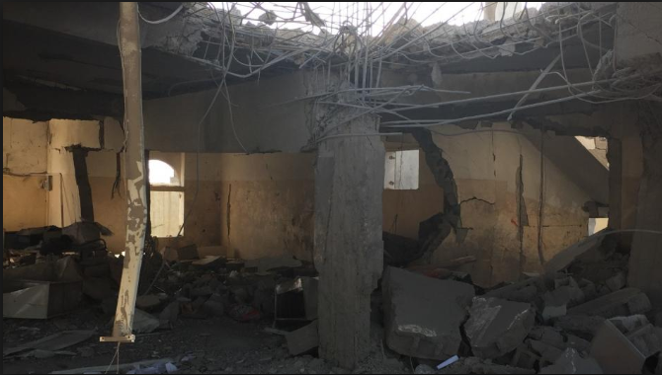

BY Victory

CHAPTER 1
Long ago, there was a very intelligent girl called Victoria, she could definitely,
always find a way out of trouble (heaven knows how). It was 1940 when the Blitz began.
She was in despair, Victoria did not know what to do. She shouted to her Mother, “MUUUUUUUM!”
Victoria rushed downstairs and found her Mum on the ground not breathing. She started to sob, blood was dripping down her neck. The bomb hit the living room where her mum was staying. She rushed back upstairs and packed her bag, gas mask and her loose cash. BANG, SMASH, CRASH! Victoria ran through the front door and a tear dropped onto the dusty ground.
Victoria didn’t know where she was going, so she looked around in horror and went nearer to the west. Suddenly, she felt like someone was following her. She turned around, no one was there, Victoria turned again, and nobody was there. She put on a brave face and walked on.
CHAPTER 2
“Hello there, I’m Lenny.” The voice echoed
“Umm, me V-Victoria,” she squeaked. “Show yourself! I-I’ve, um, got a sock.”
A shadow popped out and the girl came out with it. Victoria breathed. “Oh, wait you’re not here to kill me right?”
Lenny said,” You don’t know what you did to me, I was the one who bombed your house.
She remembered what her mother told her before the war started. Think of what you do know, to find out what you don’t know. What a wise mother she was. Her violence started to get onto her nerves. “How dare you I loved my family and their lives,” she said in anger.
“Well… you don’t recognise me because we were only two years old,” shouted Lenny, while Victoria was looking confused. “This is what happened, when we were two, Mum and Dad loved YOU so much, OH Vic how are you sweetheart. OK maybe I was a bit jealous…”
CHAPTER 3
AROUND TEN MINUTES LATTER…
“So I ran away. “ Lenny started to cry.
“Wait you’re my sister, why did you drop that bomb, and it’s a war type as well,” said Victoria.
Victoria was torn – Lenny was her sister, but she had also killed her mother and therefore was a criminal. She needed to be stopped otherwise who else would she kill?
‘You can’t carry on this killing – you need to stop.’ Victoria knew the difference between right and wrong – and Lenny was most definitely doing the wrong thing.
‘You just try and stop me.’ Lenny turned and ran down the alleyway and into the darkness. Victoria began to chase her, she couldn’t let her get away. How many other people would she hurt?
The chase went on and on until she found a way to get her. A Morrison shelter!
She captured Lenny, and called the Bobbies. “I’ll get you one day!” shouted Lenny.

