Ways to support literacy and maths development at home through play and everyday activities
Sharing stories  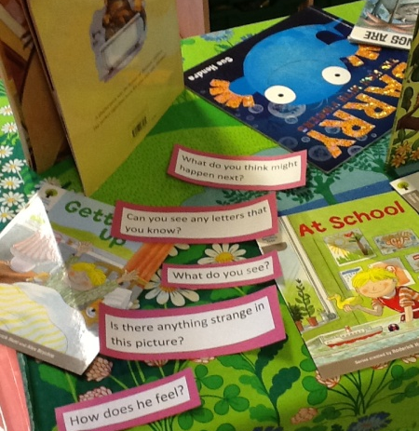  Questions to ask your child:  - What do you see?  - Is there anything strange in this picture?  - Can you see any letters that you know?  - What do you think might happen next?  - How does the character feel?  - What is your favourite part of this story?  - Can you tell me the story from the pictures? | Sensory mark-making and writing  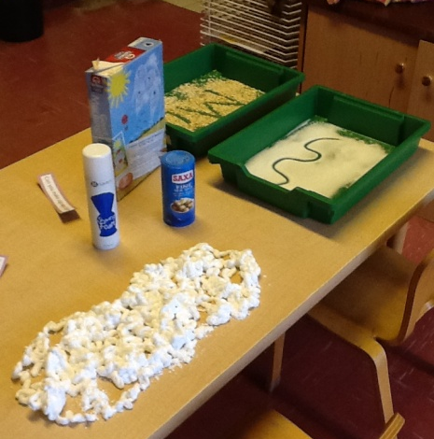  Questions to ask your child:  - Can you write your name in the sand?  - Can you make zigzags/spirals?  - How does it feel?  - What can you draw in the foam?  Try saying letter sounds when making shapes and patterns in the sensory materials.
At the dinner table  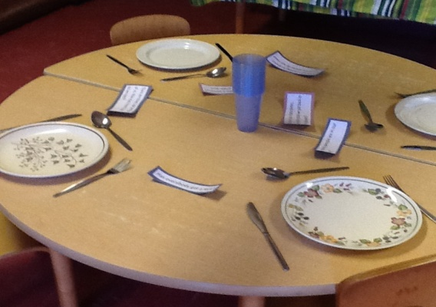  Questions to ask your child:  - How many people are in our family?  - A friend is coming to dinner, how many places do we need today?  - Has everybody got a fork?  - There are three cups and four of us. How many more cups do we need?  - We have too many plates, how many shall we put back in the cupboard?  - I have got three potatoes and you have two, who has more? How can we make it the same? | Dinosaurs and small world toys  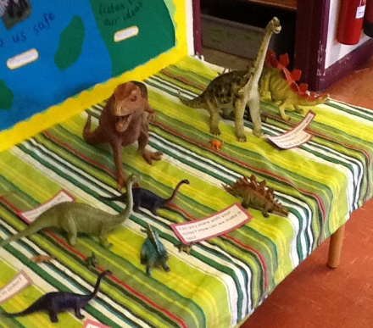  Questions to ask your child:  - Can you share with your sister? How can we make it fair?  - Which ones are the same/different?  - Can you put them in order?  - Can you make a pattern with your dinosaurs? (Big, small, big small)  - Can you find a dinosaur taller than this one?  - How many green dinosaurs have you got? How men red? How many altogether?
Sorting and threading household items  At home, try using pasta shapes, dried beans and egg boxes for sorting and threading activities.  Questions to ask your child:  - What numbers can you see?  - How many beans belong in this pot?  - Can you make a pattern with the pasta?  - Can you make a necklace longer than this one?  - Can you add together all the beans in your pots? | Recycling junk mail  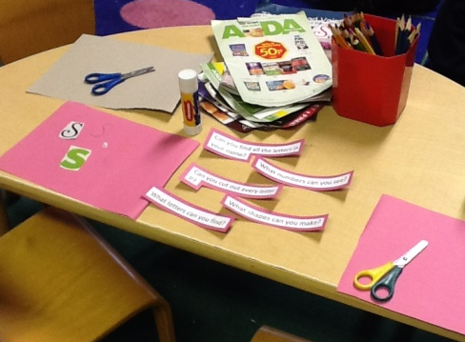  - Can you find all the letters in your name?  - What letters can you find?  - Can you cut out every letter P?  - What shapes can you make?  - What sound does that letter make?  - Can you make a number line?  Provide pens and paper to add to a letter-hunt through the junk mail.

Please check the Nursery blog for more ideas: www.cathedralprimaryschool.com. If you have enjoyed any of these activities with your child at home, or have come up with any more ideas you would like to share, please leave a comment on our class blog.
Best wishes,

Miss Dace
Class Teacher

