Book Bingo Year 3 and 4 Book List
A
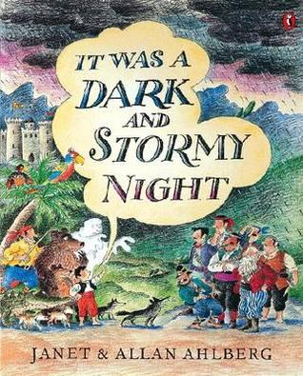 | 6+ | A small boy who has been kidnapped by brigands, passes the dark and stormy night in their cave weaving for them incredible stories of their own exploits. Through the stories he solves his own problem and manages to escape.
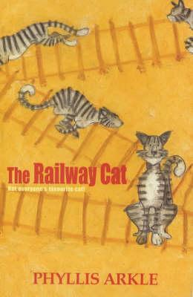 | 6+ | A collection of five adventures in the life of Alfie, the irrepressible railway cat. He gets snow-bound, he saves a life from an out-of-control train, he is kidnapped and taken to London, and he has his usual scrapes and run-ins with Hack, the leading railman at the station.
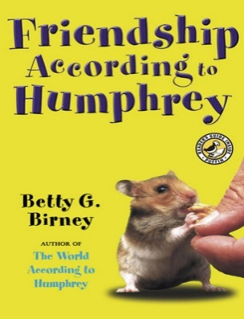 | 7+ | After the holidays, Humphrey is shocked by a big surprise in Room 26-a new class pet! Humphrey tries to be welcoming, but Og the frog doesn't respond to any of his friendly squeaks or visits (remember, he has a lock-that-doesn't-lock). Plus, the students are so interested in Og, they almost stop paying attention to Humphrey altogether. Humphrey doesn't like the mad-bad-sad feelings he's had since Og came, but luckily he still gets to have adventures with different kids on the weekends.  Friendship can be tricky, but Humphrey is an intrepid problem-solver. If any hamster can become buddies with a frog, he can.
B
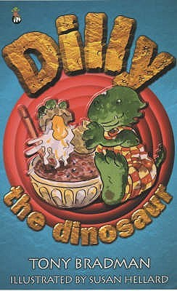 | 6+ | Introducing Dilly, the world's naughtiest dinosaur, by internationally acclaimed author, Tony Bradman. Reissued in a special 30th anniversary edition. In his first four stories, Dilly the Dinosaur gets up to all sorts of mischief. When he decides he doesn't want to wash any more, Dilly ends up becoming a very smelly dinosaur indeed! And when he's told he can't have his birthday every day he gets very grumpy. And you know what happens when Dilly gets grumpy... cover your ears, here comes the ultra-special, 150-mph SUPER SCREAM! Tony Bradman's dinosaur stories are the most fun books for early readers you're likely to come across.
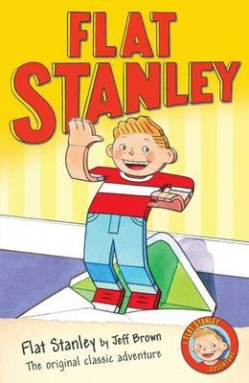 | 6+ | Stanley Lambchop wakes up one morning to find a notice-board has dropped on him in the night, leaving him happy and healthy, but only half an inch thick. It's a little unusual, but he finds he can fly like a kite, be sent on holiday through the post and can use his special skills to foil a burglary at the local art gallery. Still, he's glad when his brother Arthur has a bright idea to help bring him back to his normal shape.  This inventive story is full of wit and humour, and is sure to intrigue young readers. Originally published in 1964, Jeff Brown's ingenious tale has since become a well-established favourite both in the classroom and at home.
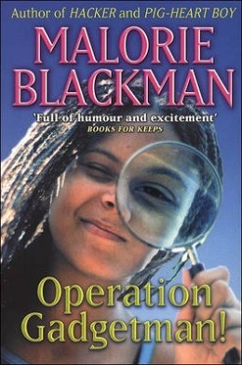 | 8+ | Beans's Dad is a bit of an eccentric. When he's not embarrassing her in front of her friends with his strange behaviour, he's in his workshop inventing ridiculous things like exploding shortbread (and irritating the neighbours while he's about it). But one day, Beans comes home from school to find that he has been kidnapped! She and her friends set out to find him using only their wits and the extraordinary 'Gadgetman Spy Kits' he has given them, and in the process uncover a sinister criminal conspiracy…  Beans is a likeable lead, and despite the unlikely series of events that the story relates, her relationships with her friends and family are warmly and believably portrayed. A lively (if not madcap) adventure that will find fans amongst younger readers.
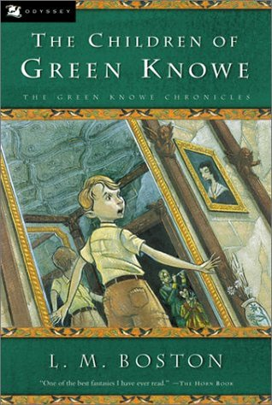 | 8+ | "Tolly" Toseland 7 is rowed up to great-gran Linnet Oldknow by servant Boggis - there has always been a Boggis at Green Knowe. The real "castle" is over 900 years old. Gran tells old family stories, and songs. Over the generations there have been many who can see, hear, and feel the ghosts, evoked by white-on-black illustrations. Toby 14, Alexander, and Linnet 6 linger after the Plague, as does the cursed topiary Green Noah.
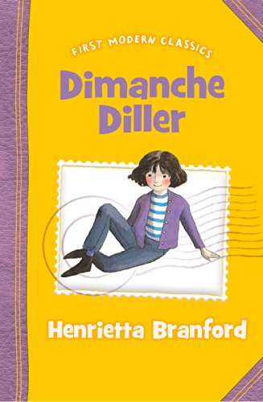 | 8+ | When Dimanche is orphaned at the tender age of one, Chief Inspector Barry Bullpit advertises for any known relative to come forward. Unluckily for Dimanche, her real aunt does not see the message, but an evil money-grabbing imposter does. Dimanche, heir to an enormous fortune, is sent to live with the dreaded Valburga Vilemile, who tries to rid herself of Dimanche at every opportunity. But her lack of success is partly due to Dimanche's wits and courage, and partly to Polly Pugh, Dimanche's young and pretty nanny, who foils all Valpurga's attempts and helps Dimanche find long-term happiness with her real aunt.  All the ingredients for a brilliant, attention-grabbing shorter novel are here; evil plots, kidnapping, wicked villains and gorgous heroines. Every chapter makes you want to shout 'Look behind you' or 'Oh no she doesn't' at almost every page turn.
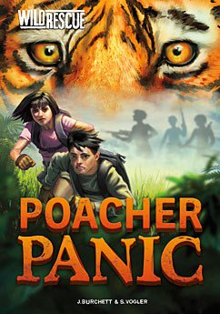 | 8+ | Twins Ben and Zoe travel the world on secret missions for their uncle's elite environmental organization, WILD. In these exciting, informative books, the two teens travel all over the world to save animals in danger and protect the environment. No matter how dangerous the mission, no matter what's at stake, Ben and Zoe will do whatever it takes to rescue at-risk animals.
C
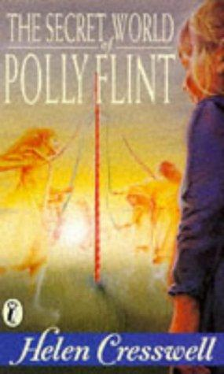 | 7+ | Polly Flint, a girl who sees things other people can't, finds herself involved with the "time gypsies" of Grimstone, inhabitants of a lost village who have become trapped in a time not their own.
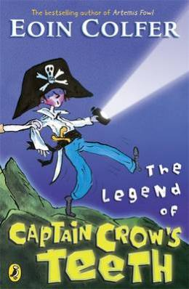 | 6+ | Five brothers are spending the summer holidays in a cramped caravan in Ireland with their parents. They are mischievous little monkeys who are a trial to their parents.  Marty, the eldest, reads his brothers spooky stories, and his favourite is about Captain Crow, a cut-throat pirate who is out to get his revenge on any available nine year old boy. This summer, Will who is nine years old, is to be the butt of Marty's most elaborate prank so far.  With characters last seen in Colfer's The Legend of Spud Murphy, this is another light-hearted adventure for younger readers, in which the issue of sibling rivalry is deftly and humorously handled.
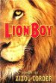 | 8+ | What do you do when you come home one day and discover that your parents have been kidnapped? Well, if you're a brave young guy named Charlie Ashanti, you go off in search of them. And since you happen to know how to speak Cat, your feline friends—the stray cats of the city and the caged lions on a magnificent, astounding floating circus—rally around you, bringing help, advice, and occasional special deliveries. Little do you know that in this search of yours, the fate of the world is at stake.  From an exciting new mother/daughter writing team comes this captivating adventure full of heroes, villains, and astounding events. Set in a near future that blends the familiar and the new in unexpected, intriguing ways, Lionboy is an exhilarating, suspenseful whirlwind of a novel—a book destined to become a classic.
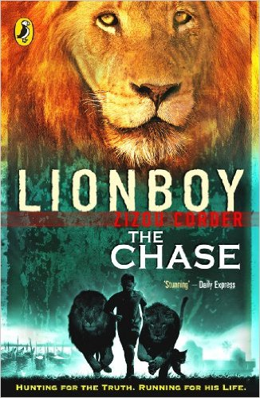 | 8+ | Charlie and his lion friends have made it safely to Venice, but it turns out that their journey has only just begun. King Boris's palace was meant to be a haven, but it's starting to feel more like a prison. When word arrives from the cat grapevine that his parents are not being held in Italy after all, Charlie knows he must take fast action. Luckily a new ally has come on the scene - and just in the knick of time: Rafi is in hot pursuit.
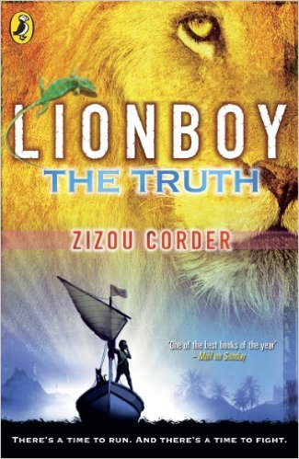 | 8+ | The second volume in the Lionboy series ended with Charlie Ashanti, the Catspeaker, finally reunited with his parents. The evil lion trainer Maccomo has gotten his comeuppance, and only troublemaking Rafi Sadler left to worry about. Everything is great, right?  Not for long, as Charlie is soon kidnapped, and he and his parents become involved in a high-speed Atlantic Ocean pursuit. Charlie's beloved lions get in on the act, and Charlie finally has his chance to confront the powerfully evil Corporacy --- but not before he must make some tough choices.  There are plenty of surprises along the way, including more discoveries about Charlie's family, some of them not entirely welcome. Charlie also learns more about his past, and even has an emotional --- and surprising --- reunion with the leopard responsible for his ability to speak the language of cats.
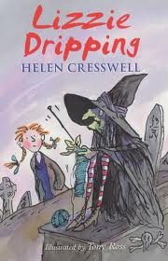 | 8+ | No-one in the village believes that Lizzie's seen a witch! But Lizzie doesn't care because she knows that in all Little Hemlock there's no one half as interesting as this witch - and besides it makes life far more exciting to have such an unusual friend.
D
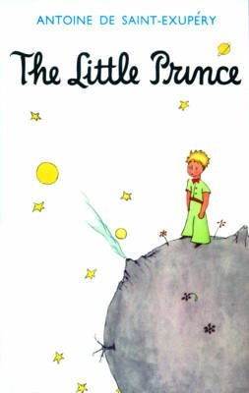 | 8+ | An air pilot makes a forced landing deep in the Sahara Desert. There, he makes a mysterious Little Prince, who tells him a series of wise and enchanting stories.  This simple, beautiful fable has captured the imaginations of both adults and children ever since it was first published in the 1940s. Now considered a contemporary classic, it is a book to share and to treasure.
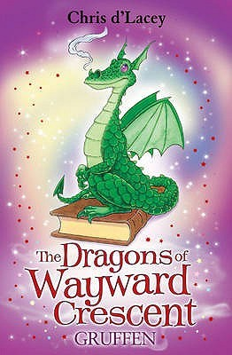 | 7+ | When Lucy suspects there's a 'monster' in her bedroom, her mum knows exactly what to do. Liz makes a guard dragon, Gruffen, to look after her....
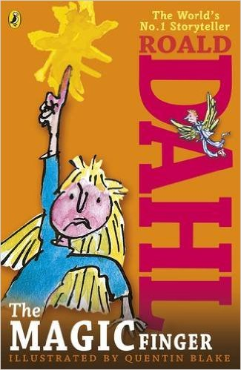 | 6+ | When the girl in this story gets cross, strange things start happening. Above all, she can't bear it when people are cruel to animals. So when her neighbours the Greggs go shooting, her magic finger teaches them a lesson they'll never forget...
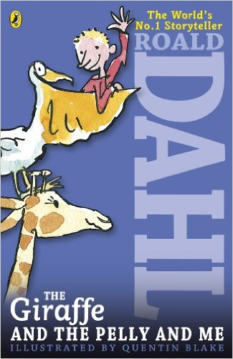 | 7+ | The Ladderless Window-Cleaning Company has just moved in to the old wooden house not far from where Billy lives. He'd rather have a wonderful sweet-shop, but when he meets the members of the Company - the Giraffe, the Pelican and the Monkey - he can't believe his eyes.
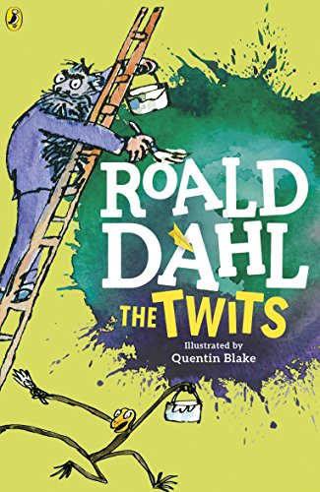 | 6+ | Mr Twit is a foul and smelly man with bits of cornflake and sardine in his beard.  Mrs Twit is a horrible old hag with a glass eye.  Together they make the nastiest couple you could ever hope not to meet.  Down in their garden, the Twits keep Muggle-Wump the monkey and his family locked in a cage. But not for much longer, because the monkeys are planning to trick the terrible Twits, once and for all . . .
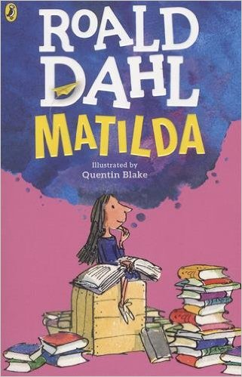 | 8+ | Matilda is not yet five years old, and already she is a very unusual child. Teaching herself to read, she works her way through all the books in the children's library and then gets started on the adult section, to the amazement of the librarian. Her narrow minded parents don't notice that they have a genius in their midst - but is soon becomes clear that underestimating Matilda is a big mistake.  When she starts school at Crunchem Hall, Matilda meets the frightening and bullying headmistress, Agatha Trunchbull, and witnesses her terrible temper. Soon, she puts her very special talents to work to get the better of Miss Trunchbull and the other unpleasant grown-ups around her - as well as to help warm-hearted class teacher Miss Honey.  This modern fairy-tale with a brilliantly inspiring young heroine is one of Roald Dahl's best loved stories. Full of magic and mischief, children will love witnessing Matilda pit her strength, courage and cool intelligence against the nasty and spiteful adults in her life, and ultimately coming out on top.
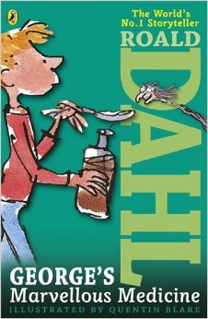 | 6+ | George's nasty old grandma needs teaching a lesson. George decides the best remedy for her grumpiness is a special home-made medicine. But Grandma gets more than she bargained for!  In George's Marvellous Medicine, published in 1981, George Kranky's Grandma may not anticipate the results of the medicine fed to her by her grandson, but like George, Roald Dahl also had fun mixing marvellous concoctions. He called them witches potions and delivered them to his children just before bedtime. They included ingredients like tinned peaches blended with milk and either pink, blue or green food colouring. His were put together carefully, though - none of the nasty side effects George's Grandma experienced..
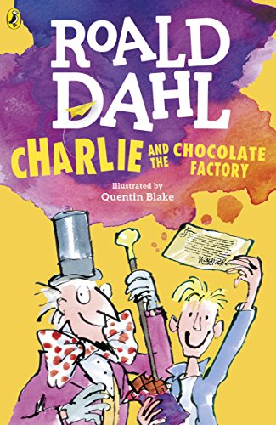 | 7+ | The famous story of Charlie Bucket and his Golden Ticket, and Willy Wonka and his amazing chocolate factory. Mr Willy Wonka, the most wondrous inventor in the world, opens his gates of his amazing chocolate factory to five lucky children.Gobstoppers, wriggle sweets and a river of melted chocolate delight await - Charlie needs just one Golden Ticket and these delicious treats could all be his!
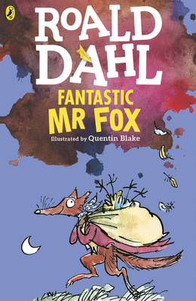 | 6+ | I hope you’ve never had the misfortune to meet anyone as cruel and callous as Mr Boggis, Mr Bunce and Mr Bean. These three men are farmers and a more disgusting trio cannot be imagined. They usually spend their time gobbling down enormous dinners of boiled chicken, duck-filled doughnuts washed down with gallons of cider but now these three repulsive specimens are at war.  For under a tree on the hill nearby live a fox and his friends: Mr Badger, Mr Mole, Mr Weasel, Mr Rabbit and their families. Every night cunning Mr Fox creeps into their farms and helps himself to a delicious dinner, but now Mr Boggis, Mr Bunce and Mr Bean have other ideas.
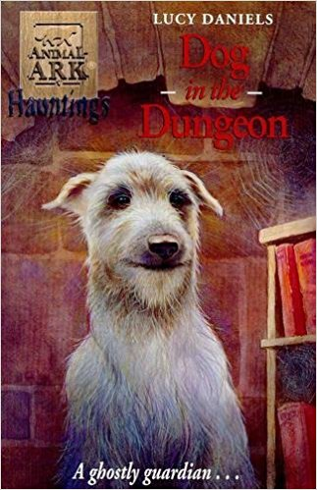 | 6+ | The first in an exciting spin-off trilogy as Mandy and James follow up ghostly sightings of animals and unravel the secrets behind them. This story features an aristocratic deerhound called Aminta. The last in a long line of dogs that protected the owners of the castle Mandy and James are visiting, the ghostly dog has been regularly sighted since the death of the owner of the estate. Mandy and James discover that the land is due to be split up and sold, destroying the family heritage and Aminta, as her last act as protector of the family, has returned from beyond the grave to try and help reclaim the estate. Can Mandy and James help her last wish come true?
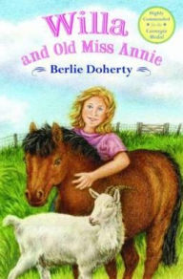 | 8+ | When Willa's family moves, the girl is heartbroken at having to leave her best friend behind. But soon she becomes friendly with her elderly neighbour, Miss Annie, and in the book's three episodes they help a lonely goat, an abandoned Shetland pony, and a tame fox. Doherty aptly and movingly describes the creatures' sad histories, but without overdramatizing them or causing alarm.
E
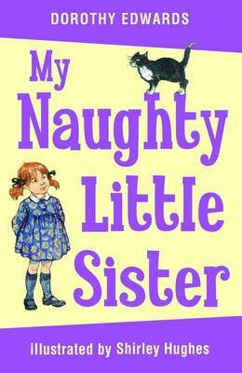 | 6+ | This affectionate portrait of family life is the story of a naughty three-year-old sister who is obstinate, inquisitive and full of mischief. She tries to cut off the cat's tail, eats all the trifle at Harry's party and gets up to all kinds of other antics, involving a wobbly tooth, a visit to the doctor, and a traumatic encounter with Father Christmas.
F
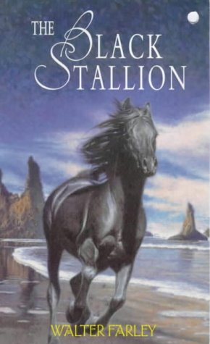 | 8+ | First published in 1941, Walter Farley’s best-selling novel for young readers is the triumphant tale of a boy and a wild horse. From Alec Ramsay and the Black’s first meeting on an ill-fated ship to their adventures on a desert island and their eventual rescue, this beloved story will hold the rapt attention of readers new and old.
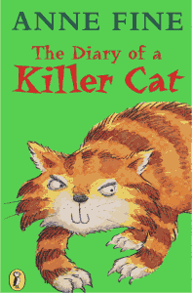 | 6+ | A cat’s eye view of the world is not exactly the same as a humans! Tuffy’s got no problems with the trail of delicious victims he brings into the house. A bird, a mouse – they are both delicious. In fact, he can’t see why Ellie is so upset. How a cat can train an owner is hilariously told by Tuffy himself in this witty commentary on the strange behaviour of humans.
G
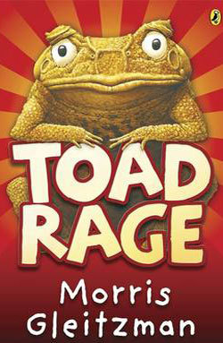 | 8+ | Limpy, the cane toad, deeply disturbed that motorists appear to swerve their cars specifically to run toads over, is determined to put a stop to this needless loss of life. He sets out on a perilous journey to try to persuade humans that cane toads are loveable, friendly creatures. He decides to endear himself to the public by becoming a mascot for the Australian Games, so travels south to begin negotiations with the Games organisers. However, the way is fraught with danger, and he often has to limp hurriedly away from the clutches of angry security guards and salivating dogs!  This hilarious and original story is superbly written.
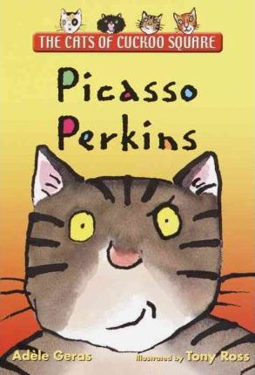 | 6+ | Perkins is a wise old tabby cat with a problem: His 8-year-old owner insists on doing his picture for a “Paint Your Pet” competition. Perkins is very fond of Lexie, but really! All he wants in life is a little peace and quiet. Perkins doesn’t expect to find a surprising talent of his own. . . .
H
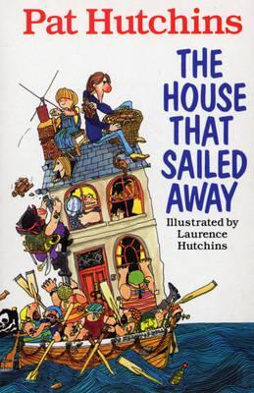 | 8+ | Poor old Grandma! It had rained every day since she came to stay with Mother, Father, Morgan, the baby and Tailcat. But just as everyone was getting really fed up of being stuck indoors, the most amazing thing happened! Suddenly the house started to shudder and rock - and then just floated off down the street and off to sea. Before long, the family find themselves on the wackiest adventure ever! Hungry cannibals, blood-thirsty pirates, a kidnapping and buried treasure are just some of the hair-raisers in store. Will the family ever see dry land again or will evil One-Eyed Jake cut them into a million tiny pieces?
I
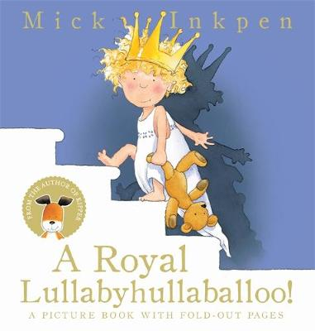 | 6+ | With a host of noisy fairytale characters and a fold-out page on every spread, this is a new edition of a read-aloud classic from the creator of Kipper and Wibbly Pig. Perfect for bedtime! The sun is down, the moon is up, and it is past bedtime. But outside the castle there's an awful lot of noise! Will the princess ever get to sleep? Mick Inkpen has won the British Book Award, the Children's Book Award and has been shortlisted for both the Kate Greenway Medal and the Nestle Prize.
J
K
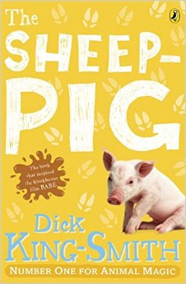 | 7+ | When Farmer Hogget wins a piglet at the fair, he is amazed that Fly, his sheep-dog, welcomes him as one of her own pups. Fly names the piglet Babe and teaches him all he needs to know about the farm and its animals.  As he watches his 'mum' round up the sheep, he decides he would love to try too. However, his legs are too short and he is far too plump to run around after a flock of sheep. He then tries a different tactic; politely asking the sheep to form an orderly line! The sheep are so surprised to be treated with respect that they happily oblige and Farmer Hogget soon notices that Babe has a certain knack with them...  One of Dick King-Smith's best-loved tales, this wonderful book is full of gentle humour. The short chapters make it ideal for early confident readers, and it will be especially adored by young animal lovers.
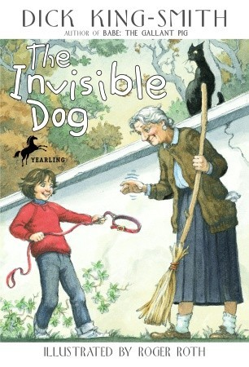 | 7+ | Illustrated in black-and-white. When her parents can't afford a new pet, seven-year-old Janie invents one. Her new pretend dog is Henry, an invisible Great Dane who eats invisible food bought with invisible money. Then some mysterious events--and perhaps a touch of magic--bring the invisible Henry to life.
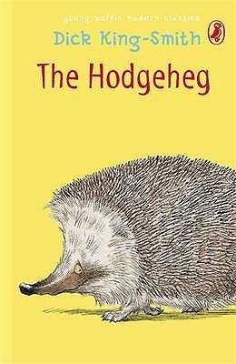 | 7+ | Max's family dreams of reaching the Park. But no one has ever found a safe way of crossing the very busy road. Young Max, who is brighter than the average hedgehog, is determined to solve the problem.
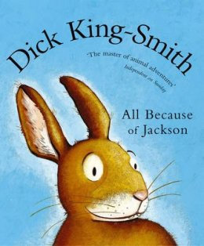 | 6+ | How did the humble rabbit originally find its way to Australia? And what caused the great Australian plague of rabbits? Simple - according to Dick King-Smith, it was all because of Jackson. A superbly-told story of a young rabbit whose dream of travelling overseas comes true.
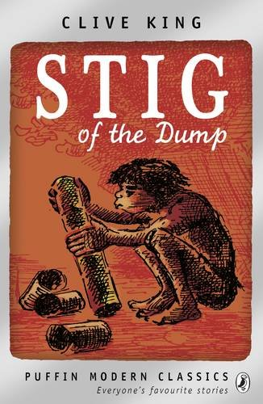 | 8+ | Barney is a solitary little boy who often wanders off by himself in the countryside. Exploring an old chalk pit, he finds himself in a cave where he meets a strange boy who wears a rabbit skin and speaks in grunts. His grandparents don't believe Barney when he tells them about his new cave boy friend - but nevertheless, the two enjoy plenty of fun together.  This lovely story about the unlikely friendship between Barney and stone-age Stig has stood the test of time. Although it is now over 50 years old, contemporary children will love reading about the pair's lively adventures. Clive Kings' story is perfectly accompanied by Edward Ardizzone's classic illustrations.
L
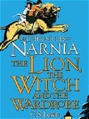 | 8+ | When the Pevensie children - Peter, Susan, Edmund and Lucy - step through a wardrobe door in the strange country house where they are staying, they find themselves in the land of Narnia. Frozen in eternal winter, Narnia is a land of snow and pine forests, and its creatures are enslaved by the terrible White Witch.  Tempted by the promise of endless Turkish Delight, Edmund becomes the White Witch's servant - and its up to his brother and sisters to release him from his enchantment and to rid Narnia of the witch. But just when it seems that all hope is lost, the Great Lion Aslan returns to help the children to save Narnia.  This classic story is certain to capture young imaginations, cleverly blending elements of fairy-tale and fantasy to create a wonderfully engaging adventure.
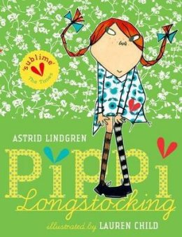 | 8+ | Follow Pippi Longstocking on her amazing adventures as she moves into Villa Villekulla with a horse, a monkey, and a big suitcase of gold coins, and meets Tommy and Annika who quickly become her best friends. They join her on her amusing escapades – joining the circus, dancing with burglars and celebrating her birthday.  This lovely new edition of a classic has been brought up-to-date with delightful illustrations from Lauren Child and a new translation from Tiina Nunnally. The collection brings together 11 favourite Pippi stories, and will ensure that readers young and old fall in love with this fabulous heroine.
M
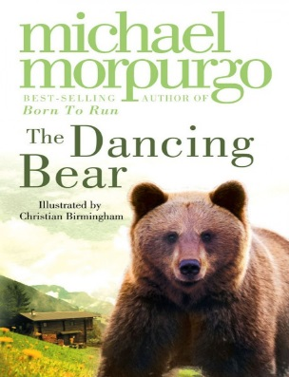 | 7+ | High in the mountains, in a tiny village, an abandoned bear cub is adopted by a lonely orphan child. Soon they are the best of friends, beloved by the whole village – safe, until the arrival of a glamorous film crew who need a dancing bear…
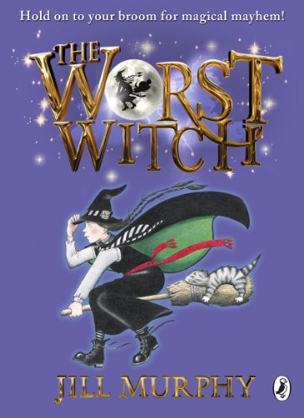 | 7+ | Hold on to your broomstick for magical mayhem! Jill Murphy's much-loved classic The Worst Witch is the original story of life at a magical boarding school, perfect for readers aged 5 - 9 years.  Mildred Hubble is a trainee at Miss Cackle's Academy for Witches, but she's making an awful mess of it. She keeps getting her spells wrong and crashing her broomstick. And when she turns Ethel, the teacher's pet into her worst enemy, chaos ensues...
N
O
P
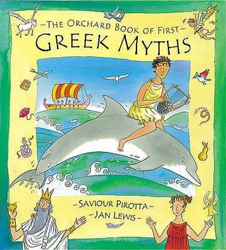 | 6+ | The perfect introduction to Greek myths, illustrated with bright pictures by Jan Lewis. Here are ten of the best loved Greek legends retold with warmth and humour to make them easily accessible to young children.
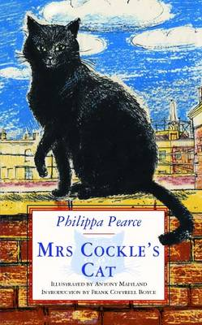 | 6+ | This magical story weaves a delightful fantasy around a simple and touching story of a lost cat. Mrs Cockle lives at the top of a very tall house which has a useful trap door that opens directly onto the roof. When Mrs Cockle is out at work all day selling balloons she lets her cat Peter out so that he can enjoy the sunshine. One day Peter goes missing and Mrs Cockle sets out on a fantastic journey, including walking on the clouds, to find him and bring him home. Hugely touching it's a story to be enjoyed by parent and child together or for a child who is just beginning to enjoy more independent reading.
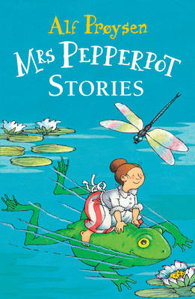 | 6+ | A fantastic collection of much-loved, classic stories for all the family! Mrs Pepperpot can't choose when she will shrink to the size of a pepperpot - it just happens! But whatever she encounters, whether it be a monstrous mousetrap, a crafty fox or a gigantic mountain of ice cream, little Mrs Pepperpot will always come out on top.
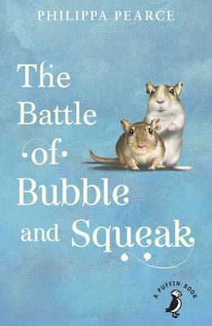 | 8+ | Sid, Peggy and Amy adore the two gerbils, Bubble and Squeak, but their mother detests them. A major family battle results, and it's clear life is never going to be quite the same again. But after a near fatal encounter between Bubble and Ginger the cat, Mrs Sparrow begins to see that life with a pair of gerbils might not be so bad after all.
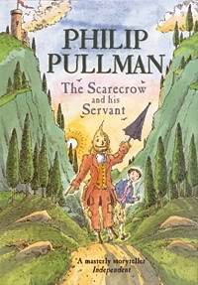 | 8+ | Struck by a sudden bolt of lightining, Scarecrow comes alive. A young boy called Jack hears the Scarecrow's call for help and, overcoming his initial shock, is persuaded to become his servant. The latest in a long line of literary masters and servants, Jack and Scarecrow are strongly reminiscent of Don Quixote and his servant Sancho Panza in Cervantes' timeless classic, as they too set off on a series of madcap adventures - some funny, others dangerous and exciting - often saved only by Jack's endless resourcefulness.  Set in Italy, this fairytale adventure is perfectly complemented by Peter Bailey’s atmospheric illustrations, which give life and shape to the characters and touchingly depict the story's climax.
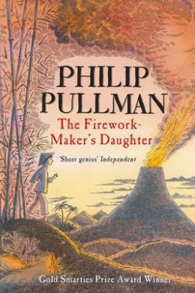 | 7+ | A fantasy adventure story of a determined girl called Lila who with the help of her friend, Chulak, and elephant, Hamlet, proves to her father that she is far more capable than he ever expected!
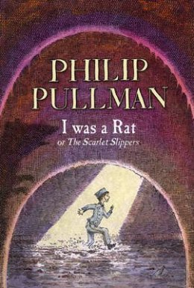 | 8+ | A small boy arrives on the doorstep of a childless couple, politely but insistently asserting that he used to be a rat.  The hapless Roger is first taken from his new home for a ‘philosophical investigation’, then exploited as a fairground exhibit and finally hunted as an alleged threat to society, until the remarkable truth finally emerges.  This is a magical, humorous and well-paced example of storytelling at its best.
Q
R
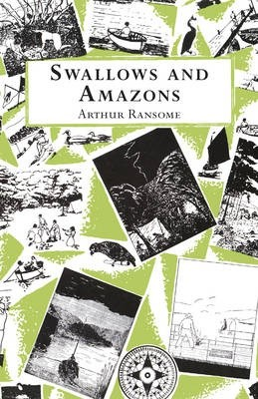 | 8+ | It's the summer holidays, and the Walker children - otherwise known as Captain John, Mate Susan, Able-Seaman Titty and Ship's Boy Roger - are excited to set sail on their boat Swallow and camp on Wild Cat Island. Exploring their new territory, camping in the open skies, swimming in the lake and fishing for their dinner would be adventure enough - but then they meet two fierce Amazon pirates who challenge them to a war.  Arthur Ransome's classic Swallows and Amazons stories begin with this first book, a delightful evocation of a wonderful summer of adventure, discovery and friendship. Inspired by the author's own real-life sailing adventures in the Lake District as a child, this enchanting story is accompanied by Ransome's simple but characterful black and white illustrations.
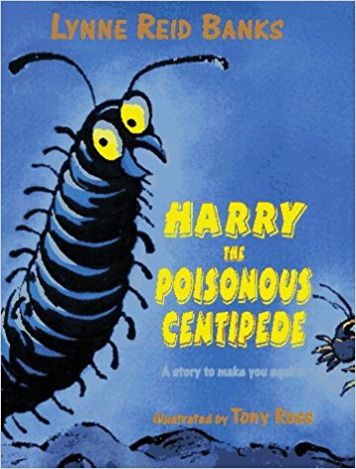 | 8+ | "It's a Hoo-Min! crackled George."  "Walking on its hairy biter feet!"  But now it was Harry who felt brave.  "Come on! Lets's peep at it."  Harry is a poisonous centipede but he's not very brave.Still, he is the star of this seriously squirmy story. Harry likes to eat things that wriggle and crackle, and things that are juicy and munchy! But there are some things that a centipede must never try to eat -- dangerous things like flying swoopers, belly wrigglers, mid the most dangerous of all ... Hoo-Mins!  Harry's mother makes him promise never to go up the Up-Pipe to the world of Hoo-Mins, but Harry's best friend, George, has other ideas! And as every young Hoo-Min knows, when your best friend wants to do something that sounds exciting, it's very hard to say no. So George and Harry poke their feelers out and smell the air....and that's when their adventures begin.  Lynne Reid Banks's storytelling sparkles in this tale of her new centipede hero and his creepy-crawly world. Fizzing with fun, it will be a delightfully squirmy experience for all young readers
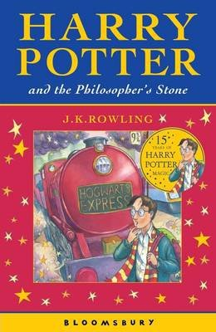 | 8+ | After the misery of life with his ghastly aunt and uncle, Harry Potter is delighted to have the chance to embark on an exciting new life at the Hogwart's School of Wizardry and Witchcraft. Learning about magic and making new friends, he has the chance to use his new-found wizarding skills to unravel some of the mysteries of his own past - and to uncover some shocking secrets about his teachers.  This brilliantly inventive, award-winning adventure story is the first in the phenomenally successful Harry Potter series. With shades of Diana Wynne Jones, Enid Blyton, Roald Dahl and Jill Murphy's The Worst Witch, this contemporary classic of children's literature is beloved by children and adults alike.
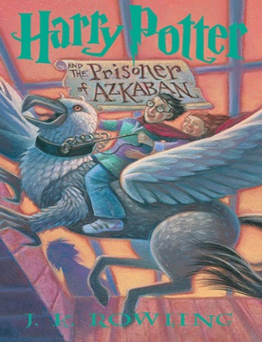 | 8+ | Harry Potter is lucky to reach the age of thirteen, since he has already survived the murderous attacks of the feared Dark Lord on more than one occasion. But his hopes for a quiet term concentrating on Quidditch are dashed when a maniacal mass-murderer escapes from Azkaban, pursued by the soul-sucking Dementors who guard the prison. It's assumed that Hogwarts is the safest place for Harry to be. But is it a coincidence that he can feel eyes watching him in the dark, and should he be taking Professor Trelawney's ghoulish predictions seriously?
S
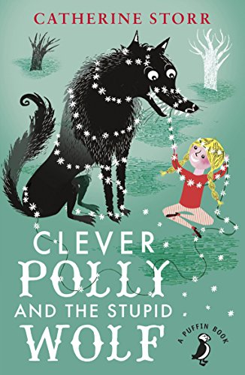 | 7+ | CLEVER POLLY AND THE STUPID WOLF by Catherine Storr has twelve stories written for the author's daughter, who was scared of the wolf under the bed! Drawing occasionally on well-known fairy tales, and skillfully blending fantasy and reality, these stories are bursting with humour, originality and charm. And Polly, not scared at all, outwits the wolf on each and every occasion!
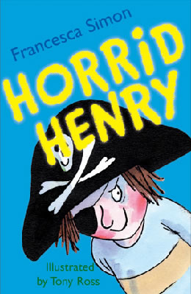 | 6+ | Stories about naughty characters have been told for centuries, and Horrid Henry is a modern-day rogue in the tradition of Dennis the Menace, Pippi Longstocking, Just William and My Naughty Little Sister.  The first in the hugely popular Horrid Henry series introduces us to Henry and his brother, Perfect Peter. The four stories it comprises are long enough to satisfy early readers, yet are short enough to be manageable, with plenty of laughs along the way. Tony Ross's mischievous illustrations are the perfect accompaniment - and children will have great fun comparing their own behaviour to Henry's, hopefully coming out on top!
T
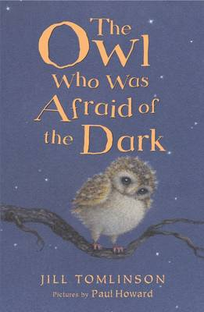 | 6+ | Plop is a baby owl. Perfect in every way - except for one. He's afraid of the dark! But he soon discovers, through a variety of new friends, that dark can be fun and exciting and magical! This is a story for very young readers.
U
V
W
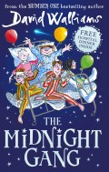 | 7+ | Poor Tom has been hit on the head by a cricket ball and wakes up in the Lord Funt Hospital with a big bandage on his head. In the children’s ward, though, he finds children with worse complaints: Amber’s got full leg and arm casts in a wheelchair; Robin has had an eye operation and can’t see; and poor Sally is too weak to get out of bed.  Worse, there’s a horrible kid-hating Matron watching over them and making sure they don’t have any fun at all – not that there is much fun to be had in hospital (or so you would think).  It transpires that the children are part of the Midnight Gang: an ages-old hospital tradition that makes dreams come true for sick children. But what will Tom’s wish be, and can the kindly hospital porter make it come true?  David Walliams’ tongue-in-cheek fun continues to amuse in this new adventure that also tugs at the heartstrings in just the right way. The Midnight Gang’s various ailments and conditions don’t affect them careering joyously around the hospital in the middle of the night, although Walliams still treats the characters and their conditions with dignity and respect where appropriate.
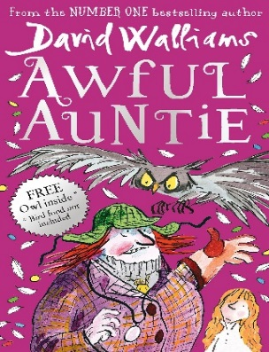 | 8+ | Aunt Alberta is the most awful aunt who ever lived. She is a pipe-smoking, monocle-wearing monster with steel toe-capped boots on her feet and a fearsome giant owl on her arm.  Little Stella Saxby is the only person standing between Aunt Alberta and ownership of Saxby Hall - which means Stella is in serious trouble. As Aunt Alberta and the owl develop ever-more-evil plots to get rid of her, Stella must use cunning tricks and a rather spooky secret weapon to foil their plans.  A conversational writing style and plentiful black-and-white illustrations draw readers into the story from the very first page. Awful Auntie is rude, witty, irreverent, just a bit scary and fantastic fun.
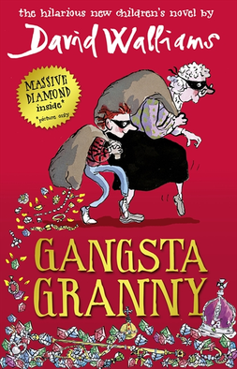 | 8+ | Ben is 11, an only child and a poor reader, whose ambition is to be a plumber. Every Friday he visits his Granny, while his parents go to watch ballroom dancing, and he hates those dull, smelly, cabbage-dominated evenings. Then he discovers that his Granny isn’t quite what she seems, and life takes a dramatic turn for the better.  Tony Ross's entertaining and funny illustrations are the ideal partner for David Walliams's outrageous, laugh-out-loud story. Walliams knows exactly what his readers want, and serves up humour filled with bums, farts and poo; but when Granny is taken into hospital the story takes a more serious turn, leaving readers to examine their own relationships with the elderly.
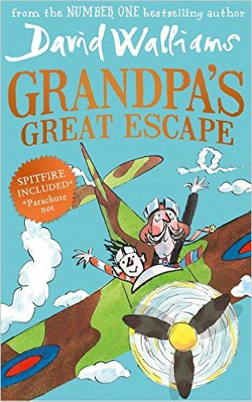 | 8+ | Grandpa is getting forgetful. But his memories of flying war planes are sharp as bayonets. Grandpa and Jack love watching World War II films, eating Spam a la Custard and visiting the Imperial War Museum. But when Grandpa goes missing and Jack finds him stowed away in the Museum's spitfire, Jack's parents decide it's time for him to move to Twilight Towers.  Sneaking in to visit Grandpa under cover, Jack spots the scary matron forging the residents' wills, discovers a room full of pills to keep them asleep and another piled high with ominous coffins, it's up to Jack to help Grandpa escape!  A daring, madcap, blockbusting adventure, full of humour, history, bravery, compassion and affection, from award-winning, best-selling David Walliams.
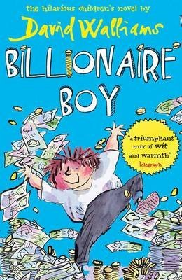 | 8+ | Having started from humble origins, Joe’s father is now a billionaire, and Joe has everything he wants, except true friends. To remedy this he enrols at the local comprehensive school, where he learns the hard way that you can’t buy them, and that family and friends are more important than any possessions.  Ross’s inimitable illustrations capture and extend Walliams’ style perfectly. Despite the book’s length, the large print would make it accessible for older but less keen readers, and the touches of satire could also attract that audience, as well as adults.
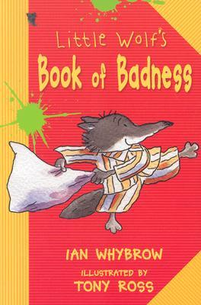 | 7+ | Little Wolf has been behaving too courteously, so his parents send him to his uncle's Big Bad Wolf school to learn to be a proper wolf.
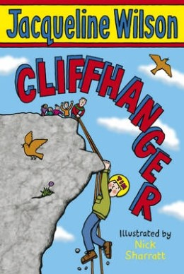 | 7+ | A salutary and funny tale about not giving up from Jacqueline Wilson. From climbing and abseiling to canoeing and a Crazy Bucket Race, the adventure holiday promises to be full of action. There's just one problem as far as Tim is concerned: he is hopeless at sports of any kind. Chapters are short and the writing is clear.
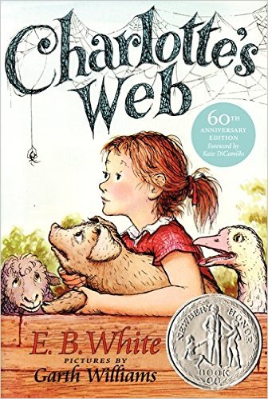 | 7+ | This is the tale of how a little girl named Fern - with the help of a friendly talking spider called Charlotte - saved her pig, Wilbur, from the usual fate of nice fat little pigs.  An unusual and witty story which provides a gentle introduction to questions of mortality, Charlotte's Web is a modern classic.

